Who is this character? Teacher’s Resource Page
Character 1 - The Beast  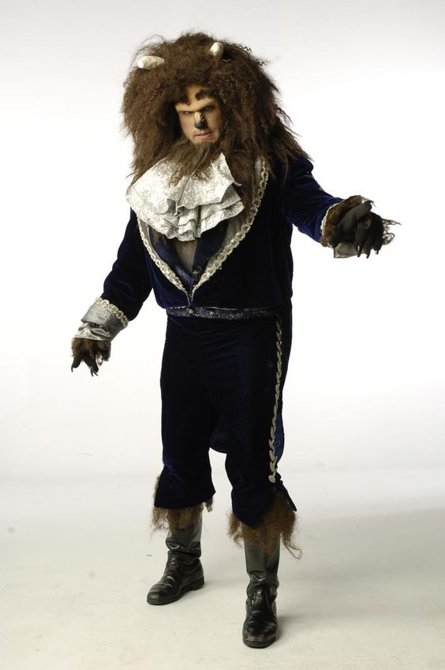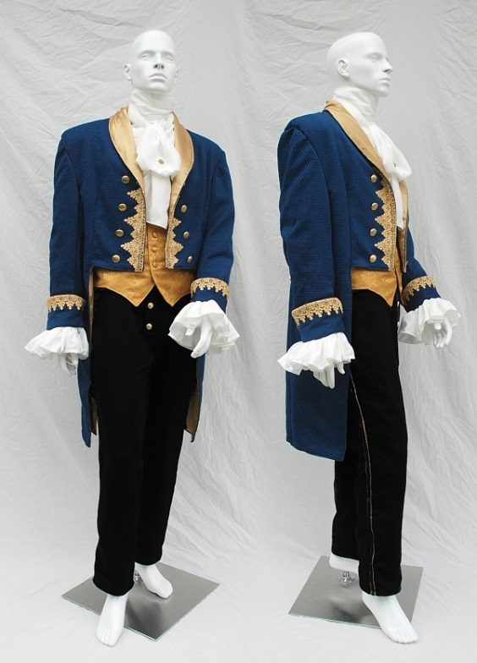 | Character 2 - The Nut Cracker  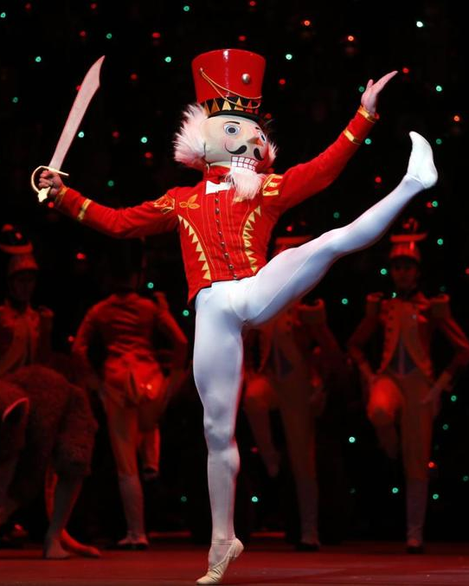  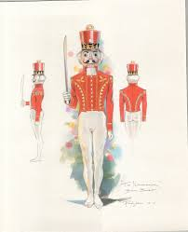
Character 3 - Sherlock Holmes  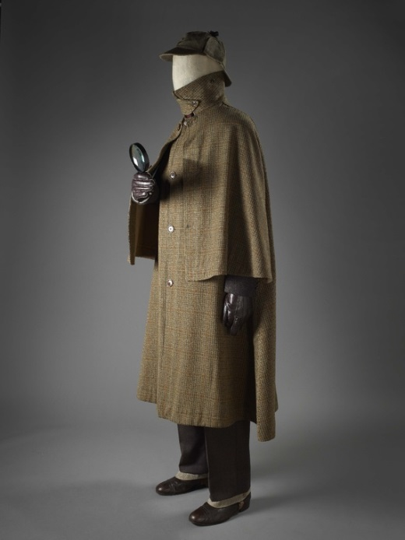  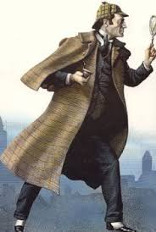 | Character 4 – Mary Poppins  Mary Shephard’s original version of Mary Poppins in the 1930’s.  Stage version of Mary Poppins #1  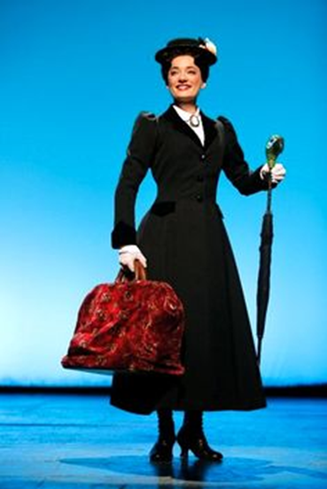
Stage version of Mary Poppins #2
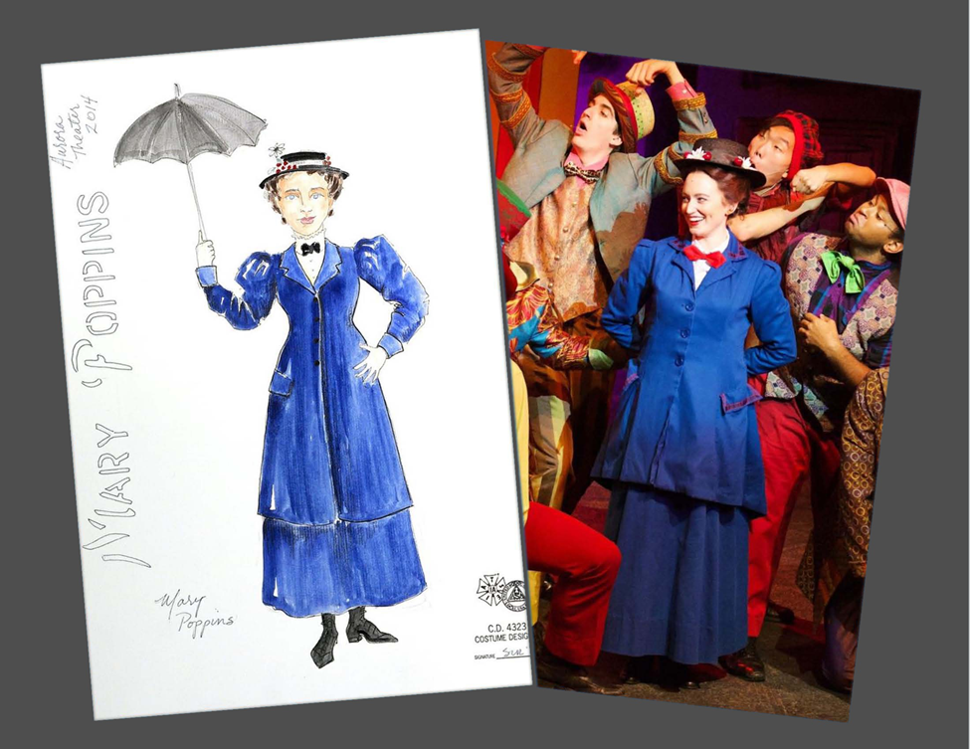

Character 5 - Miss Trunchbull

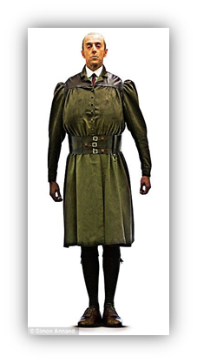

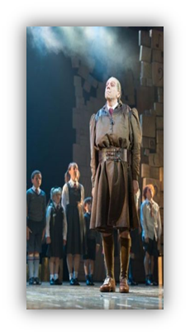
References:
Chirravoori, M. (2013). Sherlock Holmes: Fans-com. Retrieved online from http://www.sherlockholmes-fan.com/sherlock-holmes-biography.html
Dahl, R., & Blake, Q. (1988). Matilda. London: Jonathan Cape.
Lyric Theatre Company. (2008). Beauty and the beast character descriptions. Retrieved online from www.lyrictheatrevt.org/b_b/batbcharacterdescriptions.pdf
Pallardy, R. (2014). P.L. Travers: British author. Retrieved online from https://www.britannica.com/biography/P-L-Travers
Travers, P., & Shepard, M. (1962). Mary Poppins. Harmondsworth. United Kingdom: Puffin
Wilson, P. (2014). Sherlock Holmes: Fictional character. Retrieved online from https://www.britannica.com/topic/Sherlock-Holmes

