Who am I?
https://www.onthejob.education
Hint: Look under Government & Defence
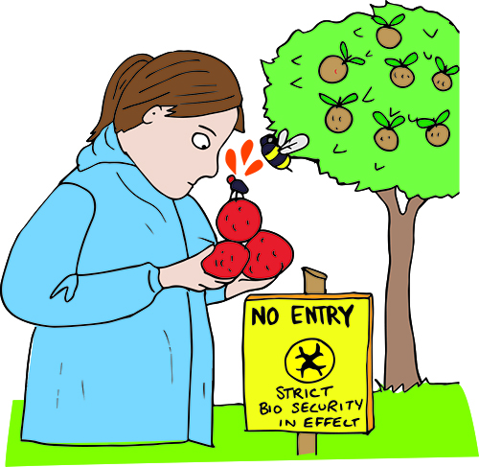

My Job Name is _________________________
The category(ies) and Skill Levels are_____________________
Information about this job: List 1 – 2 interesting things about this job.

The Activities you are asked to do are…

Is there another activity you would undertake?
________________________________________________________

Did you know? Which one did you find interesting? Why?

Links: Investigate one Link or Video. What did you discover?

Power Words: List any new words and their definitions that you have come across.

