Who am I?
Target: Years 5 - 7
https://www.onthejob.education
Hint: Look under Houses & Buildings
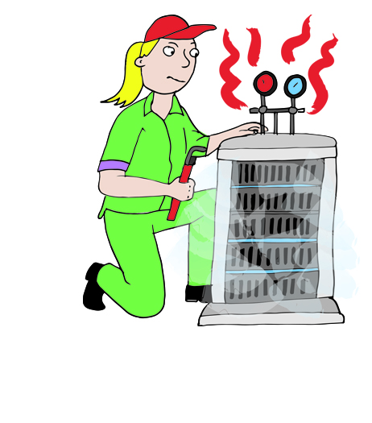

My Job Name is _________________________
The category(ies) and Skill Levels are_____________________
Information about this job: List 1 – 2 things about this job that you think are interesting.

The Activities you are asked to do are…

Is there another activity you think should be here?
________________________________________________________

Did you know? What was interesting? Why?

Links: Investigate one Link or Video. What did you discover?

Life on the Job: Do you know someone in this job? Would they be interested in being interviewed by you and have their story on this website?
Power Words: List any new words and their definitions that you have come across.

