“Unit-ed” – a 5 – 6-week programme
Teacher’s Guide
Years 5 - 10
Website:
https://www.onthejob.education/
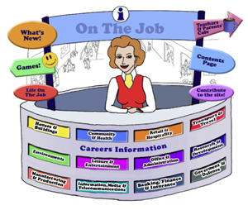
Duration: 5-6 weeks

Index
Introduction 3
Alignment with the Australian Curriculum 5
Lesson Planning – Overview 9
Process Steps 10
Week 1 - Understanding Job Categories 11
Week 2 – On the Way to Work 13
Week 3/4 – Career Path Components 18
Week 5 – The Good Manager 26
Week 6 - Parents & Work; Assessment 30

On the Job: Careers Market

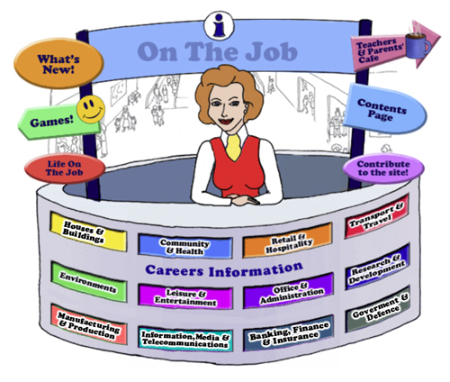
Teachers/Parents
Introduction
Welcome to this unit of work for Australian students in the middle school years (Years 5 - 8). However, there are activities that will extend students beyond these constraints.
The Design concept is based on the local Shopping Mall as students of this age are familiar with the Careers represented here. This initial concept broadened to include careers that they might have encountered outside the Shopping Mall eg. Local Government Inspector or Farmer
The website can be used as an individual activity for students or as a whole group.
This unit of work embraces 5 – 6 weeks of work, however, you can use as much or as little as you like.
This Teacher’s Guide is for the whole class and is aligned to the Australian Curriculum and the General Capabilities.
The Jobs
Each of the jobs listed has three sections

- The Information about each Job.
- Activities
- Links

The Information
All content in the Job Info sections have been taken from The Job Guide. Under copyright laws and from the Job Guide’s website – this information can be used for Educational purposes.
This content also encourages reading and therefore literacy but breaks down information into chunks and divided by “Did You Know?” segments.
The Activities
The Activities can be divided into two sections:
- Offline
- Online
The activities bring a fun element into learning. There are practical skills about the particular job eg. “How to build a beehive” [in the Beekeepers section] is an Offline activity.
The Online activities include mostly free mobile apps, YouTube Videos, games and also WebQuest activities which provide students with Problem-Based Learning and the opportunity to use their Higher Order Thinking and Collaboration Skills.
The Links
The Links provide students with access to Association websites for that particular Industry as well as links to examples of people within this job and their experiences.
Life on the Job
Life on the Job is divided into three sections:
- Historic or Famous People – mostly Australians
- Indigenous Historic or Famous People
- “Real Life People”
Historic or Famous People
Historic or Famous People are mostly famous Australians. Each person is researched and their lives summarised to give students an overview. There are links provided so students can investigate more fully themselves. At the end of the content information, students are given an activity to complete – mostly using the latest and free ICT tools available to increase their knowledge and capability.
Indigenous Historic or Famous People
Indigenous Historic or Famous People are famous Australians whose lives are usually investigated within the Australian Curriculum. Each person is researched and their lives summarised to give students an overview. There are links provided so students can investigate more fully themselves. At the end of the content information, students are given an activity to complete – mostly using the latest and free ICT tools available to increase their knowledge and capability.
Real Life People
Real Life People’s stories are provided here. Parents can submit their job and show students their educational journey to achieve employment within their job category.

Alignment with the Australian Curriculum

Curriculum Area: Australian Curriculum: General Capabilities
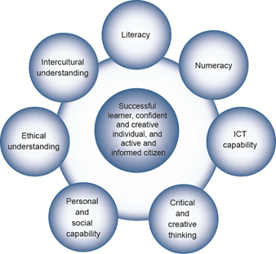
The Australian Curriculum includes seven general capabilities:
- Literacy
- Numeracy
- Information and communication technology (ICT) capability
- Critical and creative thinking
- Personal and social capability
- Ethical understanding
- Intercultural understanding.
(Source: Australian Curriculum)

Literacy involves students in listening to, reading, viewing, speaking, writing and creating oral, print, visual and digital texts, and using and modifying language for different purposes in a range of contexts.
Numeracy involves students in recognising and understanding the role of mathematics in the world and having the dispositions and capacities to use mathematical knowledge and skills purposefully.
Information and communication technologies are fast and automated, interactive and multimodal, and they support the rapid communication and representation of knowledge to many audiences and its adaptation in different contexts. They transform the ways that students think and learn and give them greater control over how, where and when they learn.
Critical and creative thinking are integral to activities that require students to think broadly and deeply using skills, behaviours and dispositions such as reason, logic, resourcefulness, imagination and innovation in all learning areas at school and in their lives beyond school.
Students develop personal and social capability as they learn to understand themselves and others, and manage their relationships, lives, work and learning more effectively. The capability involves students in a range of practices including recognising and regulating emotions, developing empathy for others and understanding relationships, establishing and building positive relationships, making responsible decisions, working effectively in teams, handling challenging situations constructively and developing leadership skills.
Ethical understanding involves students in building a strong personal and socially oriented ethical outlook that helps them to manage context, conflict and uncertainty, and to develop an awareness of the influence that their values and behaviour have on others.
As cultural, social, environmental and technological changes transform the world, the demands placed on learners and education systems are changing. Technologies bring local and distant communities into classrooms, exposing students to knowledge and global concerns as never before. Complex issues require responses that take account of ethical considerations such as human rights and responsibilities, animal rights, environmental issues and global justice.

Building ethical understanding throughout all stages of schooling will assist students to engage with the more complex issues that they are likely to encounter in the future, and to navigate a world of competing values, rights, interests and norms.
Intercultural understanding: The capability involves students in learning about and engaging with diverse cultures in ways that recognise commonalities and differences, create connections with others and cultivate mutual respect. (Source: Australian Curriculum)

On the Job – Australian Curriculum General Capabilities Alignment with Activities

All of the activities in “Life On the Job” have been aligned with the Australian Curriculum’s General Capabilities. They are meant to be fun and engaging for the student and introduce them to the world of work in a more concrete way.
On the Job builds on what students have learnt in their earlier years in Primary School about the world of work and helps students go from the concrete to the abstract in their thinking.
Each activity shows the General Capability [GC] being focussed on by showing the GC icon.

Lesson Planning - Overview
Week | Topic | Australian Curriculum  General Capabilities | Activities
1 | Understanding Job Categories – using On the Job website |  | Venn Diagram Maker  Create a Mural  Use an Online Bar Graph Maker  Use EduGlogster or Wordle to create an Online Mural
2 | On the Way to Work |  | Setting the Scene: Charlie and the Chocolate Factory [2005]  Movie Director – On the Job  Compare and Contrast Movies:  Charlie and the Chocolate Factory [2005] with Willie Wonka and the Chocolate Factory [1971]
3/4 | Career Path Components |  | Famous Australian – David Unaipon.  Early Interest – What I used to want to be...  Writing a Fairy Tale or Fable using VoiceThread or Animoto. Create a video using Stupeflix.  Socratic Discussion – Why is Education important?  Interview a Trainer  Inventions and Rap
5 | The Good Manager |  | Interview a Manager  Create a Vision Statement  A Job Well Done – a Thank You Letter  Create a Staff Newsletter  Role Play
6 | The Purposeful Outcome & Assessment |  | Interview Parents about their job  Assessment: On the Job Detective Game

Process Steps
- Divide the class into eight groups (about 2 - 3 students per group). Each group will investigate, throughout the unit, one of the following 12 career categories:

- Introduce students to the concept of Employment and link with what they already know from their studies on Community Services.
- Work through weeks 1 – 6 and conclude with the Assessment, The Detective Game in On the Job.
- Although it is better to be sequence, each week’s lessons can be stand-alone.
- There are Extension activities for all weeks’ lessons.

Week 1 – Understanding Job Categories
Teaching Notes
There are many ways to categorise the labour force but the classification outlined in On the Job is easily understood by students in the middle school and high school years:
- Houses & Buildings
- Community & Health
- Retail & Hospitality
- Transport & Travel
- Environments
- Leisure & Entertainment
- Office & Administration
- Research & Development
- Manufacturing & Production
- Information, Media & Telecommunications
- Banking, Finance & Insurance
- Government & Defence

Activity 1: What’s in a Category?
Australian Curriculum General Capability: Numeracy
Randomly assign to each group one of the career categories from “On the Job”.
Provide the groups with an A3 sheet of paper and ask them to list jobs within their assigned category [before looking at On the Job website]
Ask two groups to pair up and view each other’s list. Get the second group to add, if possible, to the first group’s list.
Are there any jobs that are in both categories?
When the groups have exhausted their collection, you might direct the students to the Information Desk at the Careers Mall at https://www.onthejob.education/info.htm to investigate these categories.
Are there any differences?
Show the students how to create a Venn Diagram using Venn Diagram Maker and direct the students to create a Venn Diagram showing their jobs, the jobs from “On the Job” and the jobs from the second group if they are different from the first group.

https://www.lucidchart.com/pages/examples/venn_diagram_maker

Activity 2: Create a Mural
Australian Curriculum General Capability: Critical & Creative Thinking
Australian Curriculum General Capability: Numeracy
Australian Curriculum General Capability: ICT Capability

1. Students are to have a look at the murals within the “Activities” pages within On the Job – there are 7 different murals. Look at the following 3 examples:
2. For each of the 7 murals, get the students to categorise each job shown into one of the twelve categories. Are any categories represented more than others? Male/Female ratio? Is it balanced? Ethnicity – is this covered? Are the 5 Skill Levels [Skill Levels - On The Job] and 7 Job Categories [Job Categories - On The Job] well represented? Are there any imbalances?
3. Create a Bar Graph to show the differences using Meta-chart – Online Bar Graph Maker
4. Give the students a large sheet of paper, some pencils and crayons. The groups are to create a mural that captures their career category in action. Ask the students to include fine detail in their artwork.
When all illustrations are complete they could be:
- displayed around the classroom. The full display gives the students a feel for the variety of careers particular to each career category.
- scanned, sent as a jpeg file (no bigger than 600 x 500 pixels) to Frances.Moore@onthejob.education
Activity 3: EXTENSION: Create an Online Poster
Australian Curriculum General Capability: ICT Capability
- Have the students create a Poster using Canva.com, (https://www.canva.com/) (Free), OR
- Create a word cloud out of all the jobs within their category with Wordle.
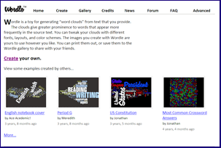
http://www.wordle.net/
Week 2 – On the Way to Work
Teaching Notes
Activity 1: Setting the Scene: Charlie and the Chocolate Factory
Australian Curriculum General Capability - Literacy
Roald Dahl’s "Charlie and the Chocolate Factory" provides a comprehensive look at employment from many perspectives.
Have the students view the movie Charlie and the Chocolate Factory [2005] with Johnny Depp as an introduction to the topic.
10 minute preview is at Charlie and the Chocolate Factory | Full Movie Preview | Warner Bros. Entertainment https://youtu.be/wcdBCanllNA
Viewing is an important part of any English program as it encourages students to make external connections with their own experiences, knowledge, and ideas. Movies are an important component of Visual Literacy.
While viewing the movie the students can be looking for information about: career paths, workplaces, managers, workers, and products.
Note-taker's guide: See Template below
After the movie, organise the students into their groups. Each group will need a large sheet of paper and pencils. Pose a series of questions that require varying levels of response: eg.
Remembering/Knowledge: What did Charlie’s mother do for a living?
Understanding: Why didn’t Charlie’s grandparents work?
Applying: What were some interesting design features at the Chocolate factory?
Analysing:
a. Describe Violet Beauregarde’s personality.
b. Will Charlie make a good boss? Why?/Why Not?
Evaluating: What made Willie Wonka’s Chocolate Factory so successful?
Creating: Create a Board Game around the Wonka Chocolate Factory. Any ideas about what to do to create a board game.

See these games that have been created in the past. What do you think might be the rules for these games?
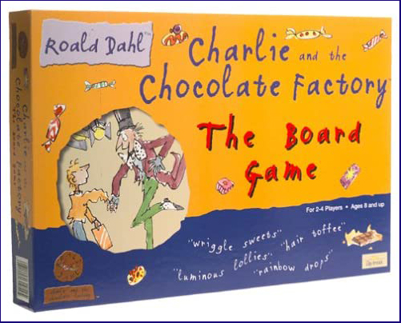
What do you think might be the game here?

Or in the next game?
What would you do to create an interesting game?

When the groups have completed their written responses conduct a class conversation. The students should be encouraged to speak on behalf of their group and in keeping with their written answers. Facilitate dialogue not just discussion.

Activity 2: On the Job – On the Way to Work – Movie Director [Information, Media & Telecommunications]
Australian Curriculum General Capability – Critical & Creative Thinking
Australian Curriculum General Capability - Information and communication technology (ICT) capability
Australian Curriculum General Capability - Personal & Social Capability

- Students are to go to the Movie Director – On the Job.
https://onthejob.education/information_media_telecommunications/director.htm
Students are to read about the Director’s job description and especially the Personal Requirements.
- They are to decide amongst their group which student has the closest Personal Requirements to a Director. They are to nominate that person for their group as their Director.
Go to
- They are to go to “Activities” and select one Movie app under the Activity Title: “Be a Director – Decide which program is the best for you!”
- Students are to create their Version [one scene] from “Charlie and the Chocolate Factory” - In their group, students are to discuss which adaptation of one scene they could role play. It would be a good idea for student groups to have different scenes.
Role play and film.
As a Movie Director: How would you represent one scene as an adaptation of Roald Dahl’s "Charlie and the Chocolate Factory"?

Activity 3: EXTENSION - Compare and Contrast
Students are to view [or see the preview] Willie Wonka and the Chocolate Factory [1971]
Willy Wonka & The Chocolate Factory (1971) Official Trailer - Gene Wilder, Roald Dahl Movie HD https://youtu.be/2cBja3AbahY
and compare and contrast the 2005 movie with this 1971 version.
 | Charlie & the Chocolate Factory [2005] – Johnny Depp | Willie Wonka and the Chocolate Factory [1971]
Characters

Setting

Plot

Technology

Music

Costumes

Week 2: Appendix: Note Taker’s Guide

NOTE TAKER’S GUIDE
STUDENT NAME:
PRODUCTION DETAILS:
Title: |  | Production company:
Date: |  | Rating:
MOVIE CREDITS:
Who contributed to the movie’s production?
Producer:
Director:
Writer:
Cinematographer:
Leading Actors:
SETTING THE SCENE:
Describe how workplaces are shown in the movie?
WORKPLACE | SETTING
CHARACTERISATION:
What types of personality have been given to career characters in the movie?

CAREER CHARACTER

REVIEW:

Reviewers give information and advice on a movie’s suitability

Week 3 – 4: Career Path Components
Teaching Notes
There are many biographies written for middle school and high students about famous characters.
David Unaipon’s Australian story is an ideal example that demonstrates how career path components
- experience
- opportunity
- education
- training
influence career paths.
Activity 1: David Unaipon’s Story
Australian Curriculum General Capability: Personal & Social Capability
Australian Curriculum General Capability: Ethical Understanding
Australian Curriculum General Capability: Intercultural Understanding
- Introduce students to the concepts of Career Path Components: experience; opportunity; education & training
- Go and read David Unaipon's story! In “On the Job”
https://www.onthejob.education/life_job/famous_people/David_Unaipon.htm
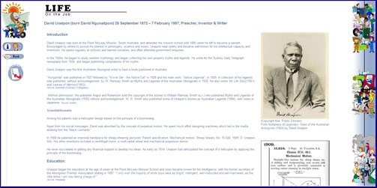

- Select one of the Links [like the Reserve Bank of Australia]
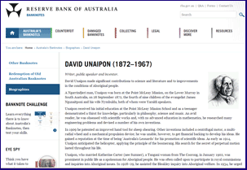
- Read it to the class.
As David’s story is being read to the class each of the career path components can be emphasised through discussion and activities [listed below]:
- experience
- opportunity
- education
- training
David Unaipon on a 50-dollar note. Some notes show his name at the bottom, some don’t.
Experience: When David Unaipon was young he had a number of experiences that can be seen to link his early interests with later career choices.
Activity 2: Early Interest
Australian Curriculum General Capability: Personal & Social Capability
Australian Curriculum General Capability – Literacy

Have the students reflect on fond experiences they remember from their earlier childhood. Ask how these might one day be linked to particular career choices.
What I used to want to be
"I'm an architect...when I was little I loved to draw and build with blocks."
"I'm a professional coach - I would organise the kids in my street to play all kinds of games."
"I'm a police officer - I helped a lost child find her Mum at the shopping centre when I was little."
Most of us have some idea of what types of jobs appeal to us - and what we want to be when we grow up.
Get students to make a list of their interests, and another list of areas they are NOT interested in. Then match the seven occupational categories to their list of interests.
See: https://www.onthejob.education/categories_Index.htm for a listing of these categories:

Students are to write up their experiences and reflect on how these might one day be linked to a particular career choice.
Choose one example of an experience/career link up to write up and illustrate.
The students can each choose an example of the experience/career link to write-up and illustrate:
- for inclusion in a class book or a wall display, or
- scan and send as a jpeg file (no bigger than 600 x 500 pixels) to On the Job web site for inclusion on the site.

Opportunity
With the story of David Unaipon continuing as the class "novel" it becomes obvious that the young inventor was sometimes just at the right place at the right time. He was willing to accept opportunities and make the most of small events in his life.

Activity 3: Writing a Fairy Tale or Fable
A Modern English-Australian Inventor - Opportunity
Australian Curriculum General Capability – Literacy
Australian Curriculum General Capability – Critical & Creative Thinking
Australian Curriculum General Capability - Information and communication technology (ICT) capability
Get the students to investigate a modern day British-Australian inventor – Nick D'Aloisio an inventor of an app [Summly] that Yahoo has brought for $30M. Nick was 17 when this happened.

Go to “On the Job” – Life on the Job – Historical People – Nick D’Aloisio
https://www.onthejob.education/life_job/famous_people/Nick_DAliosio.htm
Students are to find out more about Nick D'Aloisio the inventor of the app Summly.
Read about this inventor and write his story as a Fairytale or Fable Using VoiceThread or Animoto

Students are to then to create a video using Stupeflix about their own dreams as a Fable.
https://studio.stupeflix.com/en/

Education
The role of education in career selection has changed over the past two centuries. The days of a father passing on his career knowledge and skills to his sons has long since gone. Our education systems have espoused the virtues of "lifelong learning" for over a century. We are beginning to see how fundamentally this phrase puts an onus on schools to offer comprehensive programs in career education. David Unaipon’s formal education was minimal and makes an interesting classroom talking point.
Activity 4: Why is Education so important? Does it change outcomes for students? A Global Perspective!
Australian Curriculum General Capability: Intercultural Understanding
Australian Curriculum General Capability – Literacy
Go to “On the Job” – Life on the Job – Historical People - Malala Yousafzai
https://www.onthejob.education/life_job/famous_people/Malala_Yousafzai.htm
Students are to read about this remarkable young woman and her striving to have girls educated in her country. Complete the activity suggested….
Socratic Discussion: Education – is it important?
Use the following website to aid you in setting up a Socratic Seminar...
https://discover.hubpages.com/education/Socratic-Seminar-A-Practical-Guide
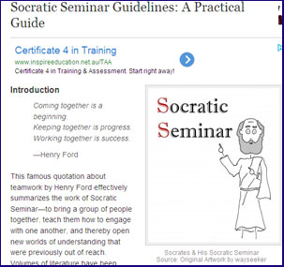

Training
Bound up in the concept of lifelong learning is the need for Vocational Education and Training (VET). Lifelong learners need to have a continuous and flexible connection with training authorities.
In David Unaipon’s day he had many examples of on-the-job training. Training has traditionally been associated with lower skilled jobs; however, governments are keen to change this perception.
Students in the latter years of schooling are being encouraged to enter vocational education and training programs; as part of a progression to tertiary study if required. For middle school students this means that the world of work is not too far away.
Teenage employment is synonymous with training. Many students in the class will have brothers, sisters or older friends who have had work experiences that included training.
Activity 5: Interview a Trainer
Australian Curriculum General Capability – Literacy
Australian Curriculum General Capability: Personal & Social Capability
Teaching Notes:
Fast food services are renowned for their training regimes. Organise for the students to visit a Fast Food Service. A presentation by the Site Manager or Trainer provides students with an opportunity to ask prepared and spontaneous questions.
Have the students prepare some questions beforehand eg. How many hours does it take to train a .... Front of House staff member? Do the trainees have exams? Practical?
Activity 6: EXTENSION: Inventions & Rap
Australian Curriculum General Capability – Critical & Creative Thinking
- Each group is to go to their particular job [see table below for the particular job] eg. for Houses & Buildings go to the “Construction Worker”.
- Using the information found in the Activities, Links, or, Did You Know, students are to find out about the invention of their job category and then create a “Rap” using the following website: http://www.wikihow.com/Write-a-Rap-Song
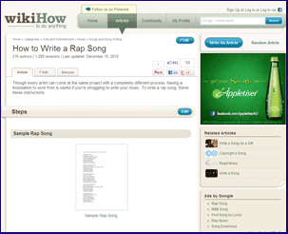
- Students are to include the following information:
  - The Inventor – their experience, opportunity, education and, training
  - What the invention is used for
  - Special characteristics
  - How it has changed lives

Houses & Buildings  Pneumatic Pump | Environments  Honeyflow
Community & Health  Stethoscope | Leisure and Entertainment  Aboriginal Fish Traps
Transport & Travel  Brakes | Retail & Hospitality  Bar Codes
Office & Administration  Telephone or Mobile | Research & Development  Facial Recognition Technology
Manufacturing & Production  Orange Peel Plastics | Information, Media & Telecommunications  Telephoto Lens
Banking, Finance & Insurance  Australian Polymer Banknotes | Government & Defence  Barometer
Week 5: The Good Manager
Teaching Notes
Bosses have not really had the greatest of press over the years. From Scrooge to Simpson’s boss, Mr. Burns, their personalities are portrayed as driven by control and fiscal efficiencies.
Individuals are asked to adopt lifelong learning habits, so too are industries being encouraged to become "learning" organisations; motivated to operate on principles that are efficient, effective, and equitable.
Activity 1: Interview a Manager
Australian Curriculum General Capability – Literacy
Australian Curriculum General Capability: Personal & Social Capability
Organise for students to interview members of the community who work in each of the “On the Job” twelve career categories. Interviewing members of the community provides students with an important understanding of the role of a Good Manager.
Manager: Interview Questions: Example
Questions | Answers
How did you become a Manager?

Education

Training

Experience

How many people do you manage?

Describe a typical day for you

What things do you like about your job?

What Learning Opportunities do you have as a Manager?

Conferences?

Professional Development?
Activity 2: Vision Statements
Australian Curriculum General Capability - Personal & Social Capability
Australian Curriculum General Capability: Ethical Understanding

A boss’s capacity to motivate staff relies on the development of a collective vision.
Get students to analyse at the following website: 30 Example Vision Statements
Discuss: “Which is the “best” vision statement?” Why? Give reasons
Students in their various career groups are to create a vision statement for their career character’s workplace. They will have to use their imagination!

Activity 3: A Job Well Done!
Australian Curriculum General Capability - Personal & Social Capability
Australian Curriculum General Capability – Literacy
Workers appreciate a boss who recognises effort and achievement. Students are to assume the role of "boss". From this viewpoint they are to send to their career character a thankyou letter for a job well done.
Letter writing provides a good opportunity to use ICT skills. The letters could be word processed and finally emailed to Frances.Moore@onthejob.education for display. This task would give the project an office-like purpose.
Student Instructions: A Job Well Done!
We all like to be told that we’re doing a good job and that our work is appreciated. In the workplace this is called "Positive Feedback"
Write a letter to your career character thanking them for something they have done to improve the workplace.
You might look at the change in work practices of the Postie within Australia …..
FROM…. TO TO…….
List down the Pros and Cons of each image. What has changed? What is more efficient?
How would you write about the great innovation in work practices?
Activity 4: Creating a Staff Newsletter
Australian Curriculum General Capability – Literacy
Australian Curriculum General Capability – Critical & Creative Thinking

Have the students create an office newsletter for their career character’s workplace that includes the following range of topics: event diary, a report on productivity, a description of a new process, some workers’ information, and a letter from a happy customer.

Student Instructions: Creating a Staff Newsletter
- You’re to publish a newsletter for your Career Character’s workplace.
- Try to make your newsletter show the type of activities that happen at work during a busy week.
- Your newspaper should include:
- The Cartoon Image of Your Character/Job from On the Job
- An image reporting on productivity
- A description of a new process
- Some workers’ information
- A letter from a happy customer.
- Your group is to create a scene that can be used as a photograph in your paper.

Resources for this activity:
e-How – How to write an employee newsletter
Snapcoms – Internal newsletter ideas
Company Newsletters

Activity 5: EXTENSION Create a Role Play
Australian Curriculum General Capability – Literacy
Australian Curriculum General Capability – Critical & Creative Thinking
Australian Curriculum General Capability - Personal & Social Capability

This activity requires considerable teamwork.
Each group is to create a workplace scene for their career character’s office newsletter. Students dress-up and construct the scene so as to reflect an active workplace moment.
A digital camera makes transferring the images to the word-processed newsletter very simple.

Week 6: The Purposeful Outcome & Assessment
Activity 1: Parents/Carers and Work
Australian Curriculum General Capability – Literacy
Australian Curriculum General Capability - Personal & Social Capability
Teaching Notes
Parents or Carers are highly influential in a student view of work. They can be passive or active about their child’s choice of study and work.
Even without meaning/wanting to be involved, parents will influence their children’s course choices [at school, TAFE or university] by the work example they have lived and the values they have shown. Students will often (but not always!) want to enter a career that fits in with their parents values. (Source: Swinburne University of Technology)
Get the students to interview their Parent or Carer and then submit their interview to “On the Job” website.
Parent Interview Sheet: What is Your Job Like?
There are a few things that you need to ask your Parent or Carer about their Job/Career. You can interview your Parent or Carer and write down the answers then submit them to “On the Job”
OR
Your Parent or Carer can go directly to the “On the Job” website and submit their answers directly.
https://www.onthejob.education/submit_job.htm
Don’t forget to also provide a photo of your Parent or Carer at their workplace!
Filling out this form and submitting it to “On the Job” shows other students what the jobs are like for them to read. Not all jobs will be put onto the website – it depends on how interesting the description of the job is.
Parent Interview Sheet: What is Your Job Like?
Parent’s Name:

Questions | Answers
DESCRIPTION OF JOB:
Can you please give me, in detail, a description of your job/career and what you do in your job.

- What is a ....eg. Accountant?
- What tasks do you perform in your job
- A typical day involves working on...?
- Any interesting features of your job?

EXPERIENCES:

Throughout childhood we do activities; play and work. Some activities appeal to us. These enjoyable activities can give us ideas for the future and might inspire us to pursue a particular career.

Describe for me your experiences that may have formed a positive attitude to your chosen career.

Did you follow in any family footsteps?

Was childhood activity relevant to your current position?

Was there a childhood moment of "Truth" when your career became obvious?

OPPORTUNITIES:

Our family, our community, our nation provides individuals with many experiences. The range of experiences can open up opportunities. Some opportunities may lead directly into a career.

Describe ways in which opportunities helped to form your career.

Were there any lucky breaks along the path to your career?

What doors were opened for you?

Was the timing right for your career choice?

Did particular people help to maximise opportunities?

EDUCATION:

Education helps us to use our skills and knowledge. Helping us to reach our full potential is an important part of education. Being able to communicate and participate in the community prepares us for a productive life.

Describe how your schooling contributed to the development of work related skills.

Was a teacher helpful in directing your energies toward a career choice?

Did you shine in particular subjects?

Would past teachers be surprised with what you've become?

Is your school-work still helpful?

TRAINING:

Because each career has unique skills and its own body of knowledge we need to specialise. Training is how we are prepared for particular jobs. Training can happen "on the job" or at a place of learning: a college or university.

Describe the processes by which you were trained.

Did you have to eliminate other career choices?

Was training as you expected?

How was your training different to your education?

What did training teach you?

Are people trained the same as you were?

How long did training take?

EMPLOYMENT:

When we are paid to be productive we are employed. Being employed gives us an income. A nation's economy relies on production. Work should also be stimulating, enjoyable and healthy.

Describe how your career path led to a source of income.

How did you find a boss; or were you self employed?

Was your first pay important?

Do you think or prepare for retirement?

Does your career have a "Typical Day"?

Does your work include other people?

Is the outcome of your work obvious to others?

Are people interested in your career?

DEVELOPMENT:

When we work it is important to grow more skilful and more knowledgeable. As we develop we can become more productive. Professional development helps us keep a workplace active and modern.

Describe the activities that are used to staff at your workplace.

Does the employer encourage growth?

Do staff make regular use of professional development?

Is further study a possibility in your career?

Is productivity linked to professional development?

OTHER FACTS:

Are there any other facts about your job that you would like to share?

LINKS AND OTHER RESOURCES:

Do you have any useful web addresses that we can include on the site?

Are there any books or videos that you find particularly interesting or useful?

Don’t forget: Get Your Parent or Carer can go to the “On the Job” website and submit their answers directly if they would like to help other students know what their job is like.
https://www.onthejob.education/submit_job.htm

Activity 2: Assessment - Learning Journey
Teaching Notes
Continuous assessment informs better teaching. Throughout the "On the Job" unit the teacher will have had many opportunities to observe learning outcomes being displayed.
Learning Journeys are a summative form of assessment that capture and collate the various formative observations into one event. The visual nature of this unit lends itself well to a display of outcomes for parents and community.

End of Unit Assessment
Australian Curriculum General Capability – Literacy
Australian Curriculum General Capability - Information and communication technology (ICT) capability

"On the Job" has developed four Detective Games suited to the various ages and developmental level of students in the middle school. These games incorporate information about the careers highlighted within this web site.

Game Instructions
https://onthejob.education/game/index.htm

To begin click on the "Start a New Game" icon.
(There are buttons at the bottom of job description pages that are involved with the games)

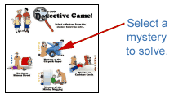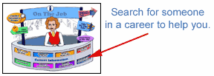
Once you find the job read over the information about that job and then click on the "Continue Game" Icon.
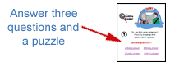
Once you have found enough clues you will be sent to the police station for a quiz and to identify the criminal!
IMPORTANT: Students need to take notes about each job so they can answer the questions! After answering the 3 questions correctly, students will be given a clue. They will need to use this information later on to solve their mystery and find out ..... Whodunnit!

Contact Details
If you have any questions regarding this Teacher’s Guide or the website “On the Job” please contact
Frances Moore
Frances.Moore@onthejob.education

