Understanding Job Categories
https://www.onthejob.education/

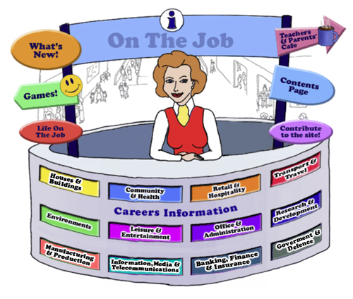
Teaching Notes
There are many ways to categorise the labour force. The classification adhered to in On the Job website has been chosen to broadly cover each job.
This classification is arbitrary!
Another classification would be just as good or even better. Sometimes it is difficult to allocate a job to one particular classification. For example, the Chemical Engineer – could be in Research & Development or in Environments or in Manufacturing and Production where we have selected.
Each job has been allocated to one of the 12 classification categories as seen on the Information Desk:

There are also 7 “Type of Work” Categories allocated by the Job Guide [by the Australian Government] which we have adhered to as well to show the students the type of work required by each job. https://www.onthejob.education/categories_Index.htm
On this page, you will be able to see the information about each Type of Work category.

Artistic or Creative | Clerical or Organising  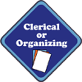
Helping or Advising | Nature or Recreation
Practical or Mechanical | Scientific or Analytical
Service or Persuading
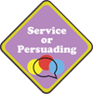

NB
If you are unsure of a particular job and where you would find it – ALWAYS look under “” for a full listing of the jobs on the website: https://onthejob.education/full_job_listing.htm
OR use our Search function

Putting items into categories helps students with their conceptual exploration.
The following activities are for students in Years 5 - Years 8 (Primary Middle)
They cover the following Australian Curriculum General Capabilities:
Australian Curriculum General Capability: Critical and creative thinking
Australian Curriculum General Capability: Numeracy
Australian Curriculum General Capability: ICT Capability

Activity 1 – Using the Dichotomous Key
A dichotomous key is a sequence of steps that allows the identification of an object or living thing. The key consists of a series of choices that lead the user to the correct name of the given item. The term dichotomous means that there will always be two choices in each step of the key until the object is correctly identified.
Show the students the following example of how different leaves could be identified with a simple Yes/No Question.
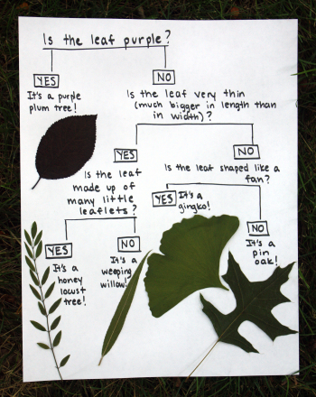

Activity 1 – Using the Dichotomous Key – Activity A - Discover which bird is which…
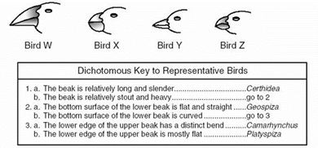
Answers:
Bird W

Bird X
Bird Y

Bird Z

Activity 1 – Using the Dichotomous Key - Activity B: Create a Dichotomous Key
You are to make up Yes/No Questions to divide the following garden tools according to their use:
Axe; Broom; Fork; Hose; Leaf Rake; Rake; Secateurs; Shears; Spade; Shovel; Trowel; Watering can; Wheelbarrow
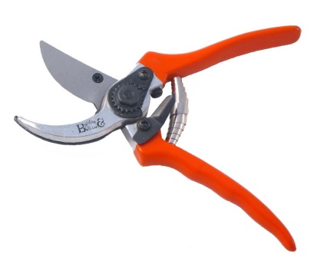 | 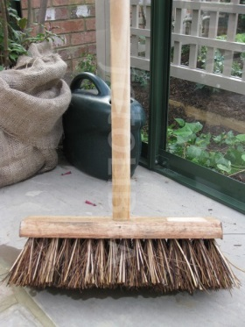 | 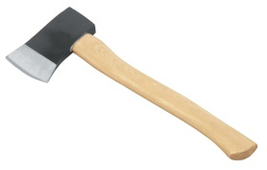  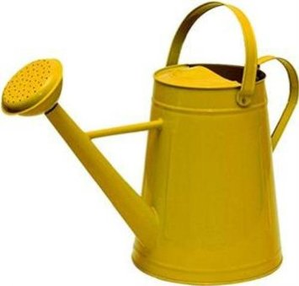 | 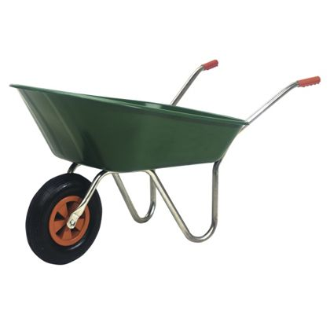
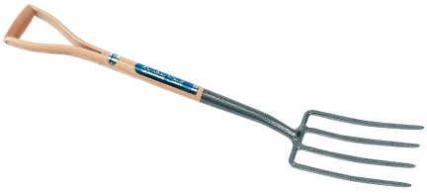 | 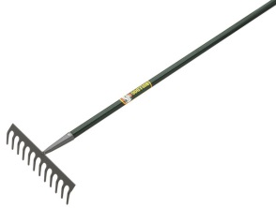 | 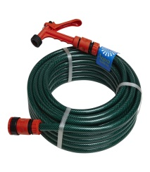 | 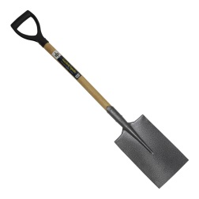
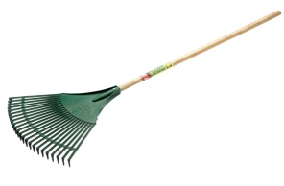 | 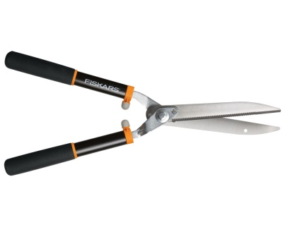 |  | 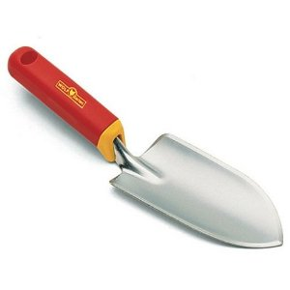

Activity 2: What’s in a Category?
Australian Curriculum General Capability: Numeracy
Randomly assign to each student group, one of the 12 classification categories from “On the Job”:
Provide the student groups with an A3 sheet of paper and ask them to list jobs within their assigned category [before looking at On the Job website]. List as many jobs as possible.
Ask two groups to pair up and view each other’s list. Get the second group to add, if possible, to the first group’s list.
When the groups have exhausted their collection, you might direct the students to the Information Desk at the Careers Mall at https://www.onthejob.education/info.htm [go through the Entrance to the Mall to get to the Info Desk] to investigate the categories listed there.
Get the students to create a list of the jobs that they thought would be in their category.
Get the students from the second group to add to the list of jobs they thought would have been in the first group’s list but weren’t present.
Create a third list of the actual jobs.
Are there any differences?
Show the students how to create a Venn Diagram using Venn Diagram Maker and direct the students to create a Venn Diagram showing their jobs, the jobs from “On the Job” and the jobs from the second group if they are different from the first group.
https://www.lucidchart.com/pages/examples/venn_diagram_maker
Activity 3: Create a Mural
Australian Curriculum General Capability: Critical & Creative Thinking
Australian Curriculum General Capability: Numeracy
Australian Curriculum General Capability: ICT Capability

1. Students are to have a look at the murals within On the Job – there are 7 different right side murals on the Activities pages.
Answers:  Salesperson  Electrician (old representation)  Fitness Instructor  Scientist (old representation)  Secretary  Hairdresser  Mechanic  Architect  Mathematician  Farmer  Green Grocer  Police Officer | Answers:  Green Grocer  Truck Driver  IT Consultant  Chef  Judge  Garbage Collector  Waiter  Sports Coach  Archaeologist  Construction Worker | Answers:  Zoo Keeper  Karate/Martial Arts Instructor  Journalist  Real Estate Agent  Travel Agent  Local Government Inspector  Horticultural Assistant
Answers:  Bricklayer  Butcher  Social Worker  Photographer  Dancer  Minister of Religion  Baker  Veterinary Surgeon  Home Entertainment Store Assistant (old representation) | Answers:  Environmental Scientist  Early Childhood Educator  Management Consultant  Newsagent  Lawyer  Corporate Trainer  Director  Accountant | Answers:  Fire Fighter  Paramedic  Postal Worker  (old representation)  Painter  Artist  Dentist  Teacher  Physiotherapist
Answers:
Jeweller
Taxi Driver
Musician
Fisher
Flight Attendant
Beautician
Pharmacist
Automotive Electrician
2. Get the students to list all the jobs within their selected mural.

- Categorise each job shown into one of the 12 classification categories.

- Are any categories represented more than others? Male/Female ratio? Is it balanced? Ethnicity – is this covered? Are there any jobs shown twice? Has the Scientist cartoon changed? Why do the students think this has happened?
- For different reasons, why has the Electrician’s image been changed?
- Go to each job and write up the “type of job” categories (see below) for each job within one mural. Are the 7 Type of Job Categories well represented? Is there any imbalances?

6. Create a Bar Graph to show the differences using– Online Bar Graph Maker
https://nces.ed.gov/nceskids/graphing/classic/bar_pie_data.asp?ChartType=bar
EXTENSION:
7. Give the students a large sheet of paper, some pencils and crayons. The groups are to create a mural that captures their classification category - those that are not included in any of the murals.
Ask the students to include fine detail in their artwork.
When all illustrations are complete they could be:
- displayed around the classroom. The full display gives the students a feel for the variety of careers particular to each classification career category.
- scanned, sent as a jpeg file (no bigger than 600 x 500 pixels) to
Frances.Moore@onthejob.education

