Game: Spot the Difference: Student Handout
Target group: Primary
You are to spot the differences between a video representation of jobs and that of the “On the Job” website. https://onthejob.education/
Procedure
- You have two places to compare:
Look at the following video: Job Song: What do you want to be? https://youtu.be/MdvTlQzsaYI
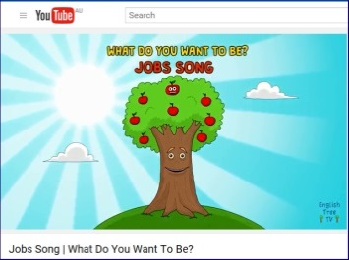
This song was written and performed by Adam Williams-Walters. Video Animated by Danny Lesco.
This Job Song video looks very simple BUT it highlights a lot of differences. You need to be observant and quick!
List the differences while playing the video ONCE.
You can re-play this video a number of times after this initial viewing.
Then look at how On the Job’s cartoons represent this job. What is the difference?
How hard can it be?
- With a family member or another student, you are to SPOT the differences between the song and the way these jobs are shown on website “On the Job”.
- The person with the most differences scores the highest points. You need to fill in the following table, swap your papers and get another pair or family member to check on the number of differences noted.

Job in Video & Job Name | Your comment:  Spot the differences. List as many as possible. Talk over with a partner | Same Job in Website –  “On the Job”
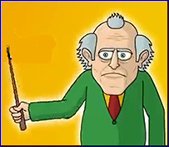  Teacher | Example: One is old; both are males; one has a stick (teachers don’t have these anymore); one is leading children; one is happy and smiling; …
Public Speaker is not available in “On the Job”.
Draw a cartoon.
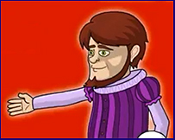
Soccer Player
is not available in “On the Job”.
Draw a cartoon.
Astronaut is not available in “On the Job”.
Draw a cartoon.

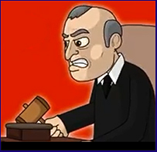
TOTAL NUMBER OF DIFFERENCES ________________
Compare with your partner! Which differences did you spot easily? Which ones did you miss altogether?
What are the major differences between the images? Is this important?
Check again: You might like to look at [if you haven’t already], how many males to females? Ethnicity?

- There are a few “characters” or “jobs” that have not been done by “On the Job” graphic designers. Draw what you think these characters should look like for “On the Job” website:

- Public Speaker
- Soccer Player

- Astronaut

Transcribe the Video
- You are to look up the words of the video. The transcript is at the bottom of the video.
Some LYRICS:

What do you want to be when you’re older?
When you’re big and a little bit bolder
What do you want to be?

Maybe you want to be a fire fighter,
maybe you want to be a writer,
Just believe in yourself, oh yah yah!
What do you notice about these lyrics? Rhyming?
6. Analyse the words/lyrics of the video. For example, the use of “older” to rhyme with “bolder”.

- List the actions and words of the video that show its humour! What did you enjoy the most? Why?
- You are to add FOUR more jobs as if you are the video creator.
a. List these 4 jobs
b. Write up the lyrics (make sure they rhyme! As in the video and add some humour)
c. Draw up the video cartoons to represent these jobs and the one you think “On the Job” should look like.
d. Optional: If you are a musician, re-create the music for your next 4 jobs!

Investigate
Now go to the On the Job website https://onthejob.education/info.htm
Each job has been allocated to one of the 12 classification categories as seen on the Information Desk: 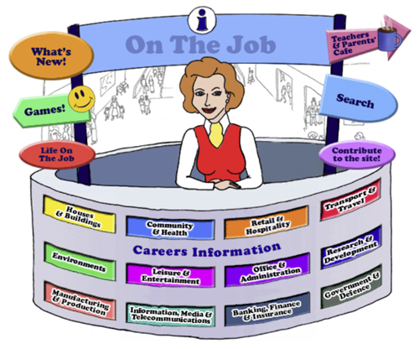

- Which category would interest you? Click on this category and explore the range of jobs here.

- Find 3 jobs to investigate.

Name them:
1. _______________ _________________ ________________
2. _______________ _________________ ________________
3. _______________ _________________ ________________

What is it about these jobs that are interesting to you?

- Write up a line in the song for each of these three jobs.
- Draw what they would look like in the video!
- Optional: Make up a new song in the same vein as the video for the new jobs that you like. How many new jobs would you add? 24? 12? 6?

