“On the Job” – Social Justice Considerations? A Global Education Focus
Teacher’s Guide
https://www.onthejob.education
Suitable for students in Years 5 – 10
Duration: 4 - 20 Lessons (depending on the depth of discovery)
These lessons require students to explore Australian or Famous peoples’ stories from “Life On the Job”
Notes for Teachers
These 4 – 20 lessons are based around Global Education.

What is Global Education?
Twenty-first century Australians are members of a global community, connected to the whole world by ties of culture, economics and politics, enhanced communication and travel and a shared environment.

Enabling young people to participate in shaping a better shared future for the world is at the heart of global education. It emphasises the unity and interdependence of human society, developing a sense of self and appreciation of cultural diversity, affirmation of social justice and
human rights, building peace and actions for a sustainable future in different times and places.

It places particular emphasis on developing relationships with our neighbours in the Asia-Pacific and Indian Ocean regions.

Global education promotes open-mindedness leading to new thinking about the world and a predisposition to take action for change. Students learn to take responsibility for their actions, respect and value diversity and see themselves as global citizens who can contribute to a more
peaceful, just and sustainable world.

With its emphasis not only on developing knowledge and skills but also on promoting positive values and participation, global education is relevant across all learning areas. (Source: Global Education: http://www.globaleducation.edu.au/verve/_resources/GPS_web.pdf)

The following Australian Curriculum: General Capabilities covered are:

- Personal and social capability
Students develop personal and social capability as they learn to understand themselves and others, and manage their relationships, lives, work and learning more effectively. The capability involves students in a range of practices including recognising and regulating emotions, developing empathy for others and understanding relationships, establishing and building positive relationships, making responsible decisions, working effectively in teams, handling challenging situations constructively and developing leadership skills.
- Ethical understanding involves students in building a strong personal and socially oriented ethical outlook that helps them to manage context, conflict and uncertainty, and to develop an awareness of the influence that their values and behaviour have on others.
As cultural, social, environmental and technological changes transform the world, the demands placed on learners and education systems are changing. Technologies bring local and distant communities into classrooms, exposing students to knowledge and global concerns as never before. Complex issues require responses that take account of ethical considerations such as human rights and responsibilities, animal rights, environmental issues and global justice.
Building ethical understanding throughout all stages of schooling will assist students to engage with the more complex issues that they are likely to encounter in the future, and to navigate a world of competing values, rights, interests and norms.
- Intercultural understanding: The capability involves students in learning about and engaging with diverse cultures in ways that recognise commonalities and differences, create connections with others and cultivate mutual respect. (Source: Australian Curriculum)
Along with
- Literacy
- Numeracy
- Information and communication technologies
- Critical and creative thinking
And,
- Australian Curriculum: Cross Curriculum Priorities: Aboriginal and Torres Strait Islander histories and cultures

Introduction:
Many people face Social Justice issues within their job or about their job. This set of 4 – 20 lessons explores 8 people and some of these social justice issues confronting them in their jobs or as a consequence of their jobs.
The seven people are:
- Malala Yousafzai [Educational Activist] for girls getting an education.
- Len Waters [Pilot] the only Aboriginal Fighter Pilot in WWII and the discrimination he faced on returning home after the war
- Paris Touma [Marketing Officer] and her research into Designer Luxury goods in Australia
- Heather Machin [Nurse] and her work in helping people with eye problems
- Caroline Chisholm [Social Worker]
- Professor Fred Hollows [Medical Practitioner - Ophthalmologist]
- Nic Marchesi and Lucas Patchett [Social Entrepreneurs]

Process to cover only 4 lessons
- Divide the students into pairs
- Get the students to go to the website: https://www.onthejob.education
- Get the students to go to “Life on the Job” within “On the Job”
and select one of the following people:
Malala Yousafzai [Educational Activist] | 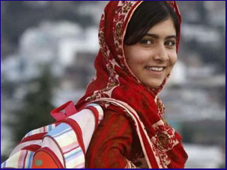 | Caroline Chisholm  [Social Worker] | 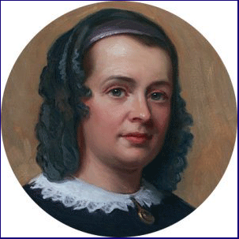
Len Waters  [Pilot] | 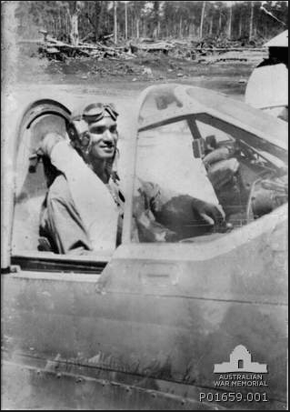 | Professor Fred Hollows  [Medical Practitioner - Ophthalmologist] | 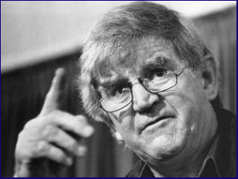
Paris Touma  [Marketing Officer] | 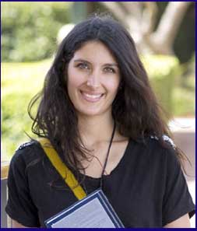 | Heather Machin  [Nurse] | 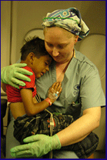
Create a WebQuest around a Social Justice Issue.

This should be related to a real person and their stance at work to a Social Justice Issue.
- Investigate this selected person and complete the activities there. Or, select a famous person that you know about and create a WebQuest around a Social Justice Issue they confronted.
- Report back to the class in the form of a presentation.

Creating a WebQuest - Instructions
Students are to develop a WebQuest around a Social Justice Issue and a particular job.
The aim of the WebQuest is to explore a Big Question from different real perspectives. Students are to develop a WebQuest around this WQ structure:
- Introduction to the Problem
- The Task showing the Big Question
- The Process with at least 3 – 5 different perspectives in the form of a role.
For example, in a WebQuest on Whaling – the Big Question would be:
Should the UN ban whaling completely?
The perspectives would be:
  - A Greenpeace Activist
  - A Japanese Scientist
  - A Traditional Whale meat consumer
  - An Historian, and,
  - A whale-watching business owner.
- Usually the roles or perspectives are antagonistic in stance or ideas.
- The Process indicates the explicit steps each student is to undertake.
- The Resources show all the Internet resources needed for each role or perspective and any skill or process required.
- The Evaluation shows a rubric on how the students will be assessed.
- The Conclusion indicates how the students could tackle a more concrete yet similar issue within their school.
- The Teacher’s Guide shows the lesson sequence; the target student group; and, any additional resources.
To create a WebQuest use any of the following templates:
Quest Garden - $20/two years
http://questgarden.com/index.php
Zunal – Free
http://zunal.com/
NB: Students might not be able to complete this activity within 4 lessons so will need other times allocated.
For the longer 20 lessons
Students are to complete 3-4 the people listed here or choose a particular topic(s).
Go to On the Job – https://www.onthejob.education

Topic: Inequality in Education
Malala’s Story
https://www.onthejob.education/life_job/famous_people/Malala_Yousafzai.htm
- Teachers read through the webpage to the students
- What are the students’ responses to “One Child, One Teacher, One Pen and One Book Can Change the World?”
- What would be their personal slogan?
- Get the students to draw it and share it.
- “The Look Up to Project”
http://lookuptoproject.org/tag/malala-yousafzai/
http://lookuptoproject.org/
Get the students to read about Malala or one of the many others from this website. Was there any one person who stood out for them? Why?
Whole class initiative:
Get the students to think of someone who they admire who has contributed to the world. Would they nominate this person to this website? Why? Why not?
Who would they nominate from people they know? In their family? In their school? In their community? Would they nominate this person to this website? Why? Why not?
- Activities on the Malala “On the Job” website
https://www.onthejob.education/life_job/famous_people/Malala_Yousafzai.htm
- Activities: Injustices righted? Australian Human Rights Commission – Children’s Rights website and Megan Mitchell’s Facebook page.
Ask the students to think about the issues facing them. What do they think of the issues reported in this Children’s Rights website? What level of concern or action should the class take on these social justice issues? Why? Why not?
Class Discussion. Report back next time about the responses of your students to this resource.
- Why is Education so important?
https://www.onthejob.education/life_job/famous_people/Malala_Yousafzai.htm
Hold a Socratic Discussion on this topic. The resources are linked for you to be able to conduct this Socratic Discussion.

Topic: Homelessness in Australia
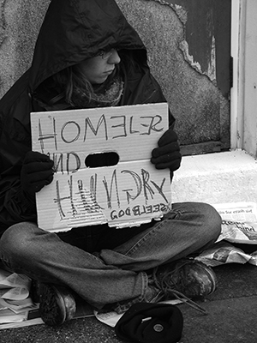
- Ask the questions: What is Homelessness? Why does it happen? Do the students know of anyone who is homeless?
Get the students to watch the following video:
Stand by Me – Playing for Change: https://vimeo.com/2539741
- What questions come from this video?
Here are some questions that Jeannette Albert’s 6th class [St Mary’s Primary School Young] asked after seeing this video:
“Why are we not doing more to help the homeless?
Why are the homeless ignored when we know they need help?
Why do some people choose homelessness?
Why are there so many people who are homeless?
Why do the abused not stand up for themselves?
Why don’t relatives help the homeless?”
- Playing for Change, http://playingforchange.com/, is one way that a group of musicians are using to create Peace in the World. Go to the website and discuss with the students whether this is effective or not.
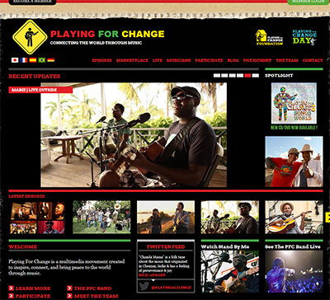

- Go to Social Entrepreneurs and research what Nic and Lucas have done with Orange Sky Laundry. https://onthejob.education/life_job/social_entrepreneurs.htm
Second activity: Debate the issue: Should we help Orange Sky Laundry or address the problem of homelessness differently? Can we do both? Students are to use Popplet – a tool for the iPad or web to capture and organise ideas. http://popplet.com/

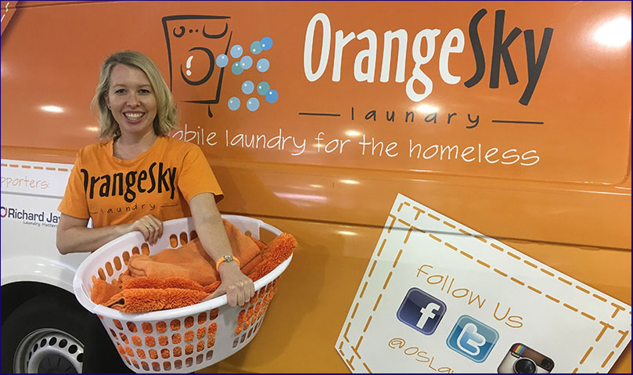

Topic: Inequality in Indigenous Health Outcomes
- Ophthalmologist: Fred Hollows
https://www.onthejob.education/life_job/famous_people/Fred_Hollows.htm
a. Introduce Fred Hollows by using the video: Meet Fred Hollows on this On the Job website.
b. Go over his philosophy – “every eye is an eye – whether for a poor person or a king!”
Indigenous eye health became his focus!
c. Get the students to read through Fred Hollows life from On the Job. Ask the questions: What made Fred great? How did he try to overcome the gap between Indigenous eye health and Australian standards?
d. Get the students to set up a Social Media story about the work of Fred Hollows with Indigenous Australians using Storify https://storify.com/
2. Ophthalmologist: Kris Rallah-Baker
https://www.onthejob.education/life_job/ophthalmologist.htm

Get the students to go to Kris’ page and browse through the information, videos and links. Ask the question: What is Kris doing “to contribute to his world”?
Students are to complete the activity on Kris’ “On the Job” page of creating a Video Game using YoYo Games http://www.yoyogames.com/studio to reinforce the message – Clean Faces, Strong Eyes.
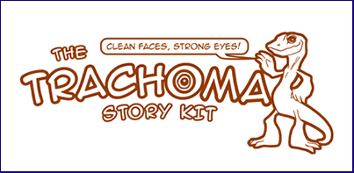
There is a free version of YoYo Games that students can use to create an interactive game.

3. Nurse: Heather Machin
https://www.onthejob.education/life_job/nurse.htm
After reading through Heather’s story and her work with the ORBIS Flying Eye Hospital, get the students to choose one of the following activities:
a. Design a model of the eye using papier mache
b. Design a Prezi on raising awareness to the plight of Indigenous children and challenge them to help the Fred Hollows Foundation
c. Create a game using Kahoot! [https://getkahoot.com/]that can be shared as a campaign to raise awareness in all Australians about the inequality in eye health.
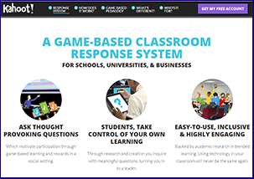
Topic: Necessity vs Luxury
Resources Used: On the Job
- Marketing Officer: Paris Touma
https://www.onthejob.education/life_job/marketing_officer.htm
Get the students to read over this article about Paris and her research into Australians buying luxury items.
Students are to complete the activity: Psychology of Buying – Designer Jeans.
They are to design a survey using Survey Monkey investigating why school student buy or not buy designer jeans or designer clothes.
They are to debate the question: “What is a necessity and what is a luxury?”
Students are to take action by… “How would you bring the purchase of designer jeans and their impact on the world to the forefront of other students at your school?”

Students can also, complete the second activity around the topic: The Psychology of Buying… by developing a conversation using Edmondo about the ethics behind two positions: buying designer goods vs Australia’s Foreign Aid cuts.

Topic: Discrimination
Resources Used: On the Job
- Len Waters – the only known Aboriginal Fighter Pilot to serve in WWII
https://www.onthejob.education/life_job/famous_people/Len_Waters.htm
  - Read through Len Waters’ profile and the links. Get all students to listen to the Audio file of Len’s nephew describing the discrimination Len faced when he came home from service. (ABC New England North West link in the Secondary Activity at the end of the page).
  - Students are to create a movie using Animoto about Len Waters’ life by collating a Storyboard first.
  - They are also to comment or make a personal statement on “Why were Indigenous Australians treated so differently during and after war? Was it ethical?”
  - You might ask them to go even further and discuss racial discrimination in a broader sense in their lives and their stance against this discrimination.

Topic: Refugees
Resources Used: On the Job
Caroline Chisholm
https://www.onthejob.education/life_job/famous_people/Caroline_Chisholm.htm
- Get the students to read through Caroline Chisholm’s life and experiences including the links provided in “On the Job”.
- After reading and viewing the websites get the students to answer the question: “What do you think? Is Caroline Chisholm Australia's first Social Worker?”
- They are to discuss and debate this issue within your class by creating an EduBlog.
- Students are then challenged to look at a contemporary issue that of refugees with a focus on unaccompanied minors.
- Get the students to read through the articles and analyse the parallels with the work of Caroline Chisholm.
- Students are to create a video using Moovly about the plight of young unaccompanied refugee minors.

Creating a WebQuest - Instructions
Students are to develop a WebQuest around a particular Social Justice Issue; a particular job – one of their choice.
The aim of the WebQuest is to explore a Big Question from different real perspectives. Students are to:
Create a WebQuest structure:
- Introduction to the Problem
- The Task showing the Big Question
- The Process with at least 3 – 5 different perspectives in the form of a role.
For example, in a WebQuest on Whaling – the Big Question would be:
Should the UN ban whaling completely?
The perspectives would be:
  - A Greenpeace Activist
  - A Japanese Scientist
  - A Traditional Whale meat consumer
  - An Historian, and,
  - A whale-watching business owner.
- Usually the roles or perspectives are antagonistic in stance or ideas.
- The Process indicates the explicit steps each student is to undertake.
- The Resources show all the Internet resources needed for each role or perspective and any skill or process required.
- The Evaluation shows a rubric on how the students will be assessed.
- The Conclusion indicates how the students could tackle a more concrete yet similar issue within their school.
- The Teacher’s Guide shows the lesson sequence; the target student group; and, any additional resources.
To create a WebQuest use any of the following templates:
Quest Garden - $20/two years
http://questgarden.com/index.php
Zunal – Free
http://zunal.com/
Send any discoveries to Frances@onthejob.education so that they can be put onto the website.

“On the Job” – Social Justice Considerations? A Global Education Focus
Student Worksheet
Introduction:
Many people face Social Justice issues within their job or about their job. This set of 4 – 20 lessons explores 8 people and some of these social justice issues confronting them in their jobs or as a consequence of their jobs.
The seven people are:
- Malala Yousafzai [Educational Activist] for girls getting an education.
- Len Waters [Pilot] the only Aboriginal Fighter Pilot in WWII and the discrimination he faced on returning home after the war
- Paris Touma [Marketing Officer] and her research into Designer Luxury goods in Australia
- Heather Machin [Nurse] and her work in helping people with eye problems
- Caroline Chisholm [Social Worker]
- Professor Fred Hollows [Medical Practitioner - Ophthalmologist]
- Nic Marchesi and Lucas Patchett [Social Entrepreneurs]

Process to cover only 4 lessons
- Get into pairs
- Go to the website: https://www.onthejob.education/index.htm
- And, then to “Life on the Job” within “On the Job”
https://www.onthejob.education/life_job/index.htm
and select one of the following people:
Malala Yousafzai [Educational Activist] |  | Caroline Chisholm  [Social Worker]
Len Waters  [Pilot] |  | Professor Fred Hollows  [Medical Practitioner - Ophthalmologist]
Paris Touma  [Marketing Officer] |  | Heather Machin  [Nurse]
Create a WebQuest around a Social Justice Issue.

This should be related to a real person and their stance at work to a Social Justice Issue.
- Investigate this selected person and complete the activities there.
Or, select a famous person that you know about and create a WebQuest around a Social Justice Issue that they faced.
- Report back to the class in the form of a presentation.

Extension Activity – Creating a WebQuest
You are to develop a WebQuest around a Social Justice Issue and a particular job.
The aim of the WebQuest is to explore a Big Question from different real perspectives. You are to:
Create a WebQuest structure:
- Introduction to the Problem
- The Task showing the Big Question
- The Process indicates the explicit steps each student is to undertake. There are at least 3 – 5 different perspectives in the form of a role (For example, in a WebQuest on Whaling – the Big Question would be: “Should the UN ban whaling completely?”;
the perspectives would be:
  - A Greenpeace Activist;
  - A Japanese Scientist;
  - A Traditional Whale meat consumer;
  - An Historian; and,
  - A whale-watching business owner
Usually the roles or perspectives are antagonistic in stance or ideas.
- The Resources show all the Internet resources needed for each role or perspective and any skill or process required.
- The Evaluation shows a rubric on how the students will be assessed.
- The Conclusion indicates how the students could tackle a more concrete yet similar issue within their school.
- The Teacher’s Guide shows the lesson sequence; the target student group; and, any additional resources.
To create a WebQuest use any of the following templates:
Quest Garden - $20/two years
http://questgarden.com/index.php
Zunal – Free
http://zunal.com/
Send any discoveries to Frances@onthejob.education so that they can be put onto the website.

For the longer 20 lessons
Students are to complete 3-4 the people listed here or choose a particular topic(s).
Go to On the Job – https://www.onthejob.education

Topic: Inequality in Education
Malala’s Story
https://www.onthejob.education/life_job/famous_people/Malala_Yousafzai.htm
- Read through the webpage about Malala’s story.
- What is your responses to “One Child, One Teacher, One Pen and One Book Can Change the World?”
- What is your personal slogan?
- Draw this slogan and share it.
- Go to “The Look Up to Project”
http://lookuptoproject.org/tag/malala-yousafzai/
http://lookuptoproject.org/
Select Malala or one of the many others from this website. Was there any one person who stood out for you? Why?
Whole class initiative:
Students - think of someone who you admire who has contributed to the world. Would you nominate this person to this website? Why? Why not?
Who would you nominate from people you know? Your family? People at school? People in your community? Would you nominate this person to this website? Why? Why not?
- Activities on the Malala “On the Job” website
https://www.onthejob.education/life_job/famous_people/Malala_Yousafzai.htm
- Activities: Injustices righted? Australian Human Rights Commission – Children’s Rights website and Megan Mitchell’s Facebook page.
Students: think about the issues facing you right now. What do you think of the issues reported in this Children’s Rights website? What level of concern or action should the class take on these social justice issues? Why? Why not?
Class Discussion.
- Why is Education so important?
https://www.onthejob.education/life_job/famous_people/Malala_Yousafzai.htm
Hold a Socratic Discussion on this topic. The resources are linked for you to be able to conduct this Socratic Discussion.

Topic: Homelessness in Australia
- Answer the questions: What is Homelessness? Why does it happen? Do you know of anyone who is homeless?
Watch the following video:
Stand by Me – Playing for Change: https://vimeo.com/2539741
- What questions come from this video?
- Playing for Change, http://playingforchange.com/, is one way that a group of musicians are using to create Peace in the World. Go to the website and discuss whether this is effective or not with a partner.

Second activity: Read about two young Australians who are Social Entrepreneurs, Nic & Lucas, who have set up Orange Sky Laundry.
Social Entrepreneurs Nic Marchesi and Lucas Patchett - Life On The Job
Debate the issue:
“Should we help Orange Sky Laundry or address the problem of homelessness differently? Can we do both?”
You are to use Popplet – a tool for the iPad or web to capture and organise ideas. http://popplet.com/

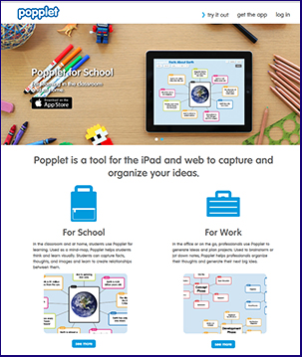
Topic: Inequality in Indigenous Health Outcomes
- Ophthalmologist: Fred Hollows
- https://www.onthejob.education/life_job/famous_people/Fred_Hollows.htm
a. Get to know Fred Hollows by using the video: Meet Fred Hollows on this On the Job website.
b. Go over his philosophy – every eye is an eye – whether for a poor person or a king!
Indigenous eye health became his focus!
c. Read through Fred Hollows life from On the Job. Ask the questions: What made Fred great? How did he try to overcome the gap between Indigenous eye health and Australian standards?
d. Set up a Social Media story about the work of Fred Hollows with Indigenous Australians using Storify https://storify.com/
2. Ophthalmologist: Kris Rallah-Baker
https://www.onthejob.education/life_job/ophthalmologist.htm
Go to Kris’ page and browse through the information, videos and links. Ask the question: What is Kris doing “to contribute to his world”?
Complete the activity on Kris’ “On the Job” page of creating a Video Game using YoYo Games http://www.yoyogames.com/studio to reinforce the message – Clean Faces, Strong Eyes.
There is a free version of YoYo Games that students can use to create an interactive game.
3. Nurse: Heather Machin
https://www.onthejob.education/life_job/nurse.htm
After reading through Heather’s story and her work with the ORBIS Flying Eye Hospital, choose one of the following activities:
a. Design a model of the eye using papier mache
b. Design a Prezi on raising awareness to the plight of Indigenous children and challenge them to help the Fred Hollows Foundation
c. Create a game using Kahoot! [https://getkahoot.com/]that can be shared as a campaign to raise awareness in all Australians about the inequality in eye health.

Topic: Necessity vs Luxury
Resources Used: On the Job
- Marketing Officer: Paris Touma
https://www.onthejob.education/life_job/marketing_officer.htm
Read over this article about Paris and her research into Australians buying luxury items.
Complete the activity: Psychology of Buying – Designer Jeans.
You are to design a survey using Survey Monkey investigating why school student buy or not buy designer jeans or designer clothes.
Debate the question: “What is a necessity and what is a luxury?”
Students are to take action by… “How would you bring the purchase of designer jeans and their impact on the world to the forefront of other students at your school?”

Students can also, complete the second activity around the topic: The Psychology of Buying… by developing a conversation using Edmondo about the ethics behind two positions: buying designer goods vs Australia’s Foreign Aid cuts.

Topic: Discrimination
Resources Used: On the Job
Len Waters – the only known Aboriginal Fighter Pilot to serve in WWII
https://www.onthejob.education/life_job/famous_people/Len_Waters.htm
  - Read through Len Waters’ profile and the links. Listen to the Audio file of Len’s nephew describing the discrimination Len faced when he came home from service. (ABC New England North West link in the Secondary Activity at the end of the page).
  - Create a movie using Animoto about Len Waters’ life by collating a Storyboard first.
  - You are also to comment or make a personal statement on “Why were Indigenous Australians treated so differently during and after war? Was it ethical?”
  - Extension: Discuss racial discrimination in a broader sense in your lives and your stance against this discrimination.

Topic: Refugees
Resources Used: On the Job
Caroline Chisholm
https://www.onthejob.education/life_job/famous_people/Caroline_Chisholm.htm
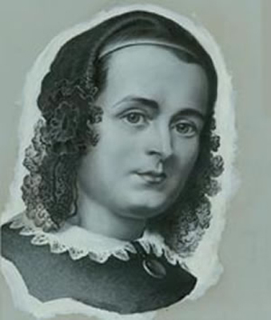
Read through Caroline Chisholm’s life and experiences including the links provided in “On the Job”.
After reading and viewing the websites, answer the question: “What do you think? Is Caroline Chisholm Australia's first Social Worker?”
Discuss and debate this issue within your class by creating an EduBlog.
Now, look at the next activity: a contemporary issue of refugees with a focus on unaccompanied minors.
Read through the articles and analyse the parallels with the work of Caroline Chisholm.
Create a video using Moovly about the plight of young unaccompanied refugee minors.

Creating a WebQuest - Instructions
You are to develop a WebQuest around a particular Social Justice Topic that interests you. It does not have to be the ones reported previously.
The aim of the WebQuest is to explore a Big Question from different real perspectives. Students are to:
Create a WebQuest structure:
- Introduction to the Problem
- The Task showing the Big Question
- The Process with at least 3 – 5 different perspectives in the form of a role.
For example, in a WebQuest on Whaling – the Big Question would be:
Should the UN ban whaling completely?
The perspectives would be:
  - A Greenpeace Activist
  - A Japanese Scientist
  - A Traditional Whale meat consumer
  - An Historian, and,
  - A whale-watching business owner.
- Usually the roles or perspectives are antagonistic in stance or ideas.
- The Process indicates the explicit steps each student is to undertake.
- The Resources show all the Internet resources needed for each role or perspective and any skill or process required.
- The Evaluation shows a rubric on how the students will be assessed.
- The Conclusion indicates how the students could tackle a more concrete yet similar issue within their school.
- The Teacher’s Guide shows the lesson sequence; the target student group; and, any additional resources.
To create a WebQuest use any of the following templates:
Quest Garden - $20/two years
http://questgarden.com/index.php
Zunal – Free
http://zunal.com/
Send any discoveries to Frances@onthejob.education so that they can be put onto the website.

