Title: Let’s Analyse: How Jobs are Represented
This activity has been developed for students in Years 5 – 6 [or older]
Target group: Primary Middle
Lessons: 3 x 45 mins
Why does it matter how jobs are represented?
An increasing number of occupations and sectors are diversifying in gender makeup but there is still a gap in salary for females doing the same job. In 1980, employers paid women ages 25 to 34 about 33 cents less per hour. As of 2020, that number wasn’t yet zero, but it was much smaller at 7 cents per hour. There are some gendered jobs are clearly rooted in stereotypes – like women as teachers and men in finance – but should this be the case?
A 2017 study published in the American Sociological Review found that a profession that’s considered a “male” job is perceived as more credible than a “woman’s” job.
Do you think of jobs as male or female jobs?
Let’s Analyse: How Jobs are Represented.
Puzzle. You are to match the name to the cartoon image. Draw a line from the cartoon to the correct name. Use different colours to show the connection. Were there any jobs that you had to guess?
Firefighter |  |  | Police Officer
Waiter |  |  | Public Speaker
Dentist |  |  | Nurse
Doctor |  |  | Hearse Driver
Chemist | 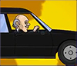 |  | Engineer
Punk Rocker |  |  | Pilot
Diplomat |  |  | Actor
Teacher |  |  | Bank Officer
Soccer Player |  |  | Astronaut
News Anchor |  |  | Gamer
 |  |  | Writer
Robotics Engineer |  |  | Lawyer
Chef |  |  | Judge

Checking the answers!
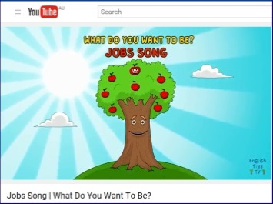
Watch the video: https://youtu.be/MdvTlQzsaYI

- Watch the video to check the matching of cartoon to name of job.
Did you get them correct? Which ones did you have to really check as you had no idea?
- At university, we spend a lot of time critically thinking about things. This is called analysis.
You are to analyse the video.

This time you are to look at how the jobs are portrayed. You will need to look at the following questions first to figure out how you are going to record the answers.
Look at the video again and take note of:

Questions to think about:
How many are males___ are there? How many are females____ are there?
Graph your results in a bar graph.
Does this reflect our society? Is this correct? What do you think?
Check with the Australian Bureau of Statistics: Population Census
https://www.abs.gov.au/statistics/people/population/population-census/2021
Are these cartoons a good way to represent males and females in jobs? Why/Why not?
Can girls/boys do these jobs? Why/Why not?
Is there a balance between old and young people? How are they represented? Is this a “good” representation?
What about ethnicity [people from different countries]? Are there any people represented whose background is Indigenous? Or Muslim? Or Asian?
Activities
1. Re-draw one of the jobs in the video to be represented as either… Male, Female; Indigenous; Muslim or Asian

- Look at On the Job: https://onthejob.education/info.htm

And, find 4 jobs not shown in the video. Look at ONE category by clicking on the categories below the information lady’s desk.

Write up a verse and cartoon for each of the 4 jobs in the same way as the video– with a sense of humour.

Make sure this time – that the cartoon character from On the Job is a female. You will be able to tell from the post note eg.
Animal Control Officer
http://onthejob.education/government_defence/animal_control_officer.htm

- How many more jobs shown as females will you have to have in the video to make it even for males and females?

- Look at the following graph from the Australian Bureau of Statistics – ABS - for the number of persons per selected occupation of main jobs by sex 2019 – 2020

https://www.abs.gov.au/statistics/labour/jobs/jobs-australia/2015-16-2019-20#employed-persons

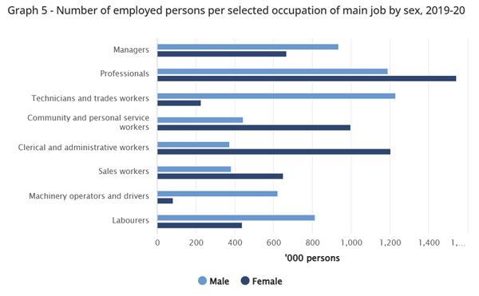

Look at the occupations in the graph above:
- Which occupations have the most females?
- Which occupations have the most males?
- Work out the ratios of F/M in each occupation – estimate the numbers in each occupation from the graph. Which is the highest ratio of F/M? Which is the lowest ratio of F/M?

Stereotypes

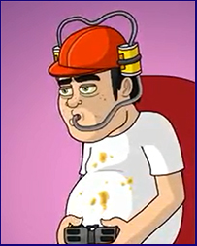

When a gamer is usually represented as a male how do girls feel? Does this representation also influence males to think that they are better than girls at gaming?
What is your opinion?
Did You Know?

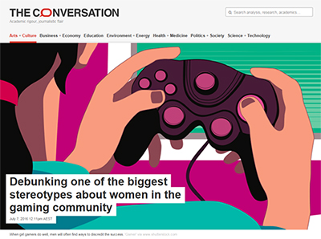
https://theconversation.com/debunking-one-of-the-biggest-stereotypes-about-women-in-the-gaming-community-60033
There’s also the long-held stereotype that men are simply better gamers than women.
But Research has shown: “Women advanced at least as fast as men did.”

What is your opinion now?

On the Job website
https://onthejob.education
We hope that stereotypes are broken here. But are they?
Let’s Analyse!
You are to select one category from the following list that might interest you.

Category: ______________________________________
You are to list all the jobs present in this category and using their image eg. Butcher

and fill out the following table.

Job | Male/Female?  Ethnicity: Indigenous; White; Asian background; Muslim background Australians? | Non-Traditional Representation of M/F in this Job? Y/N
Total=

Calculate
How many males ______ are in your category? How many females ________?
Is this a good balance? Why? Why not?
Ethnicity shown? How many Indigenous people __________? Asian people ___________
Muslim people__________

Think about
Look at the numbers represented in your category. Is it balanced?
Compared to the ABS Graph, is it represented correctly - same ratios? How different is it?

Are the stereotypes broken in this website? How? Why? Why not?

What are your recommendations to On the Job?
Email these recommendations to Frances.Moore@onthejob.education

Optional Extra
Life on the Job

In each category, some jobs also have “Life on the Job” [LOTJ] stories. You can reach a LOTJ story, if present, on the left hand side of the page.
Look at your jobs and now LOTJs within your category.
How many males ______ are in your category as Life on the Job? How many females ________?
Is this a good balance? Why? Why not? What about age?
Do some of these representations try to break stereotypes? Which ones?
How many Indigenous people __________? Asian people ___________?
Muslim people__________?
Are the stereotypes broken in this website? Why? Why not?
What are your recommendations to On the Job? Do you have any special person that should be in Life on the Job?
Email these recommendations to Frances.Moore@onthejob.education

