Jigsaw Bingo – Teacher Instructions
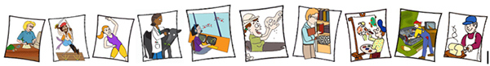
This is a simple Mix & Match Activity with 66 images and names of jobs. There is a smaller version with only 40 images and names of jobs. Both are good activities to see how classification works. Classification is “man-made” and can change.
Target group: Primary
Teacher Instructions:
Before the lesson.
1. Photocopy and laminate the following images’ pages [66 job images] into as many copies as you require – the instructions are for student pairs – but you could make this into a group of 3 students.
2. Cut up the images/jobs individually. Put them into group envelopes for each group.
3. Photocopy and laminate the names of the jobs into as many copies as you require.
4. Cut up the names of the jobs individually and place into group envelopes. Mix up both the jobs and the names.
5. Laminate and cut up the individual 12 categories for each group.
Instructions:
- In pairs, get the students to match the image with the name of the job by selecting one image and one name from the different envelopes at one time. The students are to place the images and names in front of them and as the game progresses they can start matching up. The first pair finished sings out “Bingo”. (15 -20 minutes).
- After the class has finished matching up the images with the name of the job, get the students [in pairs or as a group of 3-4 students] to classify each of these jobs into one of the following 12 classification categories as seen on the Information Desk and give reasons why they have put these jobs into these classification categories:

- Get the students to check their answers on the website. https://www.onthejob.education
To check they need to click on the category on the “Info Lady’s Desk” – there they will find all the jobs for that category listed. Or the students could go to the Search function or Full Job Listing.
- Class Reflection.
Did you, the students, have the jobs in the “correct” classification category?
- Get the students to explain and give reasons why they think their classification was different.
If you would like to do more advanced Classification lessons, go to Teacher’s Index and select lessons about Classification.

Job images to be cut up and put into envelopes for each group.
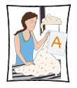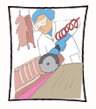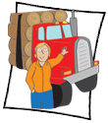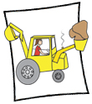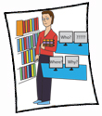

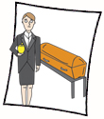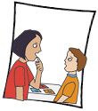
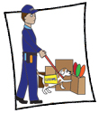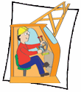

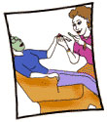
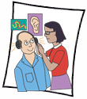

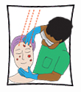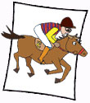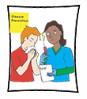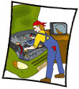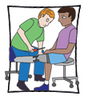

Job names to be cut up and put into envelopes
Wool Classer | Librarian | Green Grocer
Abattoir Worker | Mining Engineer | Radio Presenter
Auctioneer | Film Producer | Real Estate Agent
Logging Truck Driver | Milliner | Pool Technician
Mobile Plant Operator | Funeral Director | Army Officer
Tattoo Artist | Geneticist | Baker
Shearer | Speech Pathologist | Border Security Officer
Receptionist | Textile Designer | Director
Crane Operator | Cinematographer | Coxswain
Concreter | Cleaner | Butcher
Biotechnologist | Beautician | Jillaroo

Interpreter | Horticulturalist | Security Consultant
Confectioner | Miner | Fitness Instructor
Barista | Tiler | Audiologist
Cheesemaker | Marine Biologist | Leather Goods Maker
Air Traffic Controller | Dermatologist | Wedding Coordinator
Jockey | Winemaker | Pilot
Industrial Designer | Shipwright | Immunologist
Bank Officer | Automotive Electrician | Pool Technician
Optometrist | Bricklayer | Painter
Veterinary Surgeon | Prosthetist | Medical Practitioner
Occupational Therapist | Meteorologist | Coroner

Categories from On the Job

