Classification Activity 3: Research into Taxonomy
- Middle Secondary
Australian Curriculum General Capability: Literacy
Introduction
In groups of 3 – 4 students, read the following article from The Conversation
20 November 2012 and look at the videos. https://theconversation.com/explainer-what-is-biological-classification-10691 Note down any interesting points and questions relating to classification.
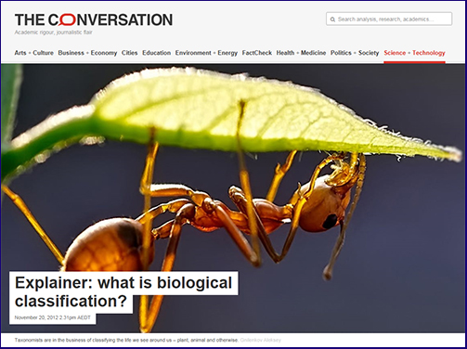
What did I know?
What do I now know?
What was interesting?
Using your notes and questions, look and compare them to the notes below.
Some points of interest
The "job of assigning species into a biological classification is the science of taxonomy – sometimes also called systematics.
In the biological sciences, taxonomy has been the bedrock of our work for over
250 years. In 1758, Carolus Linnaeus, the Swedish naturalist and founder of biological classification, published his 10th edition of the Systema Naturae.
This book of names is the commencement date for classification. No names before this date count today.
Just as many of us have double-barrel names, so too do species, with each composed of a genus name followed by a species name.
For humans, Homo is our genus and sapiens our species. This is called binomial nomenclature – or two-part naming – and it has proven to be one of the more enduring information systems developed in recent centuries.
Biological classifications are based on recovering the relationships between species, so the species most closely related share attributes (e.g. physical features, behaviour, DNA) that have been inherited from a common ancestor.
It may seem that the taxonomic task is straightforward. But this is far from the truth.
Take for example the position of insects in the Tree of Life. For much of the second half of the 20th century they were considered most closely related to the centipedes and their relatives (myriapods).
Being land-adapted groups, they both possess a tubelike “respiratory” system, which was long held to be the ultimate indicator of their close relationship. This close relationship between insects and myriapods was long held to be bomb-proof. New evidence from eye and brain anatomy and DNA sequences has, however, been combined to show insects are in fact close relative of prawns and their allies (that is, crustaceans).”
Learn this order by heart: Do Koalas Prefer Chocolate Or
Fruit Generally Speaking
Look at the following video: An introduction to: Taxonomy (5.47)https://youtu.be/NRVJyUZoQow

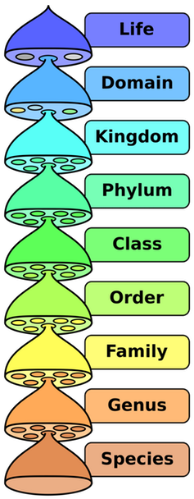

Six Kingdom System
Animal Kingdom – eukaryotic, multicellular, heterotrophs, no cell walls. Examples: invertebrates (without backbones) and vertebrates (with backbones)
Plant Kingdom – eukaryotic, multicellular, autotrophs, have cell walls. Examples: mosses, ferns, flowering and seed plants
Fungi Kingdom – eukaryotic, most multicellular and some unicellular, heterotrophs (break down other organic materials to obtain food), cells with cell walls but not green. Examples: mushrooms, molds, and yeasts
Protist Kingdom – eukaryotic, many are single-celled and others are multicellular, some heterotrophs and others autotrophs. Examples: come in a wide variety of forms: animal-like, such as amoeba, some are plant-like such as algae, and others are fungi-like.
Eubacteria Kingdom – prokaryotic, unicellular, some autotrophs while others heterotrophs. Examples: bacteria and blue-green algae.
Arcaeabacteria Kingdom - prokaryotic, unicellular, some autotrophs while others heterotrophs, live in extreme conditions. Examples: bacteria living near ocean thermal vents or in a cow’s stomach

Your Choice: Jigsaw Strategy
In your group of 3 – 4 students, each one of you are to choose ONE article to read from the following articles:
https://theconversation.com/biologys-holy-grail-the-species-and-its-controversial-recent-history-43077
https://theconversation.com/dna-barcoding-a-better-way-to-discover-species-4933
https://theconversation.com/its-not-the-science-of-tax-and-five-other-things-you-should-know-about-taxonomy-78926
https://theconversation.com/from-joseph-banks-to-big-data-herbaria-bring-centuries-old-science-into-the-digital-age-77718
https://theconversation.com/an-animal-that-could-rewrite-the-family-tree-one-of-the-top-new-species-of-2015-42179

After reading your article, you are to share with the others in your group what you have learnt.
Investigate any differences of opinion.
Share similarities.
Make a Mind Map of what you have learnt.
Explain or teach another person how scientist classify an organism including all the ranks of taxonomy.

