Classification Activity 1: The Animal Kingdom: “Talk to the Animals”
Primary
Australian Curriculum General Capability: Critical and creative thinking
Australian Curriculum General Capability: Literacy

For taxonomists [scientist who classify organisms], days often start – and sometimes end – with the question: what’s that?
What do you already know about animals?
Talk over with the person beside you.
Fill out the following table: List 10 animals you can think of and compare with a partner.

Animal Name | Animal Name

Song: Talk to the Animals
Look at the following video from Doctor Dolittle and the song “Talk to the animals”.
https://youtu.be/YpBPavEDQCk
The following lyrics for the Academy Award song: “Talk to the Animals” is written here below. Highlight the names of the animals in the song.
Song: Talk to the Animals

…If I could talk to the animals, just imagine it
Chattin' with a chimp in chimpanzee
Imagine talking to a tiger, chatting with a cheetah
What a neat achievement that would be!
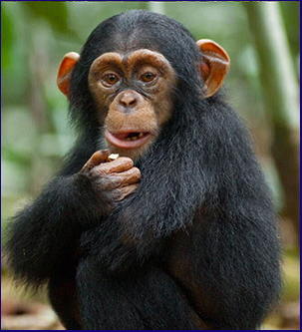
If we could talk to the animals, learn their languages
Maybe take an animal degree
I'd study elephant and eagle, buffalo and beagle
Alligator, guinea pig, and flea!
I would converse in polar bear and python
And I would curse in fluent kangaroo
If people ask me, "Can you speak rhinoceros?"
I'd say, "Of courserous! Can't you?"
If I conferred with our furry friends, man to animal
Think of the amazing repartee
If I could walk with the animals, talk with the animals
Grunt and squeak and squawk with the animals
And they could talk to me!
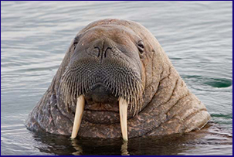
If I consulted with quadrupeds
Think what fun we'd have asking over crocodiles for tea
Or maybe lunch with two or three lions, walruses and sea lions
What a lovely place the world would be
If I spoke slang to an orangutan
The advantages why any fool on earth could plainly see
Discussing Eastern art and dramas with intellectual llamas
That's a big step forward you'll agree
I'd learn to speak in antelope and turtle
And my Pekingese would be extremely good
If I were asked to sing in hippopotamus
I'd say, "Whynotamous? and would!
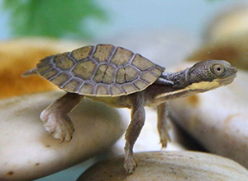
If I could parlay with pachyderms
It's a fairy tale worthy of Hans Anderson or Grimm
A man who walks with the animals and talks with the animals
Grunts and squeaks and squawks with the animals
And they could talk to him [This is the most exciting thing that has ever happened to me. I can’t wait to start. It’s incredible. It’s impossible. But it’s true.]
A man can talk to the animals. It’s a miracle. In a year from now I guarantee
I will be the marvel of the mammals
Play chess with camels
No more just a boring old MD
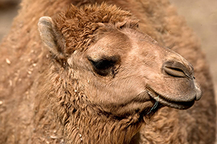
I'd study every creature's language
So I could speak to all of them on sight
If friends said, "Can he talk in crab or maybe pelican?"
You'd say, "Like hell he can and you'd be right"
Yes if you just stop and think of it ain't no doubt of it
I'm gonna win a place in history
If I could walk with the animals talk with the animals
Grunt, squeak, squawk with the animals
And they could squeak and squawk and speak and talk to me.

Put the animals listed in the song into the following categories:
Mammals | Birds | Insects | Crustaceans | Reptiles

Analysing the song: Think about the following facts:
- Mammals, Birds and Reptiles are vertebrates. They have a backbone.
- Insects and Crustaceans are invertebrates. They have an exoskeleton.
- Insects: are the most diverse group of animals on the planet including more than a million describes species and representing more than half of all known living organisms.
- Are any domestic animals in the song? Why/Why not?
- Does the song “Talk to the animals” really show the expanse of the Animal Kingdom? Explain.
- Write another verse – this time introducing 5 more animals one from mammals; birds; insects; crustaceans; and, reptiles.

