On the Job: Careers Market
Category: Houses & Buildings

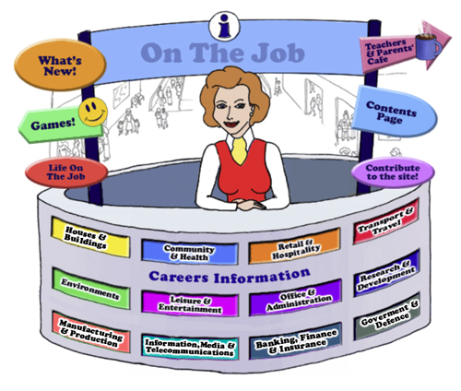

Teachers
Introduction
Welcome to this website for Australian students in Years 5 – 12, their teachers and parents.
The Design concept is based on the local Shopping Mall as students of this age are familiar with the Careers represented here. This initial concept broadened to include careers that they might have encountered outside the Shopping Mall eg. Local Government Inspector or Farmer
The website can be used as an individual activity for students or as a whole group.
This Teacher’s Guide is for the whole class and is aligned to the Australian Curriculum and the General Capabilities.

The Jobs
Each of the jobs listed has three sections
- The Information about each Job. | - Activities | - Links

All content in the Job Info sections have been taken from The Job Guide. Under copyright laws and from the Job Guide’s website – this information can be used for Educational purposes.
This content also encourages reading and therefore literacy but breaks down information into chunks and divided by “Did You Know?” segments.
The Activities can be divided into two sections:
- Offline
- Online
The activities bring a fun element into learning. There are practical skills about the particular job eg. “How to build a beehive” [in the Beekeepers section] is an Offline activity.
The Online activities include mostly free mobile apps, YouTube Videos, games and also WebQuest activities which provide students with Problem-Based Learning and the opportunity to use their Higher Order Thinking and Collaboration Skills.
The Links provide students with access to Association websites for that particular Industry as well as links to examples of people within this job and their experiences.
Life on the Job is divided into three sections:
- Historic or Famous People – mostly Australians | - Indigenous Historic or Famous People | - “Real Life People”
Historic or Famous People
Historic or Famous People are mostly famous Australians whose lives are usually investigated within the Australian Curriculum. Each person is researched and their lives summarised to give students an overview. There are links provided so students can investigate more fully themselves. At the end of the content information, students are given an activity to complete – mostly using the latest and free ICT tools available to increase their knowledge and capability.

Indigenous Historic or Famous People
Indigenous Historic or Famous People are famous Australians whose lives are usually investigated within the Australian Curriculum. Each person is researched and their lives summarised to give students an overview. There are links provided so students can investigate more fully themselves. At the end of the content information, students are given an activity to complete – mostly using the latest and free ICT tools available to increase their knowledge and capability.

Real Life People
Real Life People’s stories are provided here. Parents can submit their job and show students their educational journey to achieve employment within their job category.

Alignment with the Australian Curriculum
Curriculum Area: Australian Curriculum: General Capabilities
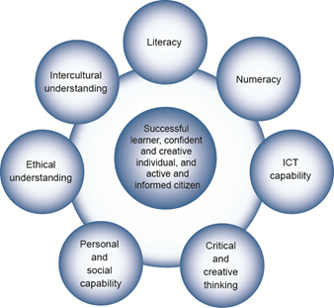

The Australian Curriculum includes seven general capabilities:
- Literacy
- Numeracy
- Information and communication technology (ICT) capability
- Critical and creative thinking
- Personal and social capability
- Ethical understanding
- Intercultural understanding.
(Source: Australian Curriculum)
Literacy involves students in listening to, reading, viewing, speaking, writing and creating oral, print, visual and digital texts, and using and modifying language for different purposes in a range of contexts.
Numeracy involves students in recognising and understanding the role of mathematics in the world and having the dispositions and capacities to use mathematical knowledge and skills purposefully.
Information and communication technologies are fast and automated, interactive and multimodal, and they support the rapid communication and representation of knowledge to many audiences and its adaptation in different contexts. They transform the ways that students think and learn and give them greater control over how, where and when they learn.
Critical and creative thinking are integral to activities that require students to think broadly and deeply using skills, behaviours and dispositions such as reason, logic, resourcefulness, imagination and innovation in all learning areas at school and in their lives beyond school.
Students develop personal and social capability as they learn to understand themselves and others, and manage their relationships, lives, work and learning more effectively. The capability involves students in a range of practices including recognising and regulating emotions, developing empathy for others and understanding relationships, establishing and building positive relationships, making responsible decisions, working effectively in teams, handling challenging situations constructively and developing leadership skills.
Ethical understanding involves students in building a strong personal and socially oriented ethical outlook that helps them to manage context, conflict and uncertainty, and to develop an awareness of the influence that their values and behaviour have on others.
As cultural, social, environmental and technological changes transform the world, the demands placed on learners and education systems are changing. Technologies bring local and distant communities into classrooms, exposing students to knowledge and global concerns as never before. Complex issues require responses that take account of ethical considerations such as human rights and responsibilities, animal rights, environmental issues and global justice.
Building ethical understanding throughout all stages of schooling will assist students to engage with the more complex issues that they are likely to encounter in the future, and to navigate a world of competing values, rights, interests and norms.
Intercultural understanding: The capability involves students in learning about and engaging with diverse cultures in ways that recognise commonalities and differences, create connections with others and cultivate mutual respect. (Source: Australian Curriculum)
Priorities:
Asia and Australia's engagement with Asia
Aboriginal and Torres Strait Islander histories and cultures
Sustainability

Philosophy: This icon represents both Critical and Creative Thinking and Ethical Understanding but at a deeper level. The activities with this icon show a high level of complex thinking is required. The activity can be used with classes undertaking Philosophy in Schools.
Cooperative Learning Activity
A collaborative (or cooperative) learning approach involves students working together on activities or learning tasks in a group small enough for everyone to participate on a collective task that has been clearly assigned. Students in the group may work on separate tasks contributing to a common overall outcome, or work together on a shared task.

Emerging Job
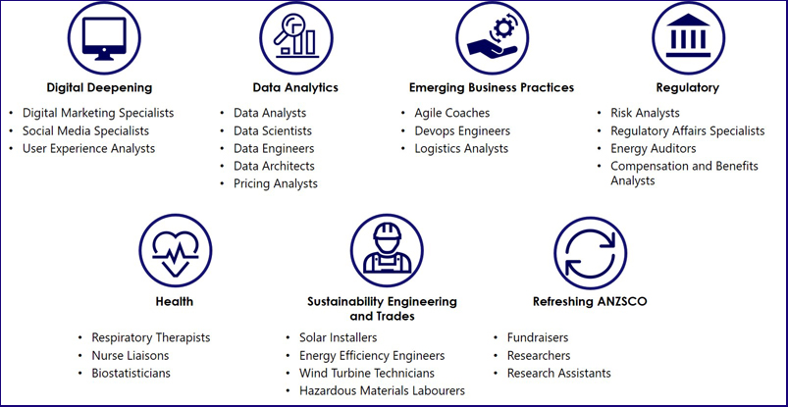
The jobs listed above are emerging jobs identified by the National Skills Commission.
Emerging occupations are defined as new, frequently advertised jobs which are substantially different to occupations already defined in the Australian and New Zealand Standard Classification of Occupations (ANZSCO) – such as data scientist and data analyst. As such, to compile our list we considered data from the time period following the last ANZSCO review in 2013.
The NSC has identified and validated 25 emerging occupations within seven categories in the Australian labour market (Figure 1). This list is not considered exhaustive, and the NSC will continue to monitor and analyse emerging trends.
An advantage of our approach is access to real time internet job advertisement data using Burning Glass Technologies, which will allow us to pick up occupations in emerging fields like blockchain, nanotechnology, quantum computing and the internet of things as soon as the employer demand for these skills increases.
https://www.nationalskillscommission.gov.au/what-are-emerging-occupations

On the Job – Australian Curriculum General Capabilities Alignment with Activities 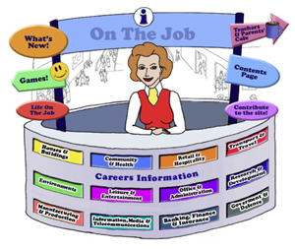
All of the activities in “Life On the Job” have also been aligned with the Australian Curriculum’s General Capabilities. They are meant to be fun and engaging for the student and introduce them to the world of work in a more concrete way. On the Job builds on what students have learnt in their earlier years in Primary School about the world of work and helps students go from the concrete to the abstract in their thinking.
Each activity shows the General Capability [GC] being focussed on by showing the GC icon and any Priorities.
Future Growth
Each job is given a Future Growth icon: either Decline; Static; Moderate, Strong or Very Strong growth. These icons were created by On the Job.
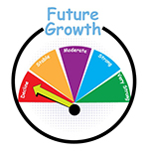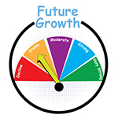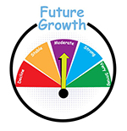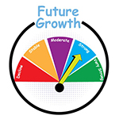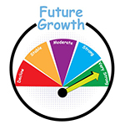
The information has been obtained from the Australian Government website: Labour Market Insights. https://labourmarketinsights.gov.au/
CATEGORY: HOUSES & BUILDINGS
HOUSES & BUILDINGS
JOB | Australian Curriculum General Capability | ACTIVITY | Target Level
AIR CONDITIONING & REFRIGERATION MECHANIC  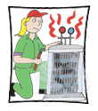 |  | - What is this job about?  - The Global Impact of Air Conditioning: big and getting bigger  - Energy-efficient house - Game | Middle Secondary  Middle Secondary  Primary
ARCHITECT |  | - Responding to the Vernacular?  - A multigenerational home: a new design  - Websites, Games and Apps: Wrecking Ball Lite (Free Mobile App); Build a Pyramid; Building Big; ArchKIDecture; Children & Architecture; World’s tallest skyscrapers; Architect Studio 3D  - WebQuests: Where did my house come from?; You are an architect | All  Middle
LOTJ – Architectural Draftsman – John |  | - Design an extension to your house | Middle  Secondary
BRICKLAYER |  | - “The Block” – Budgeting for bricks  - The Bricklayer’s Lament – Made Real? | Middle Secondary  , , All
BUILDER  BUILDER’S LABOURER  BUILDING CONTRACTOR  CONSTRUCTION PROJECT MANAGER |  | - Building a scaled down version of your house  - Sustainable buildings: What does it mean? Consider All Factors  - Websites, Games & Apps: Latest Building Games; BUILDING THEIR OWN HOME (ABC) | Middle Secondary  Middle Secondary  , , All
CABINETMAKER |  | - Make your own copy of the First Fleet Table [of sorts]!  - Copyright & Furniture: A school poster or infographic  - Websites, Games & Apps: Furniture and Cabinetmaking App; ID Wood App; iWoodwork App | Secondary  Secondary  Secondary
LOTJ – Cabinetmaker: Geoff Hannah |  | - Create a similar sketch [to Geoff Hannah] of an Australian bird | , , All
CARPENTER  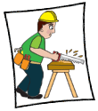 |  | - Bluebird House Plans  - “Building sites aren’t for females” – Is this still the case?  - Websites, Games and Apps: Woodworking Plan; Better Homes & Gardens DIY; DIY Woodworking; Woodwork – Research Assignment | Primary Middle  Middle Secondary  Secondary
CLEANER  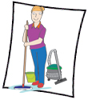  Chimney Sweep  Commercial Cleaner  Crime Scene Cleaner  Domestic Cleaner  Graffiti Cleaner  Janitor  Window Cleaner |  | - Who does the most cleaning at your place?  - “Clean Your Room!”  - Natural vs Chemical: Is there a choice?  - “How to deal with burglars – The Cleaner BBC” – next scene, previous crime scene? You decide | , , All  , , All  , , All
LOTJ – Cleaner  Shannon Lush |  | - Cleaning Kit Comparison | Primary Middle
CONCRETER |  | - Natural Concrete Sculpture for Kids  - Lesson: Concrete for Kids  - A problem with concrete? | Primary  , , All
CONSTRUCTION PROJECT MANAGER  Construction Contracts Manager  Construction Manager |  | - Master Lego and Tree Building  - Bendable concrete? Smart concrete? Ethics & Construction? What do you know?  - Tall Tower Challenge (created by TryEngineering.org) | , , All  , , All
CONSTRUCTION RIGGER  Dockside Rigger  Scaffolder  Structural Steel Erector |  | - Bridges, highways, scaffolds: how the amazing engineering of army ants can teach us to build better. #TC  - Optional Extra – Biomimicry in Engineering (TryEngineering.org) | , , All
CONSTRUCTION WORKER |  | - What is the future of construction jobs? PMI Strategy  - Safety and Construction: a Communication Strategy  - Websites & Games: Lego City construction games; the 10 Best Construction Games Online | Secondary  Primary Middle
ELECTRICIAN  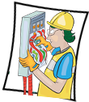 |  | - What is this job about?  - Electricity Bills – Yuck! Research & Action Plan!  - Energy Crisis 2022 – Sammy J’s Take! | , , All  , , All
FENCER |  | - Which fence will you chose to research?  - Rabbit Proof Fence – Lesson Plans, Student Worksheets; Resources | , , All  Teacher
FLOOR FINISHER |  | - Carpet, Wooden Floors, Polished Concrete, Tiles - What's the cost? | Middle Secondary
LOTJ – Iqbal Masih  Carpet Weaver and Child Labour Activist |  | - Powerful Ideas – Practical Actions: Free the Children  - My Hero Project – Iqbal Masih  - A good read? What’s Your Review? | , , All  , , All  Primary Middle
FURNITURE POLISHER  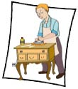 |  | - Comparing homemade furniture polish using olive oil on different surfaces.  - Beeswax and Furniture Polish | , , All  ,
GARDENER |  | - Creating a Frog Bog: at school or home  - What’s that sound? Australian Museum: Frog ID App  - Creating or revitalising an edible Indigenous garden at school | , , All  , , All  , , All
GASFITTER  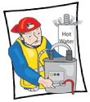 |  | - What is…? Crossword Puzzle  The Periodic Table Gases Song | Middle Secondary  , , All
GLAZIER  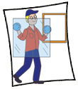 |  | - What is this job about?  - Skyscrapers and Glass | , , All  Middle Secondary
HANDYPERSON  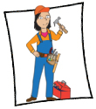 |  | - When is a Hammer, a Hammer?  - Mould and Damp: How it effects your health | , , All
LOTJ – Handyperson  Dr. Jim Penman, CEO Jim’s Group |  | - What is your dream? What things do you like now that could be your future job? | , , All
HOME IMPROVEMENT INSTALLER  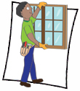 |  | - Measuring windows for blinds
INTERIOR DECORATOR |  | - Analysing the Top 50 Rooms 2021  - Websites, Games & Apps: Decorating Your Room; Decorating with Jessica; Sweet Home 3D App; Cool Hunting App | Middle Secondary
INTERIOR DESIGNER |  | - Living in a small space? Let’s analyse your options!  - Interior Design and Homelessness  - Websites, Games & Apps: Interior Designer Activities; Armstrong Design a Room; My Deco; Colours Palette Generator; Interior Design Tool for Busy Homeowners  - Elastic Annex – WebQuest | Secondary  Middle Secondary  Secondary  Secondary
JOINER  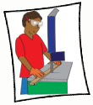 |  | - Wood Joinery Types!  - Design a wardrobe that will suit you! | , , All  , , All
LIFT MECHANIC  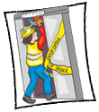 |  | - Engineering Ups and Downs (developed by Try Engineering)  - Science Fair Ideas – Pulley Lift System  - Chair Lift Challenge (developed by Try Engineering) | Middle Secondary  Primary Middle  , , All
NANNY |  | - The Adventures of Nanny Piggins  - Nanny McPhee & Mary Poppins – who would win? | Primary  Primary Middle
PAINTER |  | - Brushes and Rap  - Mr Bean – Painting his house: Next Instalment  - Maths and the Painter | Primary Middle  Middle Secondary  Middle Secondary
PLASTERER |  | - Activities with Plaster of Paris  - Creating a new Ceiling Panel  - Websites, Games and Apps: Story Tile created with Plaster; Arm and Face Masks | Primary  Secondary
PLUMBER  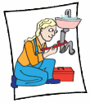 |  | - Is your school Water Wise?  - Plato the Platypus Plumber (part time): Goes ICT!  - Greywater recycling: What is it?  - Websites and Games: MATHS IS FUN: PLUMBER GAME | , , All  Primary Middle  Middle Secondary  Primary
POOL TECHNICIAN |  | - pH and Pool Technicians  - What lies lurking in your swimming pool? Fact check!  - Websites, Games & Apps: Pool Doctor App | Primary Middle  Secondary
QUANTITY SURVEYOR |  | - Day in the Life of Quantity Surveyor (developed by STEM UK)  - Graphics: Calculating Colour (developed by Try Engineering) | Primary Middle  Primary Middle
ROOFER  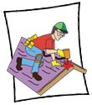 |  | - Up on the Roof – Creation of an additional verse  - The History of Roofing in Australia  - Waterproof that Roof! (developed by Try Engineering) | Secondary  , , All  , , All
SOLAR PANEL INSTALLER |  | - Solar Panels – should (or can) we all have them? Community of Inquiry  - Please Explain & Analyse! The Creation of a Cartoon  - Here Comes the Sun (developed by TryEngineering.org)  - Solar Structures (developed by TryEngineering.org) | , , All  , , All
TILER |  | - Tiling your house? How hard can it be?  - Let’s brighten up the garden with a mosaic time pot  - Websites, Games and Apps: Tile Estimate App | , , All  , , All  Secondary
UPHOLSTERER  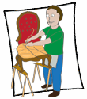 |  | - Kids Furniture – would an upholsterer be bothered? Brainstorm your new design  - “While at the Sofa Factory” by Kenn Nesbitt  - Car Upholstery: Vinyl or Leather? What would you choose? #TC | Primary Middle  Primary Middle

