On the Job: Careers Market

Category: Research & Development

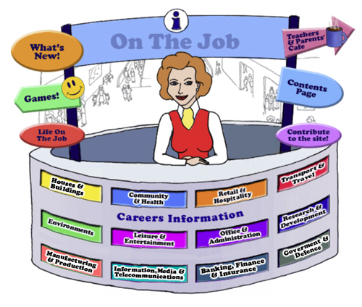

Teachers
Introduction
Welcome to this website for Australian students in Years 5 - 12, their teachers and parents.
The Design concept is based on the local Shopping Mall as students of this age are familiar with the Careers represented here. This initial concept broadened to include careers that they might have encountered outside the Shopping Mall eg. Local Government Inspector or Farmer
The website can be used as an individual activity for students or as a whole group.
This Teacher’s Guide is for the whole class and is aligned to the Australian Curriculum and the General Capabilities.

The Jobs
Each of the jobs listed has three sections
- The Information about each Job. | - Activities | - Links

All content in the Job Info sections have been taken from The Job Guide. Under copyright laws and from the Job Guide’s website – this information can be used for Educational purposes.
This content also encourages reading and therefore literacy but breaks down information into chunks and divided by “Did You Know?” segments.
The Activities can be divided into two sections:
- Offline
- Online
The activities bring a fun element into learning. There are practical skills about the particular job eg. “How to build a beehive” [in the Beekeepers section] is an Offline activity.
The Online activities include mostly free mobile apps, YouTube Videos, games and also WebQuest activities which provide students with Problem-Based Learning and the opportunity to use their Higher Order Thinking and Collaboration Skills.
The Links provide students with access to Association websites for that particular Industry as well as links to examples of people within this job and their experiences.
Life on the Job is divided into three sections:
- Historic or Famous People – mostly Australians | - Indigenous Historic or Famous People | - “Real Life People”
Historic or Famous People
Historic or Famous People are mostly famous Australians whose lives are usually investigated within the Australian Curriculum. Each person is researched and their lives summarised to give students an overview. There are links provided so students can investigate more fully themselves. At the end of the content information, students are given an activity to complete – mostly using the latest and free ICT tools available to increase their knowledge and capability.

Indigenous Historic or Famous People
Indigenous Historic or Famous People are famous Australians whose lives are usually investigated within the Australian Curriculum. Each person is researched and their lives summarised to give students an overview. There are links provided so students can investigate more fully themselves. At the end of the content information, students are given an activity to complete – mostly using the latest and free ICT tools available to increase their knowledge and capability.

Real Life People
Real Life People’s stories are provided here. Parents can submit their job and show students their educational journey to achieve employment within their job category.

Alignment with the Australian Curriculum
Curriculum Area: Australian Curriculum: General Capabilities
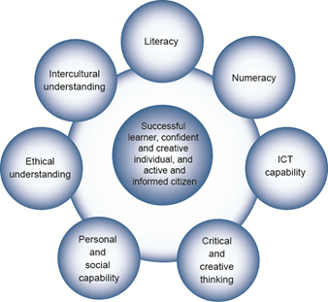

The Australian Curriculum includes seven general capabilities:
- Literacy
- Numeracy
- Information and communication technology (ICT) capability
- Critical and creative thinking
- Personal and social capability
- Ethical understanding
- Intercultural understanding.
(Source: Australian Curriculum)
Literacy involves students in listening to, reading, viewing, speaking, writing and creating oral, print, visual and digital texts, and using and modifying language for different purposes in a range of contexts.
Numeracy involves students in recognising and understanding the role of mathematics in the world and having the dispositions and capacities to use mathematical knowledge and skills purposefully.
Information and communication technologies are fast and automated, interactive and multimodal, and they support the rapid communication and representation of knowledge to many audiences and its adaptation in different contexts. They transform the ways that students think and learn and give them greater control over how, where and when they learn.
Critical and creative thinking are integral to activities that require students to think broadly and deeply using skills, behaviours and dispositions such as reason, logic, resourcefulness, imagination and innovation in all learning areas at school and in their lives beyond school.
Students develop personal and social capability as they learn to understand themselves and others, and manage their relationships, lives, work and learning more effectively. The capability involves students in a range of practices including recognising and regulating emotions, developing empathy for others and understanding relationships, establishing and building positive relationships, making responsible decisions, working effectively in teams, handling challenging situations constructively and developing leadership skills.
Ethical understanding involves students in building a strong personal and socially oriented ethical outlook that helps them to manage context, conflict and uncertainty, and to develop an awareness of the influence that their values and behaviour have on others.
As cultural, social, environmental and technological changes transform the world, the demands placed on learners and education systems are changing. Technologies bring local and distant communities into classrooms, exposing students to knowledge and global concerns as never before. Complex issues require responses that take account of ethical considerations such as human rights and responsibilities, animal rights, environmental issues and global justice.
Building ethical understanding throughout all stages of schooling will assist students to engage with the more complex issues that they are likely to encounter in the future, and to navigate a world of competing values, rights, interests and norms.
Intercultural understanding: The capability involves students in learning about and engaging with diverse cultures in ways that recognise commonalities and differences, create connections with others and cultivate mutual respect. (Source: Australian Curriculum)
Priorities:
Asia and Australia's engagement with Asia
Aboriginal and Torres Strait Islander histories and cultures
Sustainability

Philosophy: This icon represents both Critical and Creative Thinking and Ethical Understanding but at a deeper level. The activities with this icon show a high level of complex thinking is required. The activity can be used with classes undertaking Philosophy in Schools.
Cooperative Learning Activity
A collaborative (or cooperative) learning approach involves students working together on activities or learning tasks in a group small enough for everyone to participate on a collective task that has been clearly assigned. Students in the group may work on separate tasks contributing to a common overall outcome, or work together on a shared task.

Emerging Job
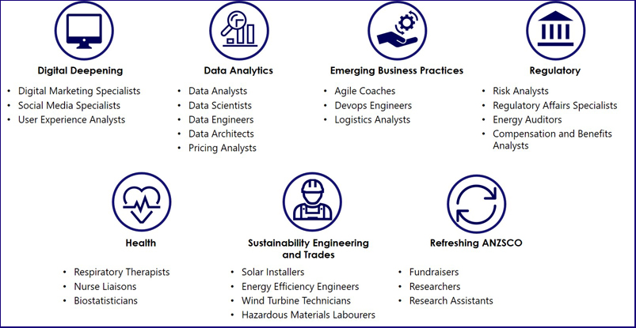
The jobs listed above are emerging jobs identified by the National Skills Commission.
Emerging occupations are defined as new, frequently advertised jobs which are substantially different to occupations already defined in the Australian and New Zealand Standard Classification of Occupations (ANZSCO) – such as data scientist and data analyst. As such, to compile our list we considered data from the time period following the last ANZSCO review in 2013.
The NSC has identified and validated 25 emerging occupations within seven categories in the Australian labour market (Figure 1). This list is not considered exhaustive, and the NSC will continue to monitor and analyse emerging trends.
An advantage of our approach is access to real time internet job advertisement data using Burning Glass Technologies, which will allow us to pick up occupations in emerging fields like blockchain, nanotechnology, quantum computing and the internet of things as soon as the employer demand for these skills increases.
https://www.nationalskillscommission.gov.au/what-are-emerging-occupations

On the Job – Australian Curriculum General Capabilities Alignment with Activities
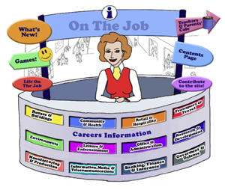
All of the activities in “Life On the Job” have also been aligned with the Australian Curriculum’s General Capabilities. They are meant to be fun and engaging for the student and introduce them to the world of work in a more concrete way. On the Job builds on what students have learnt in their earlier years in Primary School about the world of work and helps students go from the concrete to the abstract in their thinking.
Each activity shows the General Capability [GC] being focussed on by showing the GC icon and any Priorities.
Future Growth
Each job is given a Future Growth icon: either Decline; Static; Moderate, Strong or Very Strong growth. These icons were created by On the Job.
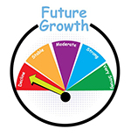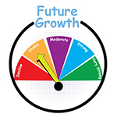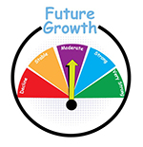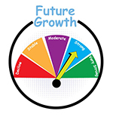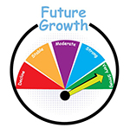
The information has been obtained from the Australian Government website: Labour Market Insights. https://labourmarketinsights.gov.au/

RESEARCH & DEVELOPMENT
JOB | Australian Curriculum General Capability | ACTIVITY | Target Level
AGRICULTURAL SCIENTIST  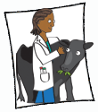 |  | - Landline and our Scientists  - Websites, Games and Apps: Sci4Kids; Spin & Solve; That’s Life; Kid’s Zone;  - Blizzard WebQuest  - Agroterrorism WebQuest  - Controlling Pests WebQuest  - Hello Dolly WebQuest | Primary  Primary  Secondary
AGRONOMIST  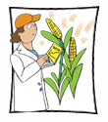 |  | - Australia’s farming future:  doing more with less water  - A Native Bush Food Agronomist: what’s the potential? | , , All  Secondary
ANTHROPOLOGIST  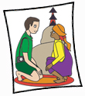 |  | - What can WE Australians do about a permanent and exciting space for the Berndt Museum?  - Parent-Infant Observation  - Websites and Games: OLogy | Middle Secondary  Secondary  Primary
LOTJ – Prof. Genevieve Bell, Anthropologist, Futurist |  | - What is in your school bag?  - Your helpful idea | , , All  , , All
ARCHAEOLOGIST  Marine Archaeologist |  | - Resources: Big Dig Archaeology Education Centre in the Rocks, Sydney; Faces of Power – Imperial Portraiture on Roman Coins  - Connect 3: Shipwrecks, Seaweed, Climate Change & Marine Archaeologists  - Wreck Seeker – an online game created by the Australian National Maritime Museum  - Websites, Games & Apps: Mysteries of Catalhoyuk!; Ancient Egypt – British Museum; Maya Adventure; Ancient India; Enquiring Minds – Archaeology  - Pompeii – Can You Dig It? WebQuest  - Should visitors be allowed in Pompeii?  - Aztechi, Maya, Incas (in Italian) WebQuest | , , All  Secondary  , , All
ASTRONOMER  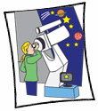 |  | - I had no idea! Aboriginal and Torres Strait Islander Astronomy: Letting the world know about Cultural Astronomy | , , All
BIOCHEMIST |  | - Food Labs (Biochemistry)  - Our Liver: its importance to the body  - The Biochemistry of Smoke Taint in Grapes  - Websites, Games & Apps: Interactive Animations; Chem4Kids; Biochemistry Activities | Middle Secondary  Secondary  Secondary  Secondary
BIOINFORMATICS SCIENTIST |  | - Bioinformatics: Food Detective for students studying Biology (created by Stevie Bain & Daniel Barker, University or Edinburgh)  - Sequence Bracelets (Created by Your Genome)  - The Koala Genome Project – A Listening and Viewing Research Project  - Cladogram  - Bioinformatics practical: the Florida Dentist reported in The Science Teacher UK) | Primary
BIOLOGIST |  | - What do you know about the Koala & what do you need to do to help it’s plight? Six Action Shoes #TC  - Rock Pools – what’s in them? (Developed by Surf Life Saving NSW) | , , All
BIOMETRICIAN |  | - Your Ear: A Medical & Technical Illustration: Intercepting with Biometrics  - 1984  - Hand Biometrics Technology (from Try Engineering) | , , All  , , All
BIOTECHNOLOGIST  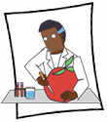 |  | - How to extract DNA from a Kiwi Fruit  - Why isn’t Australia capitalising on being “an algae gardener’s paradise”?  - Genetically Modified Foods: Because we can, does it mean we should? The ethics of GM foods! | Secondary
BOTANIST |  | - What is fruit?  - Plants and Space: Can it be done on Mars? | Primary Middle  Middle Secondary
LOTJ – Professor Kingsley Dixon, Botanist |  | - Germination of Seeds & Smoke  - Making smoke water using a bee smoker and seeing the germination difference | , , All  Primary Middle
CARDIOLOGIST  Cardiac Technologist  Cardiothoracic Surgeon  Perfusionist |  | - Find a Word  - Infographic: The Anatomy and Workings of the Heart | Primary Middle  Middle Secondary
CARTOGRAPHER  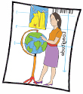  Cartographic Technician  Hydrographer  Map Editor |  | - How ancient Aboriginal star maps have shaped Australia’s highway network  - Cartography, Politics & History  - Introduction to Bathymetry (developed by Olivia Belshaw & CSIRO)  - Websites, Apps & Games: Science Buddies; Wolf-GIS App | Middle Secondary  Secondary  Middle Secondary
CLIMATE CHANGE ANALYST  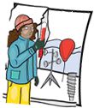 |  | - Behind the News: Understanding Climate Change  - Policies and Responsibilities | Primary Middle  Middle Secondary
CONSERVATOR  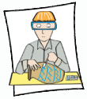 |  | - Acting as a Conservator – Creating a Hygrometer  - Damaged by damp air? How can you tell?  - Designing a new display case for your school  - A Security Alarm  - Pest – particularly insect pests can damage museums  - Design a Lamp | Middle  Primary Middle  Secondary  Secondary  Primary Middle  Middle
CRIMINOLOGIST  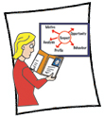 |  | - Are you one of the third of customers who use self-service checkouts to ‘swipe’ groceries?  - Sewage and the Criminologist! | Middle Secondary  Secondary
DEMOGRAPHER |  | - Do you know where you come from?  - Retrofitting our road networks for new mobility technology: Ideas anyone?  - Australian Population Clock  - Creating a Population Pyramid for Australia: 1901 – 2016 | Primary  Secondary  Secondary
LOTJ – Dr Adam Cross – RESTORATION ECOLOGIST |  | - Carnivorous Plants: Research Game of Snakes & Ladders  - Little Shop of Horrors – “feed me Seymour” to “Save Me Seymour”  - Mining Restoration: Academic Controversy Strategy | , , All
DOMESTIC ANIMAL SCIENTIST |  | - What the Duck?! The Politics of being a cow: A Community of inquiry | Secondary
ENDOCRINOLOGIST  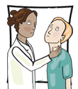  Endocrinology Nurse  Endocrinology Nurse Practitioner  Paediatric Endocrinology Nurse |  | - What are the Endocrine Glands? How do they function? A Research Assignment  - Sugar – why we need to cut back! | , , All
LOTJ – Prof. Creswell Eastman  Endocrinologist |  | - Iodised salt in your diet? | , , All
ENTOMOLOGIST  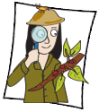 |  | - Insect Observing  - Banning of Pesticides  - Maggots and Murder  - Websites & Games: Bugs Ed; Entomology in Action – Lesson Plans; Enquiring Minds – Insects;  - Mununja the Butterfly WebQuest | , , All  , , All  Middle
LOTJ – Dr Bryan Lessard – Entomologist |  | - The Science of Classification: Taxonomy  [6 Topics & Activities]  - Mosquitoes & BTN  - Your Digital Collection | , , All  , , All
ENVIRONMENTAL SCIENTIST |  | - Local Pond Water Exploration  - Biomethane Technology.  - Websites, Games & Apps: Weed wipe out an interactive game; Australian Government: Water Education Toolkit; Murder Under the Microscope; | Middle  Primary Middle
LOTJ – Dr Leroy Gonsalves  Environmental Scientist |  | - Create a Voice Thread around the relationship between Mosquitoes and Bats  - Debate the issue: Should we get rid of ‘pesty’ Mosquitoes? | Primary Middle  Secondary
EPIDEMIOLOGIST |  | - How many people need to get a COVID-19 vaccine in order to stop the coronavirus?  - Complexity – It’s Simple (Algorithms)
EXERCISE SPORTS SCIENTIST  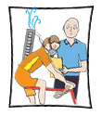 |  | - Sleep & Success in Sport  - Fundamental Movement Skills – will your school get above the national average? | , , All  , , All
LOTJ – Dr Darren Burgess  Exercise /Sports Scientist |  | - Measuring your BMI and reflecting on it | , , All
LOTJ – John Leyden  Exercise Sports Scientist |  | - Push-Ups! | , , All
FORENSIC SCIENTIST |  | - Diatoms & Forensic Science  - A single strand of hair may now help catch the criminal  - The relationship between foot length & height  - Websites & Games: Autopsy of a Murder – Interactive File; Forensics for Kids; CSI – Web Adventures; Forensic Science Kids; Forensic Science Lesson Plans; Forensics; Who Dunnit?; Enquiring Minds Crime Scene; Splatter Spread; Whodunit? Forensic Science Resource Book for Teachers  - A Murder on Midway Street! A Forensic WebQuest | ,  Secondary  Middle  Teacher  , , All  Secondary
GENETICIST  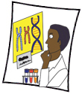 |  | - What is Cystic Fibrosis?  - New DNA study confirms ancient Aborigines were the First Australians  - The Ethical Implications of the Human Genome Project | , , All
GEOGRAPHIC INFORMATION SYSTEMS OFFICER  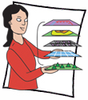 |  | - Introduction to GIS (developed by National Geographic)  - What’s so Spatial about the Cementery? | , , All  , , All
GEOLOGIST  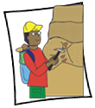  HYDROGEOLOGIST  MARINE GEOLOGIST  PALAEONTOLOGIST |  | - Perth’s “new” water! What are the consequences of using this aquifer water as Perth's drinking water?  - Is the Anthropocene real? When did it start? | Secondary
LOTJ – Brad Moggridge  Hydrogeologist |  | - Rainbow Serpent & AFL  - Geometry of water sources and landforms | Primary
GEOPHYSICIST |  | - The Pitch: Fracking is VERY Safe!  - An Infograph: Earthquakes and Nuclear Testing
HAEMATOLOGIST  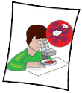 |  | - What is in our Blood?  - Blood Diseases: An animated video research display | , , All  Secondary
HERPETOLOGIST  LOTJ: Cameo: Dr Deb Bower | #TC | - FrogID – Let’s Help  - Australian Endangered Species: Sea Snakes: make a presentation and a Kahoot | , , All
HISTORIAN |  | - Time Capsules! What would you add?  - Who do you think you are?  - The Petrov Affair – Australia and the Cold War – A Rich Task  - Websites & Games: Can you strike it rich during the Gold Rush?; WW1 Hero App; | Primary  , , All
LOTJ – Dr Clare Wright  Historian |  | - History or HIS-Story: Is this the case with the Eureka Stockade?
HYDROLOGIST  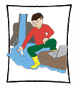 |  | - Water Pollution, Hydrologists & Engineers: One solution to the world’s drinking water  - The Great Artesian Basin: A Creative Response! | Primary  , , All
IMMUNOLOGIST  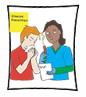 |  | - Let’s Survey Opinions on Immunisations!  - Allergies – are they on the rise? | , , All  , , All
INDUSTRIAL DESIGNER |  | - I’m an Industrial Designer  - So many public toilets are a last resort: why not a restful refuge?  - Websites, Games & Apps: Create a Ride Make Design Your Own Car Game; Customise Your Ride  - Team Designing a Prosthetic Leg for Surfing WebQuest | Secondary
LOTJ – Shirley de Vocht  Industrial Designer |  | - Designing Towels for the Olympics! | , , All
LOTJ – Jean Madden  Industrial Designer |  | - Vinnies Sleepout for School Students – Are you game?  - Create a VoiceThread on homelessness to persuade other students to help with getting the information out about this plight  - Debate the issue: Should we help charities whose focus is homelessness or address the problem differently? Can we do both? | , , All  , , All
INFECTIOUS DISEASES SPECIALIST  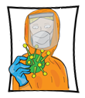 |  | - Coronavirus (COVID-19): Kids and Masks: a Tik Tok  - The Chickenpox Virus!  #TC | ,
INVENTOR  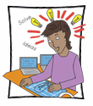 |  | - Australian Inventions Timeline: Aussies are a clever lot!  - Gadgets for Disaster Zones  - CSIRO, Inventions and Cutbacks | ,
MARINE BIOLOGIST  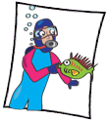 |  | - Finding Nemo – Another Story!  - Websites: What Eats What? The Food Chain game; Matchem Game; Seagrass Search Game; Birds of the Coast Game; Predator – Protector Game; Enquiring Minds – Sharks; Ocean Encounters App;  - To Dam or Not to Dam? WebQuest  - WebQuest: Sensory Biology and the Plight of the Right Whales | Primary Middle  , , All  Primary Middle  Secondary
MATHEMATICIAN  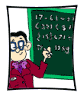 |  | - Maths Puzzle  - Hidden Figures: Calculating Launch Windows  - Websites, Games & Apps: BBC MATHS (4-11), (11 – 16); Fractals; JigZone; Mega Mathematics; Maths Goodies; MyScript Calculator App; ABS – Maths Games; DJ Decibel Game;  - Exponential Growth and the Human Population WebQuest | Primary  Secondary  , , All  Middle
PROF. NALINI JOSHI  Mathematician |  | - Fabulous Fibonacci  - Community of Inquiry: Labels and Assumptions of Women in STEM | Primary
MEDICAL LABORATORY SCIENTIST  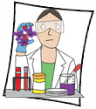 |  | - IVF – what are the steps?  - New Gardasil 9 vaccine boosts teen’s protection from HPV and cervical cancer by 23% - A Research Assignment | Secondary  Secondary
PROF. BARRY MARSHAL  Nobel Laureate – Medical Laboratory Scientist - Gastroenterologist |  | - Community of Inquiry: Scientific Proof
MEDICAL LABORATORY TECHNICIAN  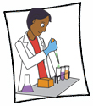  BLOOD BANK TECHNICIAN  PHLEBOTOMIST |  | - Who will be my donor?  - "Phlebotomist", Power Words and Crosswords! | , , All  , , All
MICROBIOLOGIST |  | - Corona Virus: A Research Assignment  - The Science tells us that renewable energy is the way of the Future. But is it for Australia?  - Websites, Games & Apps: Microbe Zoo; Micro-organisms; What are Bacteria; ASM – Lesson Plans  - Disease Busters WebQuest [Web Archive Only]  - Protistan Tales of Atlantic White Cedar Swamps WebQuest | Secondary  Secondary  Middle  Middle  Secondary
MUSEUM or ART GALLERY CURATOR  Museum or Art Gallery Attendant  Museum or Art Gallery Education Officer  Museum or Art Gallery Technician  Taxidermist or Preparator |  | - Examine and Catalogue the School’s Art Work and/or Trophies  - Teaching with unique Collections: Grainger Museum, University of Melbourne  - What will the museum of the future look like?  - Acknowledgement of the Histories behind Aboriginal Artefacts Acquisition & more  - Websites, Games & Apps: Ask a Curator Day; The Petrov Affair – Australia and the Cold War; Curating a Virtual Exhibit WebQuest | , , All  , , All
JANE TOSH – Taxidermist |  | - Provenance & Respect
CAROLINE FIELD – Art Curator |  | - Our Digital Collection – Curating our school’s Art Work | , , All
OCEANOGRAPHER  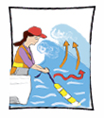 |  | - Why is the Ocean Salty?  - Social Media Action: Plastic and how it affects our oceans  - Concern for the Great Barrier Reef: 6 Thinking Hats  - Tracking Sharks | Primary Middle  , , All  , , All  , , All
ORNITHOLOGIST  Forensic Ornithologist |  | - A Study of the Australian Magpie  - Feather Identification – Forensic Ornithology  Case 1 = Poaching; Case 2= Birdstrike  (Created by Dr Carla Dove, Smithsonian Institute)  - Websites, Games & Apps | , , All
PATHOLOGIST  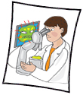  Cytopathologist  Forensic Pathologist  Forensic Technician  Pathology Collector |  | - Money, COVID tests & Pathology Companies: Cornell Note-taking Method & Community of Inquiry #TC | ,
LOTJ – Dr Natasha Prosser  Anatomical Pathologist |  | - NanoMslide – An Australian invention: How will you promote it?#TC  Cornell Note-taking Method & Infographic Development | Secondary
PHARMACOLOGIST  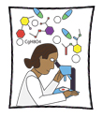 |  | - Fizzy Nano Challenge (Try Engineering experiment)  - Aspirin: what do you know? | ,  Secondary
PHYSICIST |  | - “Why is it so?” Revisited  - The Physics of Four Olympic Winter Games  - Maralinga Testing: a creative response  - Car Crash WebQuest – solving a Real Life Physics Problem | , , All  Secondary  Secondary
POLITICAL SCIENTIST  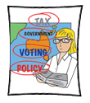 |  | - Can we replace politicians with robots?  - Is Trump using the rhetoric of dictators?  - “An Ode to King Charles the Third” by Sammy J
ROBOTIC & MECHATRONICS ENGINEER  Robotic Process Automation Engineer  Robotics or Mechatronics Technician |  | - Following on from Bumblebee [Transformers] - create a new Character & Plot  - Build Your Own Robot Arm (developed by Try Engineering)  - Modelling the Human Hand  - Music by Robots: As good as Humans?  - New things,,, A Research & Presentation Assignment  - Websites, Games & Apps: Challenge: Robots; Razor Robotics; Try Engineering | , , All  , , All  , , All  , , All
SCIENTIST  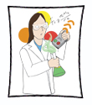 |  | - Eggnormous  - You can be a Scientist (20 Lessons)  - Websites & Games: Brain POP; Earth Sciences Enterprise: NASA; CSIRO Publishing; A Game with Proton Don; Ology; Science Facts App; Planets App | Primary Middle  ,  , , All
LOTJ – Marie Curie  Scientist |  | - Design a new Australian stamp to commemorate the achievements of Marie Curie  - Nuclear Testing in 50s and 60s in Australia – Is there still a fallout? | Primary Middle
SOIL SCIENTIST  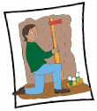 |  | - Testing soil pH  - Long term soil enrichment project: at home or school  - Websites, Games & Apps: Soils for Life – School Gardens: Resources; Soils in Schools – Teacher Resources | ,  , All  Primary;
STATISTICIAN  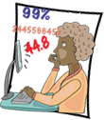  Biostatistician |  | - Tailgating & Statistics: Your PMI Analysis  - Websites, Games & Apps: Stop the Spread: A Global Pandemic Response Game (Created by ACEMS & QUT)  Websites, Games & Apps: The Big Bite Game (Created by ACEMS & QUT) | Secondary  Primary Middle  , , All
TOXICOLOGIST  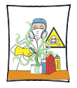 |  | - Snakes and Ladders – with a difference!  - Converting data into a presentation | ,  Secondary
UNIVERSITY LECTURER |  | - What are you passionate about? Podcast it!  - World University Rankings | , , All  Secondary
VIROLOGIST  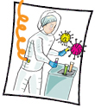 |  | - Viruses, Coronavirus variants, viral mutation, & COVID-19 vaccines: The Science you need to understand | Secondary
ZOOLOGIST  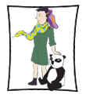 |  | - Observing a pet animal(s)  - Adaptations  - When is an animal not an ‘animal’? | Primary  Middle

