Welcome to On the Job: Careers Market

Category: Leisure & Entertainment

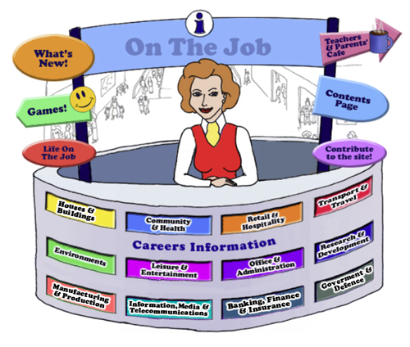

Teachers
Introduction
Welcome to this website for Australian students in Years 5 - 12, their teachers and parents.
The Design concept is based on the local Shopping Mall as students of this age are familiar with the Careers represented here. This initial concept broadened to include careers that they might have encountered outside the Shopping Mall eg. Local Government Inspector or Farmer
The website can be used as an individual activity for students or as a whole group.
This Teacher’s Guide is for the whole class and is aligned to the Australian Curriculum and the General Capabilities.
The Jobs
Each of the jobs listed has three sections
- The Information about each Job. | - Activities | - Links

All content in the Job Info sections have been taken from The Job Guide. Under copyright laws and from the Job Guide’s website – this information can be used for Educational purposes.
This content also encourages reading and therefore literacy but breaks down information into chunks and divided by “Did You Know?” segments.
The Activities can be divided into two sections:
- Offline
- Online
The activities bring a fun element into learning. There are practical skills about the particular job eg. “How to build a beehive” [in the Beekeepers section] is an Offline activity.
The Online activities include mostly free mobile apps, YouTube Videos, games and also WebQuest activities which provide students with Problem-Based Learning and the opportunity to use their Higher Order Thinking and Collaboration Skills.
The Links provide students with access to Association websites for that particular Industry as well as links to examples of people within this job and their experiences.
Life on the Job is divided into three sections:
- Historic or Famous People – mostly Australians | - Indigenous Historic or Famous People | - “Real Life People”
Historic or Famous People
Historic or Famous People are mostly famous Australians whose lives are usually investigated within the Australian Curriculum. Each person is researched and their lives summarised to give students an overview. There are links provided so students can investigate more fully themselves. At the end of the content information, students are given an activity to complete – mostly using the latest and free ICT tools available to increase their knowledge and capability.

Indigenous Historic or Famous People
Indigenous Historic or Famous People are famous Australians whose lives are usually investigated within the Australian Curriculum. Each person is researched and their lives summarised to give students an overview. There are links provided so students can investigate more fully themselves. At the end of the content information, students are given an activity to complete – mostly using the latest and free ICT tools available to increase their knowledge and capability.

Real Life People
Real Life People’s stories are provided here. Parents can submit their job and show students their educational journey to achieve employment within their job category.

Alignment with the Australian Curriculum
Curriculum Area: Australian Curriculum: General Capabilities
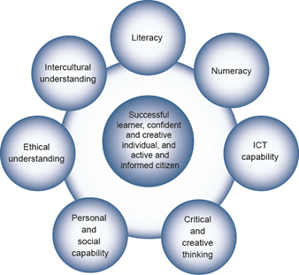
The Australian Curriculum includes seven general capabilities:
- Literacy
- Numeracy
- Information and communication technology (ICT) capability
- Critical and creative thinking
- Personal and social capability
- Ethical understanding
- Intercultural understanding.
(Source: Australian Curriculum)
Literacy involves students in listening to, reading, viewing, speaking, writing and creating oral, print, visual and digital texts, and using and modifying language for different purposes in a range of contexts.
Numeracy involves students in recognising and understanding the role of mathematics in the world and having the dispositions and capacities to use mathematical knowledge and skills purposefully.
Information and communication technologies are fast and automated, interactive and multimodal, and they support the rapid communication and representation of knowledge to many audiences and its adaptation in different contexts. They transform the ways that students think and learn and give them greater control over how, where and when they learn.
Critical and creative thinking are integral to activities that require students to think broadly and deeply using skills, behaviours and dispositions such as reason, logic, resourcefulness, imagination and innovation in all learning areas at school and in their lives beyond school.
Students develop personal and social capability as they learn to understand themselves and others, and manage their relationships, lives, work and learning more effectively. The capability involves students in a range of practices including recognising and regulating emotions, developing empathy for others and understanding relationships, establishing and building positive relationships, making responsible decisions, working effectively in teams, handling challenging situations constructively and developing leadership skills.
Ethical understanding involves students in building a strong personal and socially oriented ethical outlook that helps them to manage context, conflict and uncertainty, and to develop an awareness of the influence that their values and behaviour have on others.
As cultural, social, environmental and technological changes transform the world, the demands placed on learners and education systems are changing. Technologies bring local and distant communities into classrooms, exposing students to knowledge and global concerns as never before. Complex issues require responses that take account of ethical considerations such as human rights and responsibilities, animal rights, environmental issues and global justice.
Building ethical understanding throughout all stages of schooling will assist students to engage with the more complex issues that they are likely to encounter in the future, and to navigate a world of competing values, rights, interests and norms.
Intercultural understanding: The capability involves students in learning about and engaging with diverse cultures in ways that recognise commonalities and differences, create connections with others and cultivate mutual respect. (Source: Australian Curriculum)
Priorities:
Asia and Australia's engagement with Asia
Aboriginal and Torres Strait Islander histories and cultures
Sustainability
Philosophy: This icon represents both Critical and Creative Thinking and Ethical Understanding but at a deeper level. The activities with this icon show a high level of complex thinking is required. The activity can be used with classes undertaking Philosophy in Schools.
Cooperative Learning Activity
A collaborative (or cooperative) learning approach involves students working together on activities or learning tasks in a group small enough for everyone to participate on a collective task that has been clearly assigned. Students in the group may work on separate tasks contributing to a common overall outcome, or work together on a shared task.
Emerging Job
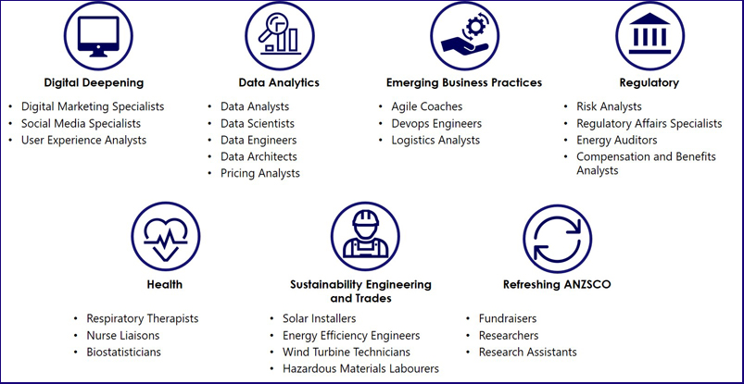
The jobs listed above are emerging jobs identified by the National Skills Commission.
Emerging occupations are defined as new, frequently advertised jobs which are substantially different to occupations already defined in the Australian and New Zealand Standard Classification of Occupations (ANZSCO) – such as data scientist and data analyst. As such, to compile our list we considered data from the time period following the last ANZSCO review in 2013.
The NSC has identified and validated 25 emerging occupations within seven categories in the Australian labour market (Figure 1). This list is not considered exhaustive, and the NSC will continue to monitor and analyse emerging trends.
An advantage of our approach is access to real time internet job advertisement data using Burning Glass Technologies, which will allow us to pick up occupations in emerging fields like blockchain, nanotechnology, quantum computing and the internet of things as soon as the employer demand for these skills increases.
https://www.nationalskillscommission.gov.au/what-are-emerging-occupations

On the Job – Australian Curriculum General Capabilities Alignment with Activities
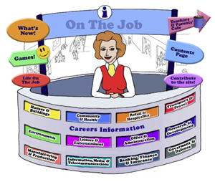
All of the activities in “Life On the Job” have also been aligned with the Australian Curriculum’s General Capabilities. They are meant to be fun and engaging for the student and introduce them to the world of work in a more concrete way. On the Job builds on what students have learnt in their earlier years in Primary School about the world of work and helps students go from the concrete to the abstract in their thinking. Each activity shows the General Capability [GC] being focussed on by showing the GC icon and any Priorities.
Future Growth
Each job is given a Future Growth icon: either Decline; Static; Moderate, Strong or Very Strong growth. These icons were created by On the Job.
The information has been obtained from the Australian Government website: Labour Market Insights. https://labourmarketinsights.gov.au/

LEISURE AND ENTERTAINMENT:
JOB | Australian Curriculum General Capability | ACTIVITY | Target Level
ACTOR |  | - Facial Expressions  - What are you doing?  - Should 'star voices' be an expected requirement of contemporary animated cinema?  - Websites, Games & Apps: New York Film Academy – Acting Apps; Drama for Kids; Drama Resource: Drama Games; Drama Toolkit | , , All  , , All  Secondary  , , All
LOTJ – Deborah Mailman  Actress |  | - “This is Your Life” Deborah Mailman | , , All
AEROBICS INSTRUCTOR |  | - Aerobics Circuit  - Stairs Challenge  - Communicating “Aerobics”  - Website: Pilates Interactive App  - Physical Fitness WebQuest | , , All  , , All  , , All  Secondary
ARTIST |  | - Paint Away!  - Websites: Painting Lesson – Colour; Painting Lesson Big Brushes, Little Brushes; Art Detective A.Pintura; FunBrain: Colour Mixing Game; ArtStudio App; Musee du Louvre App; Renaissance Connection – interactive; Enquiring Minds Art  - Art Exhibit WebQuest | , , All  Primary Middle  Middle
LOTJ – Albert Namatjira  1902 -1957  Artist |  | - Online: Use the Namatjira app to create similar landscapes  - Create a new verse to the song “Native Born” | Primary
LOTJ – Alasdair Macintyre  Artist |  | - Creating a Puppet and Diorama on an issue that you are interested in | , , All
LOTJ – Tim Sharp  Artist |  | - Education Resource Pack – Melbourne Arts Centre  - Imitating Tim – using Australian slang | , , All
CHOREOGRAPHER |  | - A New Dance? Have a go at choreographing!  - Jerusalema Dance Moves!  - Websites, Games & Apps: Showreels; Arts Alive; Dance Choreography App; 2wice: Dot, Dot, Dot App | , , All  , , All  , , All
LOTJ – Stephen Page  Choreographer |  | - Create a Dance around the Dreamtime Story: The Fish Hawk and the Lyre Bird | , , All
CINEMA OR THEATRE MANAGER  TICKET COLLECTOR OR USHER |  | - Cleaning the Cinema or Theatre is like cleaning…  - Is there an audience for Australian films?  - Coming soon to a cinema near you? Ticket prices shaped by demand.  - Toxic Popcorn Design Challenge (created by Try Engineering.org) | , , All  ,  ,  , , All
COMPOSER  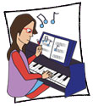 |  | - Music that you help make: composition for video gaming draws on tradition and tech  - Websites, Games & Apps: Classics for Kids; Game: Composer or Pasta?; Making Music Fun; Arts Alive – Games and Activities; Arts Edge; Sphinx Kids; Composer Time Machine | Secondary  Primary Middle
LOTJ – David Page  Composer |  | - Your Dream – use an Avatar to describe it!  - My Mental Health Pledge | , , All  Secondary
DANCER |  | - #boysdancetoo  - Websites, Games & Apps: Researching Dances; Triple Step Stomp with Video; Dancing in 3’s with video  - Entertaining with Modern Dance WebQuest | Secondary  , , All  Secondary
LOTJ – Li Cunxin  Ballet Dancer |  | - Wordle and Li Cunxin  - Balance & 6 Thinking Hats | Primary Middle
DIVER  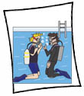 |  | - Planning a Dive to see Australian Natural Underwater Beauty!  - Teaching Others How to Snorkel | Primary Middle
ENTERTAINER |  | - Making a new vegetable hotter!  - Filming some of the Library of Juggling  - Mime… Can You?  - Creating your own puppet | , , All  , , All  , , All  , , All
LOTJ – Anh Do  Entertainer |  | - Philosophy: Community of Inquiry, the Question Quadrant, and “The Little Refugee”  - Interviewing Anh Do  - Australia’s Migration Policy – what does it mean for refugees like Anh Do? A multimodal presentation | , , All  , , All
LOTJ – Sean Choolburra  Entertainer |  | - Would I Lie to You? A Comedy Show
FISHER |  | - A Study of Australia’s Native Fish  - How to clean a fish  - Websites: My Place: Fishing; Get Hooked – it’s fun to fish (NSW); Coastal Climate Blueprint  - Yellowfin Tuna – A Problem?  - Dolphin Safe Tuna? WebQuest  - Can you help the Minister save our Marine Environment? WebQuest  - Something Fishy WebQuest  - Overfishing and the Seafood Dilemma | , , All  , , All  , , All  , , All  Primary  Secondary  Secondary  Secondary  Secondary
FITNESS INSTRUCTOR |  | - Gym Work – How much does it cost?  - The rise of the Fitbit kids: a good move or a step too far?  - Websites: BBC Online: Health; Kids Health.org; Human Body Facts App;  - Nutrition and Fitness WebQuest | Secondary  , , All  Middle  Middle
JOCKEY |  | - Design a Jockey’s colours or “silks”  - Should there be a ban on whips in Australian horse racing? A community of inquiry  - Horsing Around WebQuest  - Mustangs Run Free WebQuest (US) | , , All  Secondary  Primary  Primary
LOTJ – Frank Reys  Jockey |  | - The Melbourne Cup Numbers  - The Melbourne Cup Numbers  - Design a Stamp to commemorate Frank Reys  - Design a Memorial Sculpture to Frank Reys, the only Aboriginal Jockey to win the Melbourne Cup in 1973 | Primary  Primary
LOTJ – Michelle Payne  Jockey & Trainer |  | - Michelle’s Statistics  - Ride like a Girl | Primary
KARATE INSTRUCTOR/MARTIAL ARTS INSTRUCTOR |  | - Karate Kid Activity  - Kung Fu Panda – his moves or he moves?  - What do you know!!!  - A Handbook to the Martial Arts – a Research Assignment  - Websites, Games & Apps: Karate Activities for kids; | Primary  Primary Middle  Secondary  , , All
MUSIC DIRECTOR |  | - Favourite Songs  - Research and compare  - Have you got an Australian Musical in you?  - Websites, Games & Apps: Bravo Gustavo Game; The Orchestra App | , , All  , , All
LOTJ – Richard Gill  Music Director |  | - Your ideas for a Youth Chamber Choir  - What are your views on Music Education | , , All
MUSICIAN  Band Manager  Classical Musician  Disc Jockey or DJ  Ethnomusicologist  Jazz Musician  Music Arranger  Music Copyist  Music Critic  Music Producer  Musicologist  Performing Musician/Instrumentalist  Roadie/Guitar Technician  Vocalist |  | - Song Writing and Instrument Making  - Famous Musicians: Crossword  - Websites, Games & Apps: Up Beat; Sing! Karaoke App; The Voice App; GarageBand App; Last FM App  - Musical Instruments WebQuest | Primary Middle  , , All  , , All  Primary
LOTJ – Harold Blair  Musician – Opera Singer |  | - Harold’s Timeline  - Talent Shows: Let’s profile our young Indigenous stars | Primary
OUTDOOR ADVENTURE GUIDE  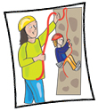 |  | - The Best School Camp EVER!  - Adventure, Risk, Uncertainty, Consequence: A Community of Inquiry | , , All
PROP AND SCENERY MAKER  Model Maker  Toolmaker & Engineering Patternmaker |  | - Let’s help make the scenery for the upcoming school musical  - Making Halloween Props for your garden! | , , All  , , All
PYROTECHNICIAN  Pyrotechnic Engineer |  | - The Firework-Maker’s Daughter by Philip Pullman: a. Standing on the shoulders of Giants; and/or b. Create a Cartoon and/or c Community of Inquiry #TC; and/or d. Scene Soundtrack  - Pets and Fireworks – Create an Infographic #TC  - The Science of Fireworks | , , All  Primary
SET DESIGNER |  | - Set Design and Budget!  - Christmas Ads – can we do better? | Primary Middle  Secondary
LOTJ Catherine Martin  Set Designer |  | - Creating a set for a Broadway Production of …”Moana” | , , All
SNOWSPORT INSTRUCTOR |  | - Teaching Suggestions for Snowboard Instructors? (Created by Snowsports Consulting Service)  - How to get fit for Skiing or Snowboarding  - The Physics of Snowboarding | , , All
SPORTS COACH |  | - Be a Sports Coach!  - Are children’s sports coaches unqualified and underpaid in Australia?  - Why are so few professional sports coaches from Aboriginal and Torres Strait Islander communities?  - The Super Coach WebQuest | Primary Middle  , , All  Middle  Secondary
SPORTS DEVELOPMENT OFFICER |  | - Marketing and Sports Development: Do they go hand in hand?  - Busting the myths around elite sports performance  - Charting Success | , , All  Secondary  Middle
SPORTS PERSON |  | - Debate; Should kids from age 2 be involved in Extreme Sports?  - Design your own school Boot Camp  - Websites: Tennis Game; AllStar Sports Games  - Extreme Sports: Blessing or Curse? WebQuest | Secondary  , , All  , , All  Secondary
LOTJ – Cathy Freeman – Sportsperson – Athlete |  | - Create a Slide Show about Palm Island  - The Stride: Cathy Freeman Park at your school | Primary Middle  Secondary
LOTJ – Evonne Goolagong Cawley – Sportsperson – Tennis Player |  | - Make a Quiz about Evonne  - Connect Three | , , All  , , All
LOTJ – Meghann Lanning – Sportsperson – Cricketer |  | - Discrimination and Cricket  - Should female Sportspeople be paid the same as their male counterparts? | Primary Middle  Secondary
LOTJ – Michael Milton  Sportsperson – Skier, Cyclist, Paratriathlete |  | - Balancing on one leg  - Create a TED-Ed Inspiration Lesson on Michael Milton | Primary
LOTJ – Lionel Rose – Sportsperson – Boxer |  | - Create a Newspaper Story about one of Lionel Rose’s matches | , , All
Ash Barty – Sportsperson – Tennis Player |  | - The Science of Grunting in Tennis  - Tennis and Statistics: A comprehension exercise
LOTJ – Patty Mills – Sportsperson – Basketball Player |  | - Robot Basketball (developed by Try.Engineering.org) | , , All
STAGE MANAGER |  | - Timelines: Career Spotlight: Stage Manager  - Cartoons and Stage Managers | , , All  , , All
STUNT PERFORMER |  | - Skateboard Science and Tricks  - Skateboard Science and Tricks (2)  - Website: Systems of Equations | Middle
TENNIS COACH |  | - The History of the Tennis Racket  - Any win for tennis? Probability [from University of Cambridge’s NRICH programme]  - Tennis Anyone [from Try Engineering.org] | , , All  , , All
THEATRICAL COSTUME MAKER AND DESIGNER  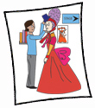 |  | - Book Week Costumes! A Classic Tale or Modern One?  - Who is this character?  - Much Ado about Costume WebQuest | Primary Middle  Secondary
LOTJ - Orry Kelly  Costume Designer |  | - Create an elegant dress  - Create an Inspiration Board | Primary  Secondary
UMPIRE |  | - AFL – Activities in the Umpire’s Manual  - Old Game, New Rules  - Old Game, New Rules: A Quiz  - Websites: Umpire Decision Game; BBC’s Interactive Umpire; You are the Ref App; You are the Umpire App | Secondary  Primary Middle  , , All
LOTJ – Glenn James  Umpire |  | - Create a Slideshow to go with the recording of the Umpire’s Song  - Create a new Umpire Football Card featuring Glenn James | Primary Middle  Secondary

