On the Job: Careers Market

Category: Government & Defence

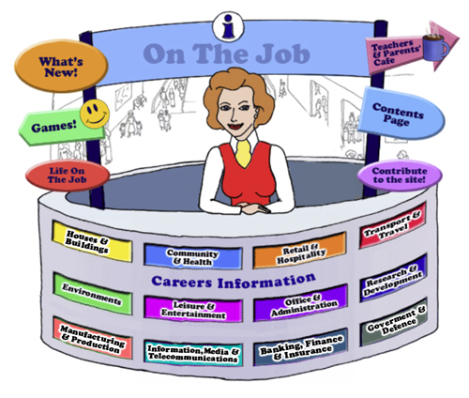

Teachers
Introduction
Welcome to this website about “work” for Australian students in school years (Years 5 - 12).
The Design concept is based on the local Shopping Mall as students of this age are familiar with the Careers represented here. This initial concept broadened to include careers that they might have encountered outside the Shopping Mall eg. Local Government Inspector or Farmer.
Each job can be used as an individual activity for students or as a whole group.
This Teacher’s Guide is for the whole class and is aligned to the Australian Curriculum and the General Capabilities.
The Jobs
Each of the jobs listed has three sections
- The Information about each Job. | - Activities | - Links

All content in the Job Info sections have been taken from Australian sites:
- The Job Guide (old website);
- Jobs & Skills WA;
- JobOutlook (Australian Government) – discontinued 2022 and replaced with Your Career;
- CareersOnline;
- CareerHQ;
- Good Universities Guide;
- Open Universities;
- My Big Tomorrow;
- Careerfaqs;
- On the Wards
- Rural Careers

And, to a lesser extent - Overseas sites
- CareerAddict (Irish)
- JobHero
- Study
- State University
- Careers in Music;
- Upskilled.

Under copyright laws and from the Job Guide’s website – this information can be used for Educational purposes. Each information page acknowledges where the information has been obtained at the end of the page.
Images that have been obtained from the Internet are acknowledged. Some images are copyright free and some have been obtained from royalty free sites and are acknowledged.
This “Job Info” content also encourages reading and therefore literacy but breaks down information into chunks and divided by “Did You Know?” segments that hopefully students will find interesting.
The Activities can be divided into two sections:
- Offline
- Online

Each activity or task is targeted to these age groups
- Primary School is for students from Years 5 – 6
- Middle School is for students from Years 7 – 8
- High School is for students from Years 9 - 12
Teachers can always look at the activities and allocate differently to students depending on their ability or interest.
The activities bring a fun element into learning. Sometimes there are practical skills about the particular job eg. “How to build a beehive” [in the Beekeepers section]. This is regarded as an Offline activity.
The Online activities include research or critical thinking skill activities using Internet resources. There are also free mobile apps, YouTube Videos, games. These activities provide students with Problem-Based Learning and the opportunity to use their Higher Order Thinking and Collaboration Skills.
There is also a focus on Mathematical and ICT activities.
The Links provide students with access to Association websites for that particular Industry as well as links to examples of people within this job and their experiences.
“Life on the Job”is a section where a person on a particular job is explored. There is information about this person, links, videos and activities.
Life on the Job is divided into three sections:
- Historic or Famous People – mostly Australians | - Indigenous Historic or Famous People | - “Real Life People”
Historic or Famous People
Historic or Famous People are mostly famous Australians whose lives are usually investigated within the Australian Curriculum. Each person is researched and their lives summarised to give students an overview. There are links provided so students can investigate more fully themselves. At the end of the content information, students are given an activity to complete – mostly using the latest and free ICT tools available to increase their knowledge and capability.
Indigenous Historic or Famous People
Indigenous Historic or Famous People are famous Australians whose lives are usually investigated within the Australian Curriculum. Each person is researched and their lives summarised to give students an overview. There are links provided so students can investigate more fully themselves. At the end of the content information, students are given an activity to complete – mostly using the latest and free ICT tools available to increase their knowledge and capability.
Real People’s Stories – or Ordinary Australian Stories.
Ordinary [or even extraordinary] Australian stories are provided here. Parents can submit their job and show students their educational journey to achieve employment within their job category. Again, there are links and activities to complete.

Alignment with the Australian Curriculum
Curriculum Area: Australian Curriculum: General Capabilities
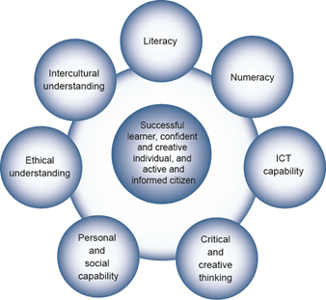

The Australian Curriculum includes seven general capabilities:
- Literacy
- Numeracy
- Information and communication technology (ICT) capability
- Critical and creative thinking
- Personal and social capability
- Ethical understanding
- Intercultural understanding.
(Source: Australian Curriculum)
Literacy involves students in listening to, reading, viewing, speaking, writing and creating oral, print, visual and digital texts, and using and modifying language for different purposes in a range of contexts.
Numeracy involves students in recognising and understanding the role of mathematics in the world and having the dispositions and capacities to use mathematical knowledge and skills purposefully.
Information and communication technologies are fast and automated, interactive and multimodal, and they support the rapid communication and representation of knowledge to many audiences and its adaptation in different contexts. They transform the ways that students think and learn and give them greater control over how, where and when they learn.
Critical and creative thinking are integral to activities that require students to think broadly and deeply using skills, behaviours and dispositions such as reason, logic, resourcefulness, imagination and innovation in all learning areas at school and in their lives beyond school.
Students develop personal and social capability as they learn to understand themselves and others, and manage their relationships, lives, work and learning more effectively. The capability involves students in a range of practices including recognising and regulating emotions, developing empathy for others and understanding relationships, establishing and building positive relationships, making responsible decisions, working effectively in teams, handling challenging situations constructively and developing leadership skills.
Ethical understanding involves students in building a strong personal and socially oriented ethical outlook that helps them to manage context, conflict and uncertainty, and to develop an awareness of the influence that their values and behaviour have on others.
As cultural, social, environmental and technological changes transform the world, the demands placed on learners and education systems are changing. Technologies bring local and distant communities into classrooms, exposing students to knowledge and global concerns as never before. Complex issues require responses that take account of ethical considerations such as human rights and responsibilities, animal rights, environmental issues and global justice.
Building ethical understanding throughout all stages of schooling will assist students to engage with the more complex issues that they are likely to encounter in the future, and to navigate a world of competing values, rights, interests and norms.
Intercultural understanding: The capability involves students in learning about and engaging with diverse cultures in ways that recognise commonalities and differences, create connections with others and cultivate mutual respect. (Source: Australian Curriculum)
Priorities:
Asia and Australia's engagement with Asia
Aboriginal and Torres Strait Islander histories and cultures
Sustainability

An additional Icons:

Philosophy in Schools.
This icon represents both Critical and Creative Thinking and Ethical Understanding but at a deeper level. The activities with this icon show a high level of complex thinking is required. The activity can be used with classes undertaking Philosophy in Schools or those schools or classes who wish to encourage higher order thinking.
Cooperative Learning Activity
A collaborative (or cooperative) learning approach involves students working together on activities or learning tasks in a group small enough for everyone to participate on a collective task that has been clearly assigned. Students in the group may work on separate tasks contributing to a common overall outcome, or work together on a shared task.

Emerging Job
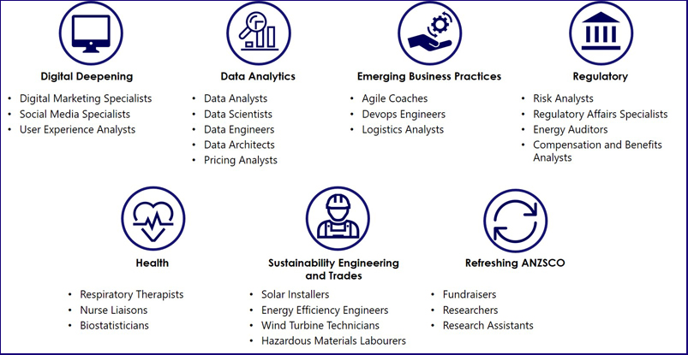
The jobs listed above are emerging jobs identified by the National Skills Commission.
Emerging occupations are defined as new, frequently advertised jobs which are substantially different to occupations already defined in the Australian and New Zealand Standard Classification of Occupations (ANZSCO) – such as data scientist and data analyst. As such, to compile our list we considered data from the time period following the last ANZSCO review in 2013.
The NSC has identified and validated 25 emerging occupations within seven categories in the Australian labour market (Figure 1). This list is not considered exhaustive, and the NSC will continue to monitor and analyse emerging trends.
An advantage of our approach is access to real time internet job advertisement data using Burning Glass Technologies, which will allow us to pick up occupations in emerging fields like blockchain, nanotechnology, quantum computing and the internet of things as soon as the employer demand for these skills increases.
https://www.nationalskillscommission.gov.au/what-are-emerging-occupations

Life On the Job – Australian Curriculum General Capabilities Alignment with Activities
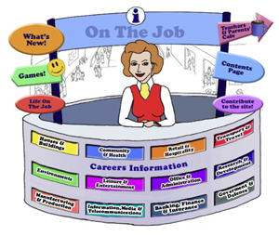
All of the activities in “Life On the Job” have also been aligned with the Australian Curriculum’s General Capabilities. They are meant to be fun and engaging for the student and introduce them to the world of work in a more concrete way. “On the Job” builds on what students have learnt in their earlier years in Primary School about the world of work and helps students go from the concrete to the abstract in their thinking.
Each activity shows the General Capability [GC] being focussed on by showing the GC icon and any Priorities.
Future Growth
Each job is given a Future Growth icon: either Decline; Static; Moderate; Strong or Very Strong growth. These icons were created by On the Job.
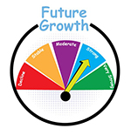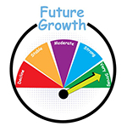
The information has been obtained from the Australian Government website: Labour Market Insights. https://labourmarketinsights.gov.au/
Government & Defence
Job |  | Activity | Target Group
AIR FORCE OFFICER  Air Combat Officer  Air Force – General Entrant  Air Force Technician/Tradesperson |  | - What do the elements on the RAAF badge mean?  - Take Flight (from Try Engineering)  - Playing with Parachutes (from Try Engineering)  - Websites, Games & Apps: NASA Aeroresearch K-12 Resources; Introduction to Flight
ANIMAL CONTROL OFFICER |  | - A Day in the Life on an Animal Control Officer  - Lady and The Tramp: Then and Now  - Alongside roads & rubbish, animal management is a key function of local government | Primary Middle  Middle Secondary
ARMY OFFICER |  | - Create your own obstacle course  - Tactical Operations  - War Debate | , , All  , , All  , , All
LOTJ – Sir John Monash – Engineer, Lawyer, Vice-Chancellor, Army Officer |  | - Letter Home: On the Eve of Gallipoli  - Becoming Historians  - Creating Secondary Sources | Primary Middle  , ,
LOTJ - Captain Reg Saunders – Army Officer |  | - Discrimination involved?
BIOSECURITY OFFICER  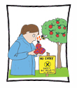 |  | - Bee Patrol  1. Bee Control  - Chestnut Industry & Fungus  - Bananas and Biosecurity  - Insect Species & Biosecurity  - Australiasect | , , All  Secondary
BORDER FORCE OFFICER |  | - Be a part of Border Force by helping raise a Detector Dog or look after an aged Detector Dog!  - Change it up – Concentration  - Worth a thousand words – how photos shape attitudes to refugees | Primary Middle  , , All  Secondary
BUILDING INSPECTOR  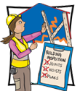 |  | - Flammable Cladding – what’s the score  Just a Minute: The Building Inspector | , , All
COMMUNITY CORRECTIONS OFFICER  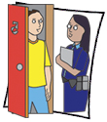 |  | - Compare and contrast: what is your opinion? How would you act? | Secondary
CORONER |  | - Coroner calls for compulsory primary school swimming lessons following beach tragedy: What notice should be taken?  - Inquest Reports: the hidden costs | Primary Middle  Secondary
DIPLOMATIC SERVICE OFFICER  Ambassador |  | - The Power of “soft” Diplomacy  - How to build a career in foreign relations - a Research Assignment  - The Pope and Diplomatic Power: Hard Quiz | , , All  Secondary
LOTJ – H.E Peter Heyward  Ambassador |  | - Australian Ambassadors | , , All
ELECTORATE OFFICER  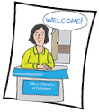 |  | - Write a media release: the greening of our school  - What’s your opinion: The Foreign ownership of Australian property  - Cast Your Vote | , , All
EMERGENCY DISASTER PLANNER |  | - A Fire Survival Kit – A Fire Safety Budgeting Unit [6 – 8 lessons]  - Your Emergency Plan  - Emergency Recovery Lessons (developed by Australian Red Cross) | , , All
FISHERIES OFFICER |  | - Minimum Requirements  - Fish n Kids  - Bycatch – How can you get Australians to eat it? | Primary Middle  Primary Middle  Secondary
HARBOUR MASTER |  | - Who are the current Harbour Masters in Australia?  - The Harbor-Master: A Classic Horror Story: A Sequel: On the Shoulders of Giants | Primary  Secondary
INTELLIGENCE ANALYST  Intelligence Officer  Surveillance Officer |  | - Change it up  - Making and Using a Scytale  - The Petrov Affair – Rich Task & WebQuest  - Today’s Espionage in Australia: Analyse #TC  - Websites, Games & Apps: Spot the difference; Spot It App | , , All  , , All
LOCAL GOVERNMENT INSPECTOR  Compliance Officer (Local Government)  Parking Inspector  Swimming Pool & Spa Inspector  Waste & Compliance Environmental Officer |  | - The Parking Meter and The Beatles!  - Mr Bean – Parking  - Deposit Schemes: What is involved?  - Websites, Games & Apps: Park Patrol and Ethics; Car Parking Games (2); Parking Mania Lite App | Primary Middle  , , All
METEOROLOGIST |  | - Build your own weather station  - Aboriginal Meteorologists – What can we learn from this extensive Indigenous knowledge?  - Websites & Games: NASA – Wild Weather Adventure; Weather WizKids; Trivia Questions; The Weather Channel;  - The Science of Bushfires WebQuest  - The Last Lighthouse Keeper WebQuest | , , All  , , All  Middle
NAVY OFFICER / NAVY SAILOR |  | - Australian “Battleship”  - Treasure Hunting vs Underwater Cultural Heritage vs Future Green Energy Projects: what's your take?  - Knots and Knots: What Sailors ought to know!  - Telescoping Periscope (from Try Engineering)  - Mental Mathematics for Maritime Warfare Officers, Pilots, & Aviation Warfare Officers  - Navy Cadets: STEM Activities (CSIRO Bebras Challenge) | Primary Middle  Primary Middle  , , All  , , All
LOTJ – Navy Officer  Capt. Mona Shindy |  | - Tweets & Government Employees: Why is it not allowed? A Community of Inquiry | , , All
PARK RANGER  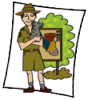 |  | - Ranger Smith in Australia!  - An episode for Landline: The Work of Indigenous Land and See Rangers  - WebQuest: Mununja the Butterfly  - Conflict Yellowstone Wolves WebQuest (Web Archive)  - Wolves of Yellowston WebQuest  - Websites, Games & Apps: Ranger Roo | Primary  Primary  Middle  Middle  Primary
PARLIMENTARIAN  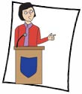 |  | - Excursion to Canberra  Website: Parliamentary Education Office – Role Play Program;  - Your Own Classroom Electorate  - Debate  - Political Cartoons Australia  - Websites, Games & Apps: Debate Game for Kids; UK – Parliament Game; Debate [Online Worksheet] | Primary  , , All  , , All  Secondary  Primary
LOTJ – Neville Bonner – Senator |  | - Create a Slide Show using PowToon | , , All
Peter Lalor, Leader of the Eureka Stockade and Victorian Parliamentarian |  | - BTN and Eureka Stockade Activities  - Eureka Stockade: Let’s Draw from Song, Story and Poetry  - Tax Revolt or a Fight for Democracy? | Primary  , , All  Secondary
LOTJ – Nova Peris – Senator |  | - Create a Story about Nova Peris using Storify  - Black Lives Matter | , , All
LOTJ – Edward Gough Whitlam – Prime Minister |  | - Indoor Plumbing  - Whitlam changed Australia's view of itself: Can you follow in his footsteps? | , , All  , , All
PATENTS EXAMINER  Intellectual Property Lawyer  Patents Attorney |  | - Biomimicry in Engineering (developed by Try Engineering)  - Dispenser Designs (developed by Try Engineering)  - How Russia is using intellectual property as a war tactic. Community of Inquiry #TC | , , All  , , All
LOTJ – Laura Smith-Hewitt  Patent Examiner |  | - You can be the Examiner! Carry out a SWOT Analysis | , , All
POLICE OFFICER |  | - Maths on Patrol  - Police Report  - Facial Recognition Technology: What do you know?  - Websites, Games & Apps: Detective Game – OTJ; Police Games; CSI Web Adventure; Who Dunnit?; CSI Hat Snatcher; CSI Tugboat Thug; CSI Squeak Sneak; CSI Mind Prison; Enquiring Minds  - Crime Prevention WebQuest | Primary  , , All
LOTJ – Senior Sergeant Tim Hardiman |  | - Neighbourhood Watch  - Police Action Role Play | Primary Middle
LOTJ – Sergeant Lillian Armfield – Australia’s first female detective |  | - Ruth Park: The Harp in the South/ Poor Man’s Orange: How much have things changed for Women?  - Issues of Gender – A Community of Inquiry | Secondary  Secondary
POSTAL WORKER  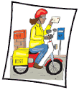 |  | - Postie for a Day  - Time to Deliver! It’s all about Numbers  - Post Office Numeracy: Research  - Learn Photoshop: How to Create a Postage Stamp using the 90th Birthday as inspiration!  - Websites: Stamp Collecting;  Stamp Arena; The Young Collector; The Post Office Game;  - Stamps: Mirrors of Australia WebQuest | Primary  Primary  Primary Middle  , , All  Primary Middle
PRISON OFFICER  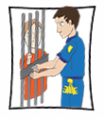 |  | - Prisons on Film: Australian Stories  - Cooma Prison: a creative response | Secondary  Secondary
PUBLIC SERVANT |  | - Help the Commonwealth Public Service? How?  - What can you do for your school?  - Public Service – Public Speaking  - Between Two Worlds WebQuest: An Australian Perspective Re-write | , , All  Primary
LOTJ – Charles Perkins  Public Servant |  | - How is Charles Perkins portrayed?  - Riding for Freedom: the campaign for civil rights for Indigenous Australians - WebQuest | , , All
LOTJ – Ken Wilkinson  Public Servant |  | - Social Justice – what can you do as a “Public Servant” at your school? | , , All
RAILWAY INFRASTRUCTURE WORKER |  | - Some new Australian Thomas the Tank Engine Characters  - What do you know about the innovations of rail travel? A Research Project #TC | Primary Middle
ROAD WORKER  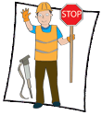 |  | - Top Gear: Road Works | Secondary
TOURIST INFORMATION OFFICER  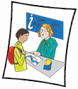  Tour or Tourist Guide |  | - Medical and Dental Tourism: Is it something you would consider?  - Do we REALLY have to go on holidays? | Secondary
TRANSPORT SERVICES OFFICER |  | - The Railway Children – A Review  - On Trial: “Teen arrested after spitting at Train Guard” | Primary
URBAN AND REGIONAL PLANNER |  | - “Where Things are From Near to Far” – A Review  - Make a Town  - What makes a city tick? Designing the ‘urban DMA’  - Trigonometric Trajectories & Glider Poles  - RMIT: Centre for Urban Research: A Research Project  - Website: ABC Splash: Urbanisation  - Global Warming WebQuest | Primary  Secondary  Secondary  Secondary  , , All
LOTJ – Walter Burley Griffin; Urban and Regional Planner  Town Planner |  | - Creating a Walter Burley Griffin Memorial | , , All
WEIGHTS & MEASURES INSPECTOR  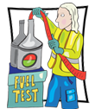 |  | - A Question of Balance (Created by TryEngineering)  - A re-run of NMI’s Harvest to Home trade measurement inspection campaign – Secret Shopper | , , All
WORKPLACE HEALTH & SAFETY OFFICER |  | - Creating a “Thank God You’re Here” TV Show  - Stick or Carrot? Which is better? | , , All

