Understanding Job Categories
https://www.onthejob.education/info.htm

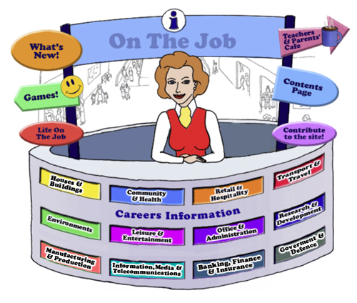
Student Notes
There are many ways to categorise the labour force. The classification adhered to in On the Job website has been chosen to broadly cover each job.
This classification is arbitrary (or random choice!)
Another classification would be just as good or even better.
Sometimes it is difficult to allocate a job to one particular classification. For example, the Chemical Engineer – could be in Research & Development or in Environments. We have selected Environments as the classification category to be consistent with the classification category in which Civil Engineer, the Petroleum Engineer, and, the Mining Engineer appear.
Each job has been allocated to one of the 12 classification categories as seen on the Information Desk:

There are also 7 “Type of Work” Categories allocated by the Australian Government which we have adhered to as well to show the students the type of work required by each job.
On this page, you will be able to see the information about each Type of Work category: https://www.onthejob.education/categories_Index.htm

Artistic or Creative | Clerical or Organising  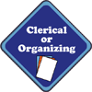
Helping or Advising | Nature or Recreation
Practical or Mechanical | Scientific or Analytical  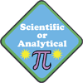
Service or Persuading
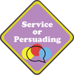

What’s in a Category?
Australian Curriculum General Capability: Numeracy
- You or your group (2 – 3 students) will be given one of the 12 classification categories from “On the Job” by your teacher:
- With the A3 sheet of paper provided, brainstorm and then list as many jobs within your assigned category [before looking at On the Job website].
- List as many jobs as possible.
- With another group view each other’s list. Get the second group to add, if possible, to the first group’s list.
- When you have exhausted your collection of jobs, you can look at the Information Desk at the Careers Mall at On the Job [https://www.onthejob.education/info.htm ] to investigate the categories listed here.
You should now have 3 lists:
- The list of the jobs you thought would be in your category.
- The list from the second group who had different or more jobs to add to this category
- A third list of the actual jobs from On the Job website.
Are there any differences?
With the 3 lists, create a Venn Diagram using Venn Diagram Maker.
https://www.lucidchart.com/pages/examples/venn_diagram_maker

Create a Mural
You are to have a look at the murals within On the Job – there are 7 different murals. You can find them on all activity pages. Go to Select one with a partner to examine more thoroughly.
2. List all the jobs within your selected mural.
3. Categorise each job shown into one of the 12 classification categories.

- Are any categories represented more than others? Male/Female ratio? Is it balanced? Ethnicity – is this covered? Are there any jobs shown twice? Has the Scientist cartoon changed?
- Go to each job and write up the “type of job” categories (see below) for each job within one mural. Are the 7 Type of Job Categories well represented? Is there any imbalances?

6. Create a Bar Graph to show the differences using– Online Bar Graph Maker
https://nces.ed.gov/nceskids/graphing/classic/bar_pie_data.asp?ChartType=bar

EXTENSION:
7. On a large sheet of paper, create a mural that captures your classification category and draw those jobs that are not included in any of the murals.
Include fine detail in your artwork.
When all illustrations are complete you could:
- Display them around the classroom. Were there any interesting jobs you would like to investigate further?
- Scan each mural and send as a jpeg file (no bigger than 600 x 500 pixels) to Frances.Moore@onthejob.education
You might see your mural up on the website!

Scientists use dichotomous keys to classify.
Using the Dichotomous Key
A dichotomous key is a sequence of steps that allows the identification of an object or living thing. The key consists of a series of choices that lead the user to the correct name of the given item. The term dichotomous means that there will always be two choices in each step of the key until the object is correctly identified.
Here is an example of a dichotomous key showing how different leaves could be identified with a simple Yes/No Question.

Discover which birds are which…
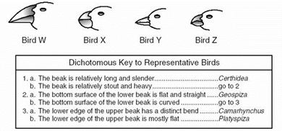
Answers: Fill in what you think is the Scientific name for the bird
Bird W

Bird X
Bird Y

Bird Z

Create a Dichotomous Key
You are to make up Yes/No Questions to divide the following garden tools according to their use:
Axe; Broom; Fork; Hose; Leaf Rake; Rake; Secateurs; Shears; Spade; Shovel; Trowel; Watering can; Wheelbarrow
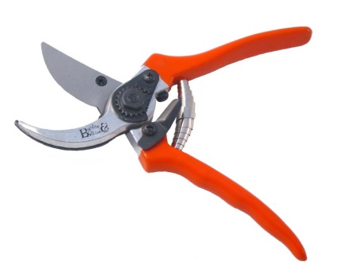 | 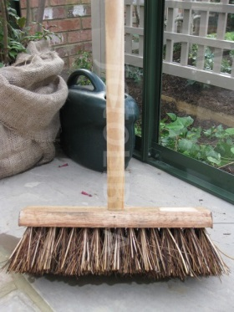 | 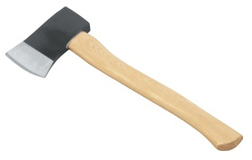  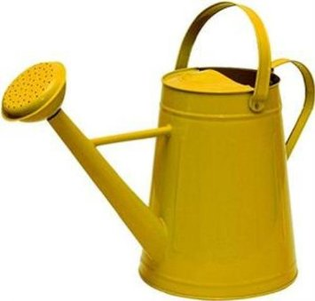 | 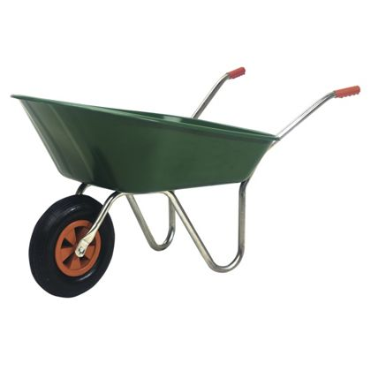
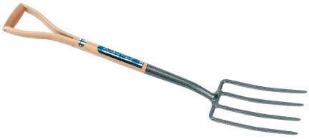 | 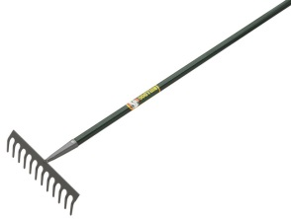 | 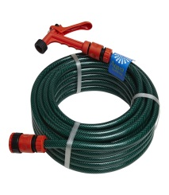 | 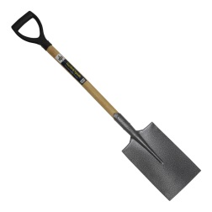
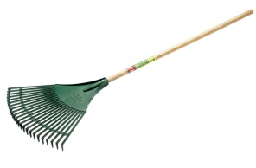 | 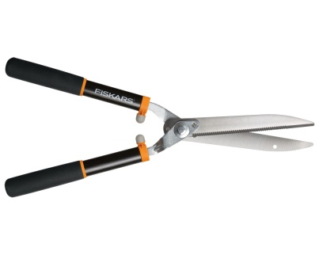 | 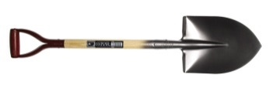 | 