Exploring “On the Job”
Teacher’s Guide:
One - Three Lessons
https://www.onthejob.education/index.htm
This lesson requires students to explore the whole website by investigating the 8 categories that “On the Job” is based on:

Teacher’s Notes:
The website: https://www.onthejob.education/index.htm is a free eLearning resource exploring careers for students from Years 5 – 12. This lesson is directed at students in Years 5 – 8.

Australian Curriculum: General Capabilities covered:
Literacy involves students in listening to, reading, viewing, speaking, writing and creating oral, print, visual and digital texts, and using and modifying language for different purposes in a range of contexts.

There is a PowerPoint Presentation included in this lesson. Go to the PPT and show it to the students so they have a better idea about how to explore this website.
Leisure & Entertainment and then the Actor is highlighted.

Student Worksheet: “Exploring On the Job”
- Log onto https://www.onthejob.education/index.htm

- You are to explore the website and fill in the information required on this worksheet.

If you find any errors, please report to Frances Moore: Frances.Moore@onthejob.education

Go to Work Around the House – the Yellow Section on the Information Desk.
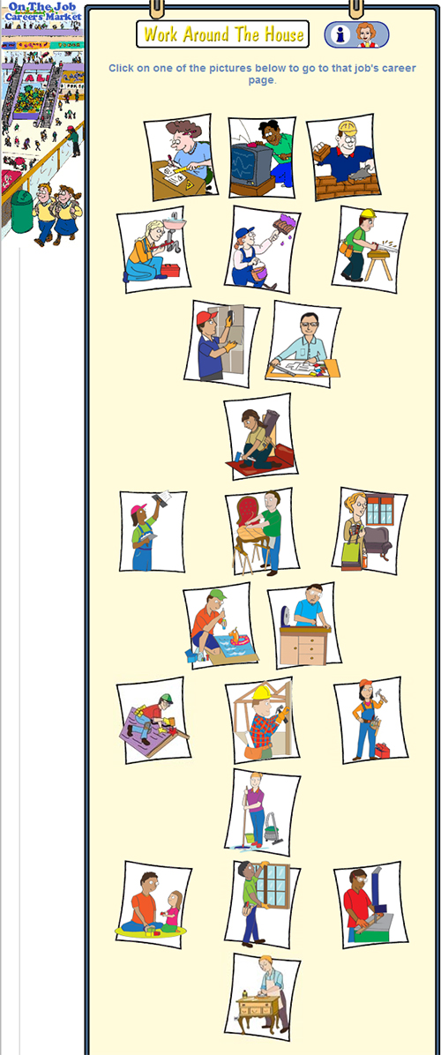
List all the New Jobs compared to this image opposite.

- _____________________________ 6. __________________________
- _____________________________ 7. __________________________
- _____________________________ 8.___________________________
- ______________________________ 9. ___________________________
- ______________________________ 11.___________________________
Hover over the new images and the name of the job will appear.
Go now to the Blue Section – Community and Health.
Go to the FireFighter.
Look at the Information presented there.
Click on the Activities Button on the Left Hand Side. List the Activities.

Go to the Links – name the Links present.

Name of Person described in “Life on the Job”? Blazing the Trail….__________________________
What is special about this person_____________________________________________________
________________________________________________________________________________

Go to the Orange Section on the Information Desk – Retail and Hospitality.
What other jobs do you think should be listed here? Why?
- _________________________ 5._________________________
- _________________________ 6. ________________________
- _________________________ 7. ________________________
- _________________________ 8. ________________________
What jobs that are listed here would interest you? Why?

Go to the Red Section – Transport and Travel.
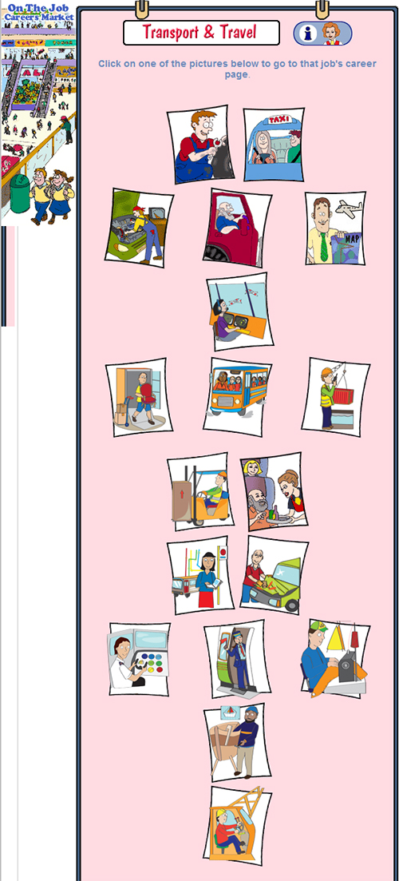
How many new jobs are there compared to this image? List them

- _________________________ 5._________________________
- _________________________ 6. ________________________
- _________________________ 7. ________________________
- _________________________ 8. ________________________
Which job is the most exciting to you? Why? _______________________________

_________________________________________________________________________________
Go to the Green Section of the Information Desk – Environments.
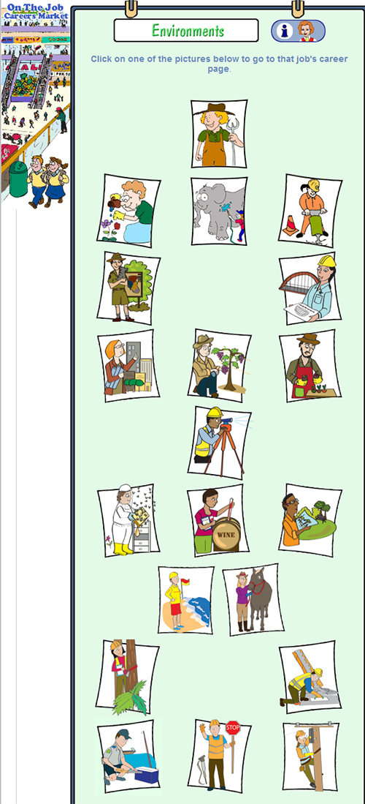
Name 5 more Jobs that where cut off from this image that might interest you:
- ________________________________
- ________________________________
- _______________________________
- _______________________________
- _______________________________
Have a look at ONE job from this list. Why did you choose this job?

Are there any ACTIVITIES you would like to do? Why

Go to the Pink Section – Leisure and Entertainment.
Go to the Journalist and click on LINKS. Then click on Heywire. Look under “Winners”. Read a story of your choice.
Give reasons why this story struck you.
_________________________________________________________________________________
_________________________________________________________________________________

Go to the Light Purple – Office & Administration.
Go to the Archivist. What does an Archivist do?
Write down 5 words to describe this job:
1. ________________________________________________
2. ________________________________________________
3.________________________________________________
4._________________________________________________
5._________________________________________________

Go to the Deep Purple Section – Research and Development.
Go to the Entomologist.
Click on the Links to see a funny page about “Beyonce is a fly… but why?”
What insect is named after Beyonce?
____________________________________________________________________

Go to the Information Desk and click on Life on the Job.
Go to the Indigenous Famous People’s Stories and select one from the list to read and do an Activity.
What did you learn about this person?

What Historic or Famous Indigenous people do you think should be here? Why?
________________________________________________________________________________

Go to the Information Desk and click on Games.
Play the game “Hangman” to find a clue to work out “who dunne it” for each Mystery. You need to write down all the clues as you discover them.
Now it is time to EXPLORE the whole website…

