Science Classification – Taxonomy
Here is a range of activities around the subject of Classification for students from Years 5 – 12.
The activities are largely based on Reasoning Skills to promote Critical and Creative Thinking. One activity was adapted from a Philosophy activity developed by Associate Professor Phil Cam.

Teacher’s Guide + Worksheets + Answers [at back]

Index of Activities
Activity | Lesson Length | Target Group/  ACGC | Description of Activity
A. Talk to the Animals [Word doc] | 1 - 2 Lessons | P | Identify animals you know  Look at the video of "Talk to the Animals". Identify the animals listed in the song. Classify them.  Write another verse to the song
B. Reasoning: Which Animal belongs to which Group [Word doc] | 1 Lesson | P | Students are provided with a set of animals that need to be put into groups. Students need to be able to explain why the animals are in their groups.
C. Research into Taxonomy [Word doc] | 1 - 3 Lessons | M, H | Read an article. Look at a video.  Divide each group so each student reads one article and then use the Jigsaw strategy.  Mind map what was learnt
D. Classification of a Creature [Word doc] | 1 - 3 Lessons | P, M, H | Using the classification of a human, a cat, a peacock and a komodo dragon: classify a creature providing reasons for this classification. The Hobbit – The Desolation of Smaug. Introduce this creature into this story.
E. Cladogram [Word doc] Minion Cladogram [PDF] | 2 Lessons | M, H | Look at video on cladogram; and;  using minions 23mins. Practice creating a cladogram
F. Dichotomous Keys [Word doc] | 1 - 2 Lessons | M, H | An example of a dichotomous key  Using a dichotomous key with smiley faces. Create a dichotomous key with garden equipment

Classification Activity 1: The Animal Kingdom: “Talk to the Animals”
Primary
Australian Curriculum General Capability: Critical and creative thinking
Australian Curriculum General Capability: Literacy

For taxonomists [scientist who classify organisms], days often start – and sometimes end – with the question: what’s that?
What do you already know about animals?
Talk over with the person beside you.
Fill out the following table: List 10 animals you can think of and compare with a partner.

Animal Name | Animal Name

Song: Talk to the Animals
Look at the following video from Doctor Dolittle and the song “Talk to the animals”.
https://youtu.be/YpBPavEDQCk
The following lyrics for the Academy Award song: “Talk to the Animals” is written here below. Highlight the names of the animals in the song.
Song: Talk to the Animals

…If I could talk to the animals, just imagine it
Chattin' with a chimp in chimpanzee
Imagine talking to a tiger, chatting with a cheetah
What a neat achievement that would be!
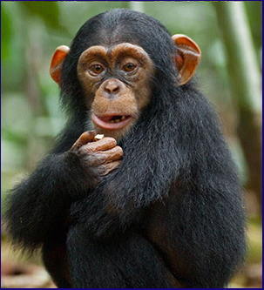
If we could talk to the animals, learn their languages
Maybe take an animal degree
I'd study elephant and eagle, buffalo and beagle
Alligator, guinea pig, and flea!
I would converse in polar bear and python
And I would curse in fluent kangaroo
If people ask me, "Can you speak rhinoceros?"
I'd say, "Of courserous! Can't you?"
If I conferred with our furry friends, man to animal
Think of the amazing repartee
If I could walk with the animals, talk with the animals
Grunt and squeak and squawk with the animals
And they could talk to me!
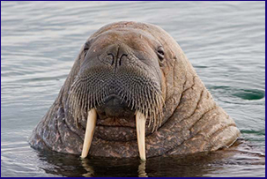
If I consulted with quadrupeds
Think what fun we'd have asking over crocodiles for tea
Or maybe lunch with two or three lions, walruses and sea lions
What a lovely place the world would be
If I spoke slang to an orangutan
The advantages why any fool on earth could plainly see
Discussing Eastern art and dramas with intellectual llamas
That's a big step forward you'll agree
I'd learn to speak in antelope and turtle
And my Pekingese would be extremely good
If I were asked to sing in hippopotamus
I'd say, "Whynotamous? and would!
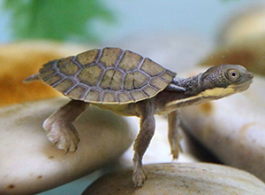
If I could parlay with pachyderms
It's a fairy tale worthy of Hans Anderson or Grimm
A man who walks with the animals and talks with the animals
Grunts and squeaks and squawks with the animals
And they could talk to him [This is the most exciting thing that has ever happened to me. I can’t wait to start. It’s incredible. It’s impossible. But it’s true.]
A man can talk to the animals. It’s a miracle. In a year from now I guarantee
I will be the marvel of the mammals
Play chess with camels
No more just a boring old MD
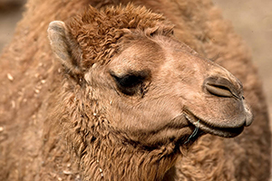
I'd study every creature's language
So I could speak to all of them on sight
If friends said, "Can he talk in crab or maybe pelican?"
You'd say, "Like hell he can and you'd be right"
Yes if you just stop and think of it ain't no doubt of it
I'm gonna win a place in history
If I could walk with the animals talk with the animals
Grunt, squeak, squawk with the animals
And they could squeak and squawk and speak and talk to me.

Put the animals listed in the song into the following categories:
Mammals | Birds | Insects | Crustaceans | Reptiles

Analysing the song: Think about the following facts:
- Mammals, Birds and Reptiles are vertebrates. They have a backbone.
- Insects and Crustaceans are invertebrates. They have an exoskeleton.
- Insects: are the most diverse group of animals on the planet including more than a million describes species and representing more than half of all known living organisms.
- Are any domestic animals in the song? Why/Why not?
- Does the song “Talk to the animals” really show the expanse of the Animal Kingdom? Explain.
- Write another verse – this time introducing 5 more animals one from mammals; birds; insects; crustaceans; and, reptiles.

Classification Activity 2: Reasoning: Which animal belongs to which group? Explain. (Adapted from Associate Professor Phil Cam)
Primary; Australian Curriculum General Capability: Critical and creative thinking; Philosophy
In small groups of 3 – 4, order the animals into GROUPS.
You can have as many groups as you like, BUT, one animal by itself is not a group. Also, you don’t want any animals being in a group where they don’t belong!
You need to have good reasons for placing your animals in these groups. You will need to explain why the animals are grouped and use the word “because”.
Each group will explain their groupings. These are all animals found in Australia or Australian Territories and depicted on stamps.
There are 3 activities that increase in difficulty.
Activity A
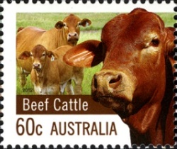 | 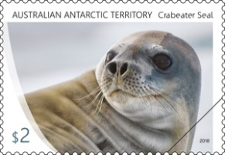 | 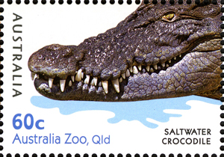
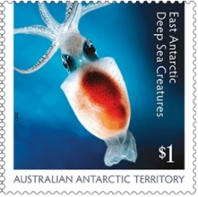 | 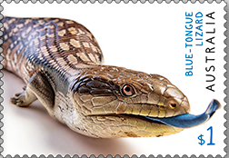 | 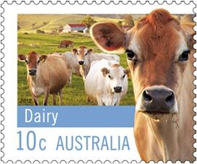
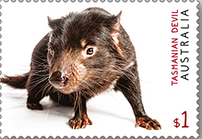 | 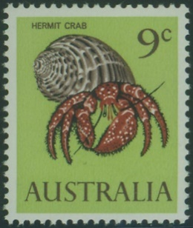 | 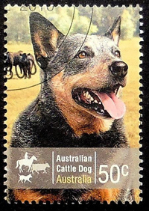

Activity B
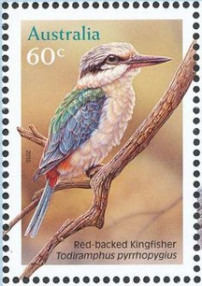 | 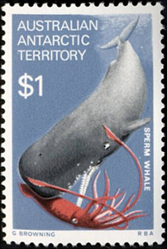 | 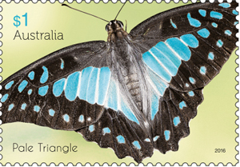
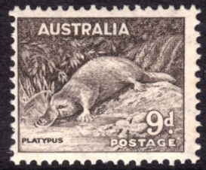 | 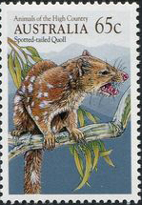 | 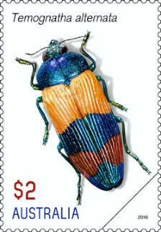
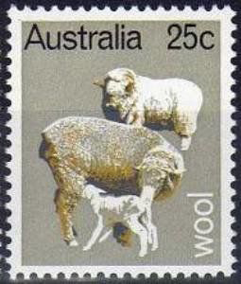 | 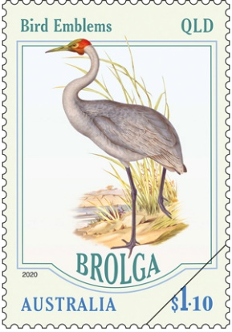 | 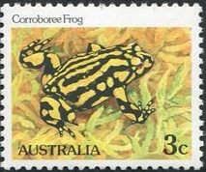
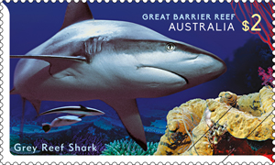 | 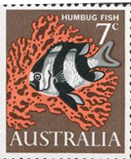 | 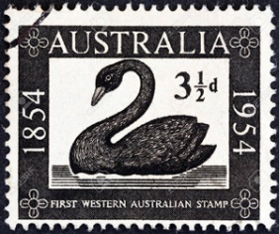

Activity C
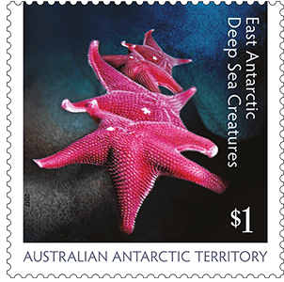 | 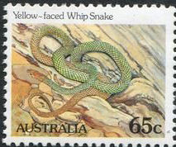 | 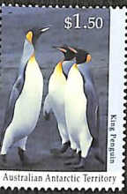
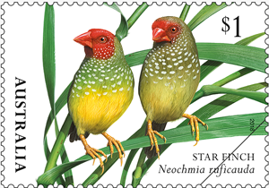 | 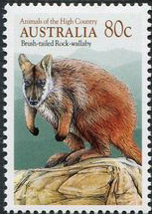 | 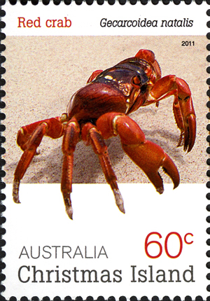
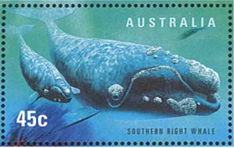 | 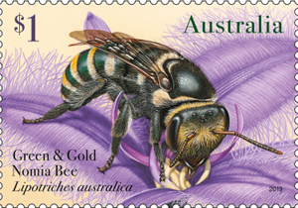 | 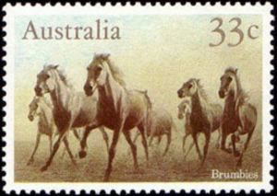
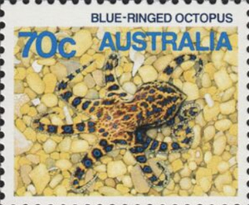 | 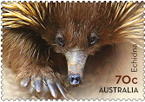 | 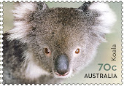
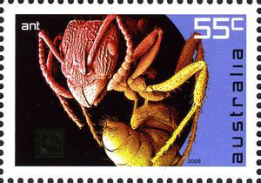 | 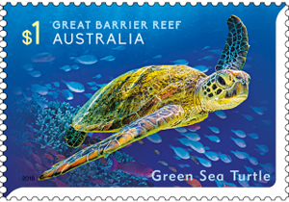 | 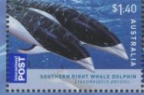

Classification Activity 3: Research into Taxonomy
- Middle Secondary
Australian Curriculum General Capability: Literacy
Australian Curriculum General Capability: Critical and creative thinking
Introduction
In groups of 3 – 4 students, read the following article from The Conversation
20 November 2012 and look at the videos. https://theconversation.com/explainer-what-is-biological-classification-10691 Note down any interesting points and questions relating to classification.
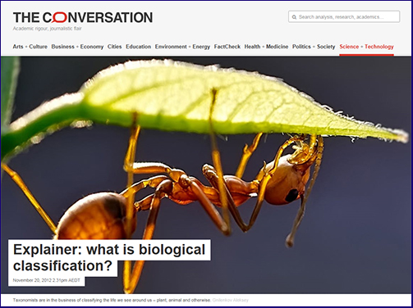
What did I know?
What do I now know?
What was interesting?
Using your notes and questions, look and compare them to the notes below.
Some points of interest
The "job of assigning species into a biological classification is the science of taxonomy – sometimes also called systematics.
In the biological sciences, taxonomy has been the bedrock of our work for over
250 years. In 1758, Carolus Linnaeus, the Swedish naturalist and founder of biological classification, published his 10th edition of the Systema Naturae.
This book of names is the commencement date for classification. No names before this date count today.
Just as many of us have double-barrel names, so too do species, with each composed of a genus name followed by a species name.
For humans, Homo is our genus and sapiens our species. This is called binomial nomenclature – or two-part naming – and it has proven to be one of the more enduring information systems developed in recent centuries.
Biological classifications are based on recovering the relationships between species, so the species most closely related share attributes (e.g. physical features, behaviour, DNA) that have been inherited from a common ancestor.
It may seem that the taxonomic task is straightforward. But this is far from the truth.
Take for example the position of insects in the Tree of Life. For much of the second half of the 20th century they were considered most closely related to the centipedes and their relatives (myriapods).
Being land-adapted groups, they both possess a tubelike “respiratory” system, which was long held to be the ultimate indicator of their close relationship. This close relationship between insects and myriapods was long held to be bomb-proof. New evidence from eye and brain anatomy and DNA sequences has, however, been combined to show insects are in fact close relative of prawns and their allies (that is, crustaceans).”
Learn this order by heart: Do Koalas Prefer Chocolate Or
Fruit Generally Speaking
Look at the following video: An introduction to: Taxonomy (5.47)https://youtu.be/NRVJyUZoQow

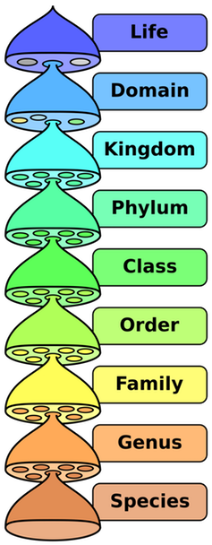

Six Kingdom System
Animal Kingdom – eukaryotic, multicellular, heterotrophs, no cell walls. Examples: invertebrates (without backbones) and vertebrates (with backbones)
Plant Kingdom – eukaryotic, multicellular, autotrophs, have cell walls. Examples: mosses, ferns, flowering and seed plants
Fungi Kingdom – eukaryotic, most multicellular and some unicellular, heterotrophs (break down other organic materials to obtain food), cells with cell walls but not green. Examples: mushrooms, molds, and yeasts
Protist Kingdom – eukaryotic, many are single-celled and others are multicellular, some heterotrophs and others autotrophs. Examples: come in a wide variety of forms: animal-like, such as amoeba, some are plant-like such as algae, and others are fungi-like.
Eubacteria Kingdom – prokaryotic, unicellular, some autotrophs while others heterotrophs. Examples: bacteria and blue-green algae.
Arcaeabacteria Kingdom - prokaryotic, unicellular, some autotrophs while others heterotrophs, live in extreme conditions. Examples: bacteria living near ocean thermal vents or in a cow’s stomach

Your Choice: Jigsaw Strategy
In your group of 3 – 4 students, each one of you are to choose ONE article to read from the following articles:
https://theconversation.com/biologys-holy-grail-the-species-and-its-controversial-recent-history-43077
https://theconversation.com/dna-barcoding-a-better-way-to-discover-species-4933
https://theconversation.com/its-not-the-science-of-tax-and-five-other-things-you-should-know-about-taxonomy-78926
https://theconversation.com/from-joseph-banks-to-big-data-herbaria-bring-centuries-old-science-into-the-digital-age-77718
https://theconversation.com/an-animal-that-could-rewrite-the-family-tree-one-of-the-top-new-species-of-2015-42179
After reading your article, you are to share with the others in your group what you have learnt.
Investigate any differences of opinion.
Share similarities.
Make a Mind Map of what you have learnt.
Explain or teach another person how scientist classify an organism including all the ranks of taxonomy.

Activity 4: Classification of a Creature
Primary Middle Secondary
Australian Curriculum General Capability: Critical and creative thinking
Look at the following examples before you attempt to classify the “Creature”!
Example 1. The classification of humans: Homo sapiens. The name of the species must include both the genus name and the specific epithet.
Domain: Eukaryote
Kingdom: Animalia
Phylum: Chordata
Class: Mammalia
Order: Primata
Family: Hominadae
Genus: Homo
Species: sapiens
Example 2. Classification of the domestic cat: Felis silvestris
Domain: Eukaryote
Kingdom: Animalia
Phylum: Chordata
Class: Mammalia
Order: Carnivora
Family: Felidae
Genus: Felis
Species: silvestris
Example 3. Classification of the peacock: Pavo cristatus
Domain: Eukaryote
Kingdom: Animalia
Phylum: Chordata
Class: Aves
Order: Galliformes
Family: Phasianidae
Genus: Pavo
Species: cristatus
Example 4. Classification of the Komodo dragon:
Domain: Eukaryote
Kingdom: Animalia
Phylum: Chordata
Class: Reptilia
Order: Squamata
Family: Varanidae
Genus: Varanus
Species: komodoensis

Classify the Creature
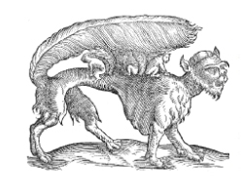
Imagine that you are a biologist working in the field, searching out new species. You have just stumbled upon this strange creature, never before seen. Examine this creature carefully. Based on your observations, knowledge of scientific classification, sense of logic and imagine, classify it.

This belongs to the Domain__________________ because
_____________________________________________________________
This belongs to the Kingdom _________________ because
_____________________________________________________________
This belongs to the Phylum _________________ because
_____________________________________________________________
This belongs to the Class ___________________ because
_____________________________________________________________
This belongs to the Order _________________ because
_____________________________________________________________
This belongs to the Family ____________________ because
__________________________________________________________
This belongs to the Genus ___________________ because
__________________________________________________________
I will call this new species____________________________________
because ____________________________________________________
___________________________________________________________

The Hobbit – The Desolation of Smaug.
Scenario. This creature was to be introduced by Fran Walsh, Philippa Boyens, Peter Jackson and Guillermo del Toro – the writers of the movie. However, due to financial restrains, this creature was left out.
You are now to create a segment [cartoon sketch] with this creature in it. It can be on either side. It needs to have a name and a personality. You can work as a group or individually on this project. Use any of the Cartoon creation apps from this page: https://onthejob.education/teachers_parents/Technology_Websites/Cartoon_Creation.htm

Classification Activity 5: Cladogram
Introduction
A cladogram is a diagram used to represent a hypothetical relationship between groups of animals, called a phylogeny. A cladogram is used by a scientist studying phylogenetic systematics to visualize the groups of organisms being compared, how they are related, and their most common ancestors. A cladogram can be simple, comparing only two or three groups of organisms, or it can be enormously complex and contain all the known forms of life. Cladogram design is universal, although simple.
A cladogram consists of the organisms being studied, lines, and nodes where those lines cross. The lines represent evolutionary time, or a series of organisms that lead to the population it connects to. Nodes represent common ancestors between species. At some point in the past a population of common ancestor organisms was divided, giving rise to the different organisms being studied. Some cladograms show evolutionary time through the scale of the lines, longer lines meaning more time. Some cladograms chose to show extinct species, while others omit them. Any particular cladogram is formulated specifically for the use it is needed. (Source: Biology Dictionary)
Watch Video: https://youtu.be/DmwnvwbXObI

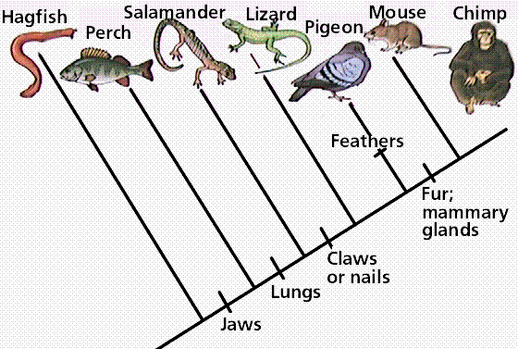
(Source: http://www.instructables.com/id/How-to-Make-a-Cladogram/)
What did you learn? Share with a partner.

Watch video: Cladogram Practice with Minions 24mins
https://youtu.be/9_QAyTk7WrA
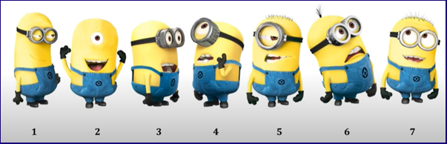
Share with a partner: How else could you draw this cladogram?
Want to do an activity based on this video? Click here
Practice: Let’s Create a Cladogram from the following:
Derived Characters
Segmented Jaws Hair Placenta Multicellular Limbs
Kangaroo + + + - + +
Earthworm + - - - + -
Amoeba - - - - - -
Lizard + + - - + +
Cat + + + + + +
Sponge - - - - + -
Salmon + + - - + -

The organism with the most characteristics will be at the top of the tree and the one with the least will be at the bottom.

Optional: Why are cladograms important? Some more research to read!
https://evolution.berkeley.edu/evolibrary/article/phylogenetics_05
https://evolution.berkeley.edu/evolibrary/article/0_0_0/phylogenetics_06
https://evolution.berkeley.edu/evolibrary/article/0_0_0/phylogenetics_07
https://theconversation.com/we-might-have-to-completely-redraw-the-dinosaur-family-tree-75018

Classification Activity 6 – Using the Dichotomous Key
A dichotomous key is a sequence of steps that allows the identification of an object or living thing. The key consists of a series of choices that lead the user to the correct name of the given item. The term dichotomous means that there will always be two choices in each step of the key until the object is correctly identified.
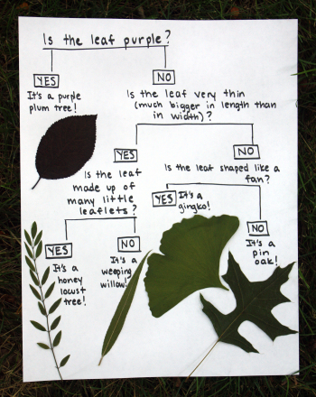
Example of Dichotomous keys…
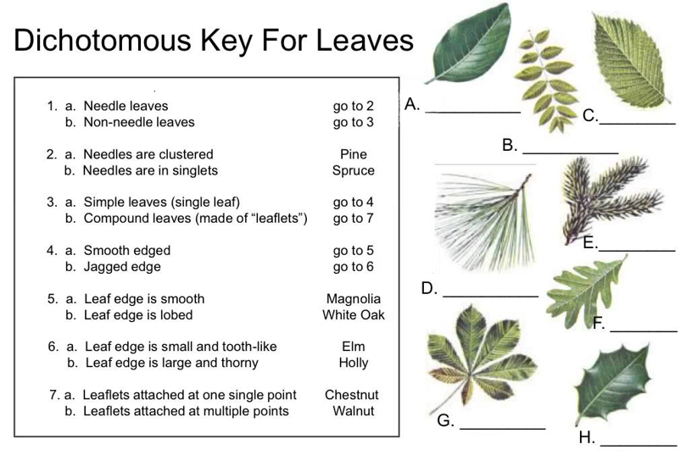
Answer….
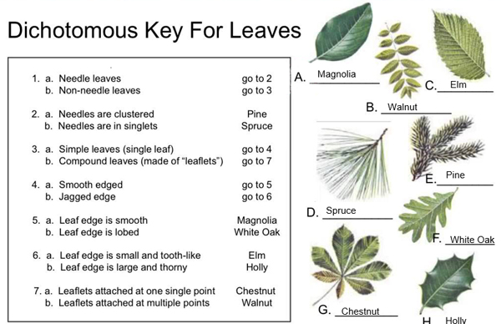

Using a Dichotomous Key with Smiley Faces
(Source: https://www.biologycorner.com/worksheets/dichotomous_key_smilies.htm)
1. Teeth visible ....................go to 2
.....Teeth not visible .................go to 4
2. Has a wide, toothy smile .......Smilus toothyus
....Is not smiling ......................go to 3
3. Visibly crying .................Smilus dramaticus
.... Frowning .......................Smilus upsettus
4. Eyes are symmetrical .... go to 5
....Eyes not symmetrical .....go to 8
5. Eyes shaped like hearts ..... Smilus valentinus
....Eyes are shaped as ovals .....go to 6
6. Smiling, happy face ...... Smilus traditionalis
.....Not happy, frowning or other .....go to 7
7. Mouth curved down, frowning .... Smilus saddus
.... Mouth is a small circle .................Smilus suprisus
8. Has a pirate eye patch ...............Smilus piratus
....Does not have eye patch ............ go to 9
9. One eye is much larger than the other eye ..... Smilus mutatus
One eye is winking .................Smilus winkus
.
Work out this dichotomous key by allocating a name to each face.
Create a Dichotomous Key
You are to make up Yes/No Questions to divide the following garden tools according to their use:
Axe; Broom; Fork; Hose; Leaf Rake; Rake; Secateurs; Shears; Spade; Shovel; Trowel; Watering can; Wheelbarrow
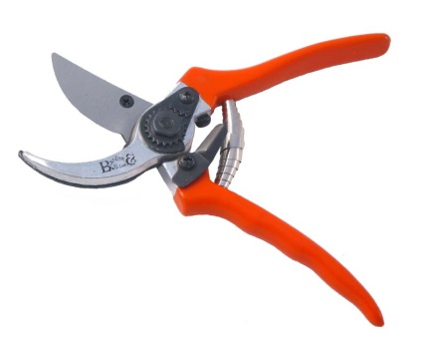 | 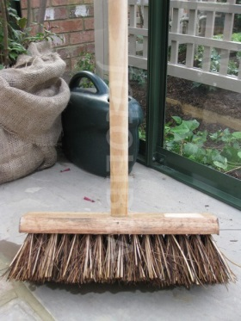 | 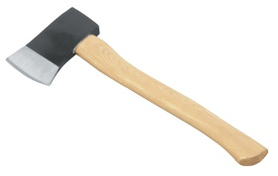  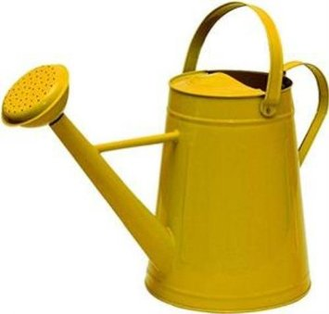
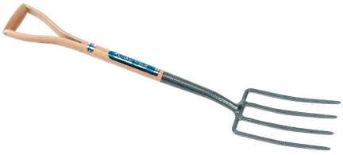 | 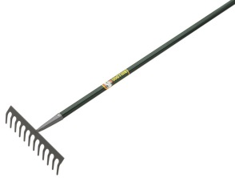 |  | 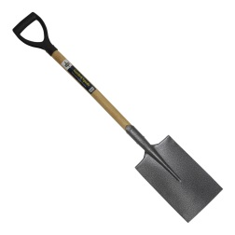
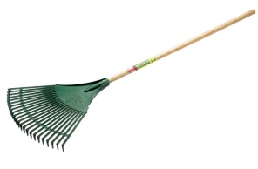 | 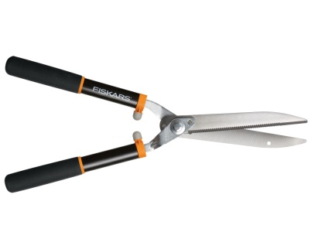 | 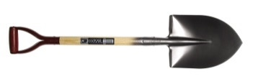 | 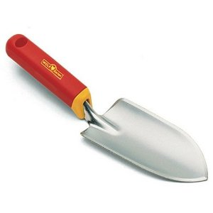

When you have completed your dichotomous key – get your partner to work it out. Did you get the correct answers?

ANSWERS
Cladogram:
