Activity 6 – Using the Dichotomous Key
A dichotomous key is a sequence of steps that allows the identification of an object or living thing. The key consists of a series of choices that lead the user to the correct name of the given item. The term dichotomous means that there will always be two choices in each step of the key until the object is correctly identified.
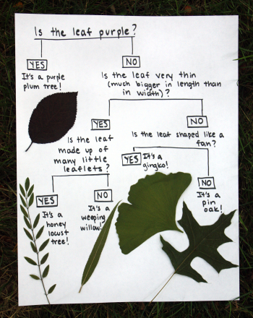

Example of Dichotomous keys…
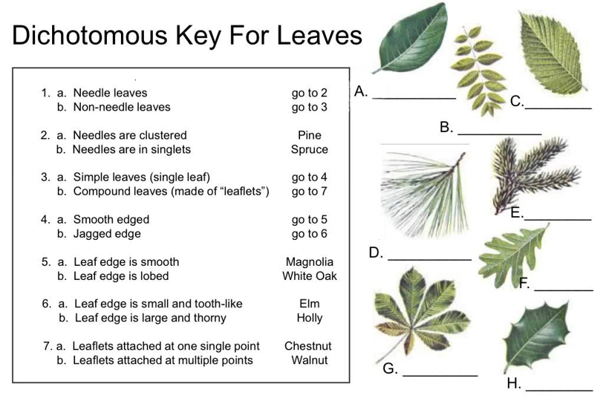
Answer….
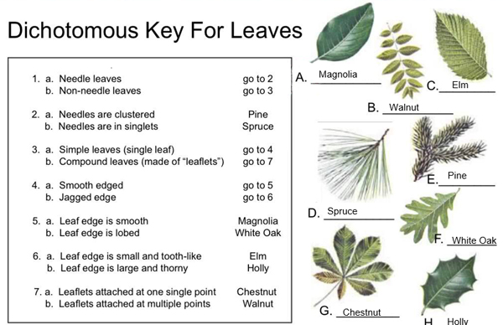

Using a Dichotomous Key with Smiley Faces
(Source: https://www.biologycorner.com/worksheets/dichotomous_key_smilies.htm)
1. Teeth visible ....................go to 2
.....Teeth not visible .................go to 4
2. Has a wide, toothy smile .......Smilus toothyus
....Is not smiling ......................go to 3
3. Visibly crying .................Smilus dramaticus
.... Frowning .......................Smilus upsettus
4. Eyes are symmetrical .... go to 5
....Eyes not symmetrical .....go to 8
5. Eyes shaped like hearts ..... Smilus valentinus
....Eyes are shaped as ovals .....go to 6
6. Smiling, happy face ...... Smilus traditionalis
.....Not happy, frowning or other .....go to 7
7. Mouth curved down, frowning .... Smilus saddus
.... Mouth is a small circle .................Smilus suprisus
8. Has a pirate eye patch ...............Smilus piratus
....Does not have eye patch ............ go to 9
9. One eye is much larger than the other eye ..... Smilus mutatus
One eye is winking .................Smilus winkus
.
Work out this dichotomous key by allocating a name to each face.
Create a Dichotomous Key
You are to make up Yes/No Questions to divide the following garden tools according to their use:
Axe; Broom; Fork; Hose; Leaf Rake; Rake; Secateurs; Shears; Spade; Shovel; Trowel; Watering can; Wheelbarrow
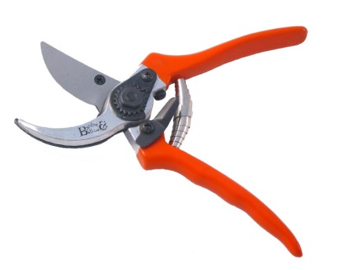 | 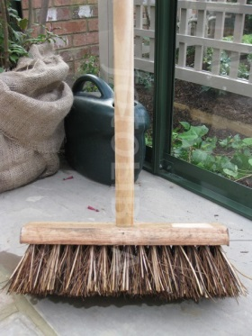 | 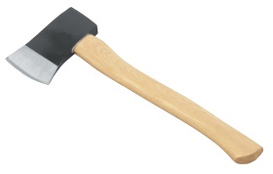  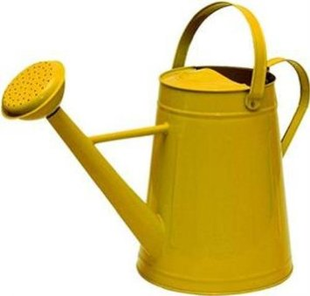 | 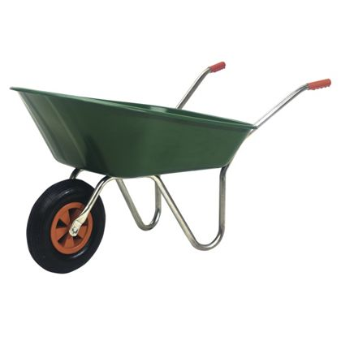
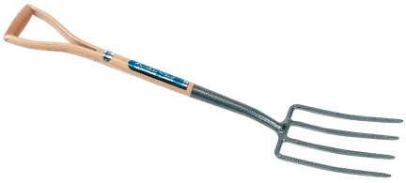 | 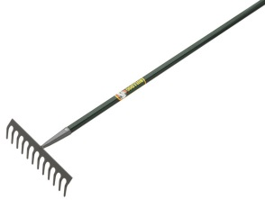 | 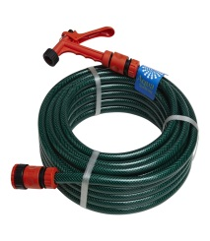 | 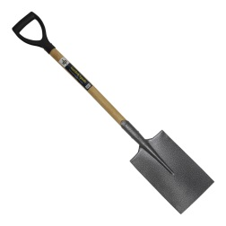
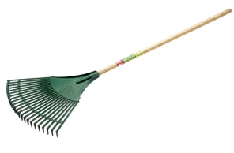 | 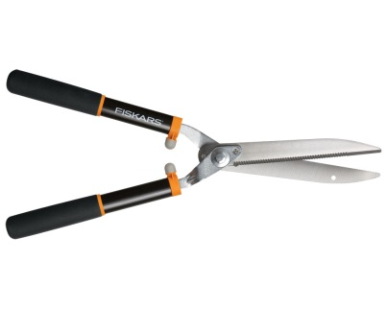 | 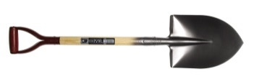 | 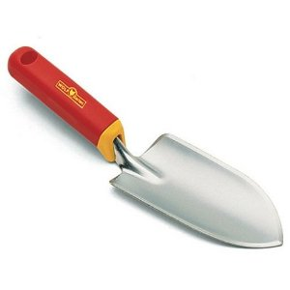

When you have completed your dichotomous key – get your partner to work it out. Did you get the correct answers?

