Activity 5: Cladogram
Introduction
A cladogram is a diagram used to represent a hypothetical relationship between groups of animals, called a phylogeny. A cladogram is used by a scientist studying phylogenetic systematics to visualize the groups of organisms being compared, how they are related, and their most common ancestors. A cladogram can be simple, comparing only two or three groups of organisms, or it can be enormously complex and contain all the known forms of life. Cladogram design is universal, although simple.
A cladogram consists of the organisms being studied, lines, and nodes where those lines cross. The lines represent evolutionary time, or a series of organisms that lead to the population it connects to. Nodes represent common ancestors between species. At some point in the past a population of common ancestor organisms was divided, giving rise to the different organisms being studied. Some cladograms show evolutionary time through the scale of the lines, longer lines meaning more time. Some cladograms chose to show extinct species, while others omit them. Any particular cladogram is formulated specifically for the use it is needed. (Source: Biology Dictionary)
Watch Video: https://youtu.be/DmwnvwbXObI

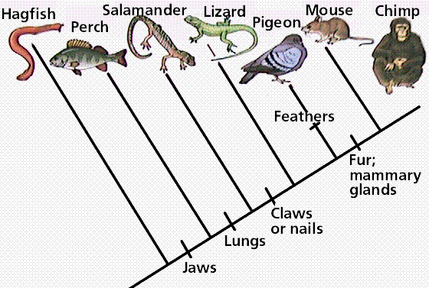
(Source: http://www.instructables.com/id/How-to-Make-a-Cladogram/)
What did you learn? Share with a partner.

Watch video: Cladogram Practice with Minions 24mins
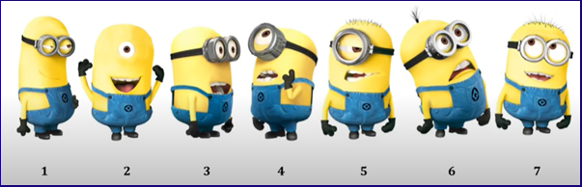
https://youtu.be/9_QAyTk7WrA
Share with a partner: How else could you draw this cladogram?
Want to do an activity based on this video? Click here
Practice: Let’s Create a Cladogram from the following:
Derived Characters
Segmented Jaws Hair Placenta Multicellular Limbs
Kangaroo + + + - + +
Earthworm + - - - + -
Amoeba - - - - - -
Lizard + + - - + +
Cat + + + + + +
Sponge - - - - + -
Salmon + + - - + -

The organism with the most characteristics will be at the top of the tree and the one with the least will be at the bottom.

Optional: Why are cladograms important? Some more research to read!
https://evolution.berkeley.edu/evolibrary/article/phylogenetics_05
https://evolution.berkeley.edu/evolibrary/article/0_0_0/phylogenetics_06
https://evolution.berkeley.edu/evolibrary/article/0_0_0/phylogenetics_07
https://theconversation.com/we-might-have-to-completely-redraw-the-dinosaur-family-tree-75018

