Teacher Instructions
Which Eggs to Buy?
Middle Secondary
Australian Curriculum General Capability: Numeracy
Australian Curriculum General Capability: Ethical Understanding
Australian Curriculum General Capability: Personal and social capability
Philosophy
Time: 1 – 2 Lessons of 45 minutes
Target Subjects: Hospitality, Commerce, Economics [particularly Marketing], Philosophy and Religious Education (Ethics)
Why this lesson?
This lesson explores the Chicken and Egg Production Industry and our responses as consumers. Collaborative and Constructivist strategies are used to promote considered reasoning. Students are required to do a lot of reading amongst their group – to summarise and present evidence. Students are to investigate and discuss the RSPCA’s Five Freedoms of Animals. Students are also asked to create an online survey to find out the reasons why their families buy particular eggs and the impact of marketing [on the egg cartons] on the buying decision.

Previous to Lesson:
Photocopy the Table showing Woolworth’s online prices of eggs onto A3 size paper and laminate [if you want to use this again]. Cut up each section showing the egg variety and its components.
For visual effect, get as many egg cartons as possible for the students to explore – particularly for the marketing aspect of the lesson.
For the Lesson:
Introduction
There is continued debate about “Free Range” eggs and “Caged” eggs in Australia. The groups involved include Government, Farmers or Producers, and Animal Activists. They have different viewpoints and these are sometimes contradictory.
You are to investigate and come to your own view. Remember at all times, you are to give a reasoned response based on evidence rather than opinion.
Readings
Form into groups of 4 – 5 students to complete this activity.
Get the students to divide the reading work, then write up a summary, and share with the group. Make sure that they are making reasoned responses. Get the students to also look at the dates, the updates and authors.

- 27 July 2016: https://theconversation.com/ten-facts-you-need-to-know-about-the-chicken-and-eggs-on-your-table-61367
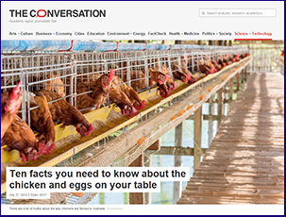

- 21 November 2011 https://theconversation.com/dont-get-eggs-cited-about-free-range-the-realities-of-poultry-production-3895
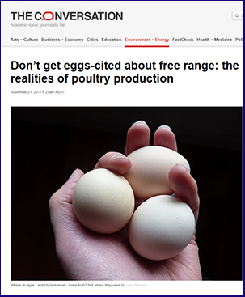

- 10 November 2016 https://theconversation.com/cage-free-sounds-good-but-does-it-mean-a-better-life-for-chickens-62083
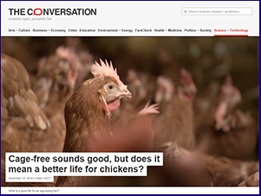

- 1 December 2017 https://theconversation.com/proposed-poultry-standards-leave-australia-trailing-behind-other-industrialised-countries-88302
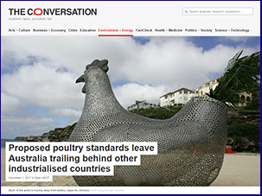

- 12 February 2018 https://theconversation.com/governments-cant-be-trusted-to-deliver-welfare-standards-for-chickens-90091
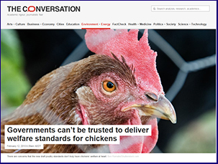
- 1 August 2017 https://theconversation.com/how-to-know-what-youre-getting-when-you-buy-free-range-eggs-81675
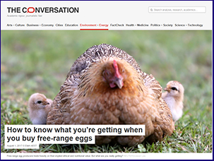
After the students have summarised and shared their findings, as a group, get them to start writing down questions they would like answered.
Five freedoms for Animals
Get the students, as a group, to go through the RSPCA’s Five Freedoms for Animals [below].
RSPCA Australia considers that the welfare of an animal includes its physical and mental state and that good animal welfare implies both fitness and a sense of well-being.
The RSPCA believes that an animal’s welfare should be considered in terms of five freedoms which form a logical and comprehensive framework for analysis of welfare within any animal use together with the steps and compromises necessary to safeguard and improve welfare within the proper constraints of an effective livestock industry.

1. Freedom from hunger and thirst: by ready access to fresh water and a diet to maintain full health and vigour.
2. Freedom from discomfort: by providing an appropriate environment including shelter and a comfortable resting area.
3. Freedom from pain, injury or disease: by prevention through rapid diagnosis and treatment.
4. Freedom to express normal behaviour: by providing sufficient space, proper facilities and company of the animal’s own kind.
5. Freedom from fear and distress: by ensuring conditions and treatment which avoid mental suffering.

RSPCA Australia considers that these freedoms will be better provided for if those who have care of livestock practise:
•caring and responsible planning and management
•skilled, knowledgeable and conscientious animal management
•appropriate environmental design
•considerate handling and transport
• humane killing

Discuss as a group these 5 Freedoms.
Have the students address the issue of the complex nature of this issue.

Why do you buy particular eggs?
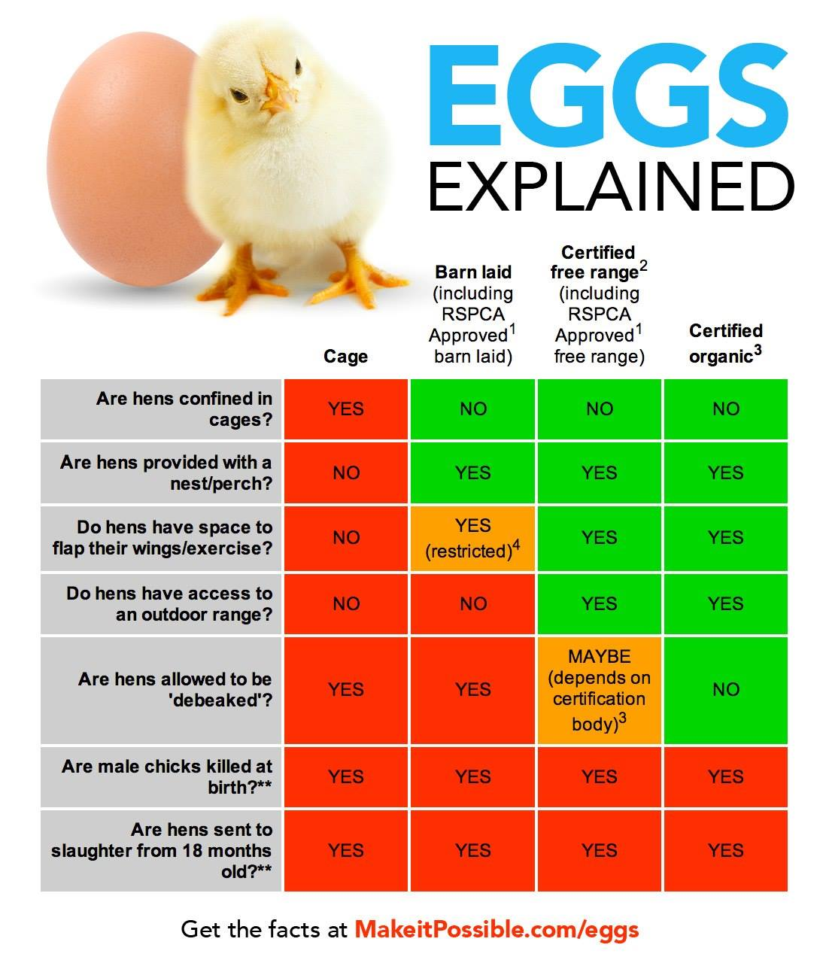
ACTIVITY
Get the students to look at this table (above), remember the 5 Freedoms and ask the question – which one would you buy? Why? Why not?

Table of Prices
Hand out the laminated and cut Table of Prices [See Egg Carton Photos + Table].
Get the students to
Maths
- Look at the pricing of eggs from Woolworths Online 17/1/2018 & 15/3/2024….
- Arrange the caged, barn laid, free range and organic.
- Look at the stocking density/ha (recommended by CSIRO at 1500/ha)
As group, re-order the eggs to reflect their price in 2018 from cheapest to most expensive. Put this information into an Excel spreadsheet.
Repeat with the data from 2024.
Which eggs have increased in cost? All? Some?
- What is the best value for money? 2018? 2024? Any changes?
- Work out the % increase for those eggs whose price has risen. Is it the same % increase? Put the eggs and the % increase into the Excel spreadsheet.
- Did you notice what eggs are now not available? Has there been any limitations in size or quantity?
- What is the most common quantity – 600g or 700g? Has this changed over time?

Which eggs to buy?
How much does price come into buyers’ decisions? Looking at the price/100g what is the lowest price?
What is category [Cage; Barn Laid; Certified Free Range; Organic] that has the cheapest prices? What is the highest price? What is category [Cage; Barn Laid; Certified Free Range; Organic] that has the highest price?
Which eggs would you now choose based on this knowledge?
Have you changed your thinking? Why? Why not?

Marketing: Exam egg cartons
[or the pictures from Woolworths Online – on a separate sheet]
Does the marketing of eggs influence buyers?
Think of the terms:
- “Fresh Cage Eggs”;
- “Liberty Barn Laid Eggs”;
- “Farm Fresh Caged Eggs”;
- Barn Laid Natural Grain Cage Free
- [or from Farmers Markets – “Fox Free eggs”
As a group, what packaging evoked any response in you? Why?
Did this packaging make you change your mind about Which Eggs to Buy?
Survey
Conduct a survey of families in your class about their egg buying habits using Survey Monkey.
What were the main reasons for buying particular eggs?
Discussion
Taking into consideration all the points of view, answer the following question as a class:

Is it ethical to buy or eat caged eggs? Y/N Why? Why not?

Optional Extra Resources: Philosophy
Get the students to analyse the following article from The Conversation
4 October 2013 [mindful of the date].
https://theconversation.com/free-range-debate-puts-the-egg-before-the-chicken-18904 by Patrick Stokes, Lecturer in Philosophy, Deakin University
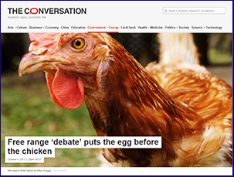
And compare with a further article in The Conversation 1 December 2017
https://theconversation.com/proposed-poultry-standards-leave-australia-trailing-behind-other-industrialised-countries-88302 by Clive Phillips, Professor of Animal Welfare, Centre for Animal Welfare and Ethics, University of Queensland.
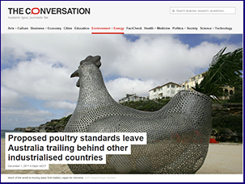
Each pair of students is to come up with 2 questions from these articles and write them up on the whiteboard. Discuss them as a class.

