“On the Job: Careers Market” Newsletter October 2016
A Free Resource for students from Years 5 - 12
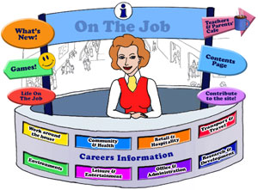
Designed for students in Years 5 – 10
240+ Jobs explored!
Hi Careers Advisors and Educators,
This newsletter is to introduce or re-introduce you to this free eLearning resource “On the Job” . If you like what you see, put it in your favourites!
It is designed to promote awareness of different jobs, career pathways and work environments of ordinary and extraordinary people. This eLearning Resource has a range of Careers for Australian students in the Years 5 - 12.
Present are:
Games Activities Videos Web Quest Historic people Links to resources Career Information Teachers and Parents cafe Lesson Plans Did You Know?
There are a range of jobs listed requiring different educational standards – jobs you can go to straight from school, those
needing TAFE qualifications and those needing university qualifications. You can see at a glance the level required by the Skill Level icons.
How to use the website
Each job (240+) has 3 sections:
and in some cases (80+ People in this section).
The website can be used as a class or an individual activity, from a single lesson to an integrated unit of work (6 weeks’ worth of lessons. With its use of technology and encouraging students to explore, this website can become an engaging online activity that students find fascinating and absorbing.
Want to engage students this Term in a meaningful activity?
With Term 4 underway, you might want to use this resource as way to engage students during this time either individually or as a class. Here are two worksheets [Word Documents] – “Discovering On the Job” and “Exploring On the Job” that you can find under Teachers & Parents’ Café.
The Australian Curriculum and “On the Job”
All of the activities have been aligned with the Australian Curriculum’s General Capabilities. They are meant to be fun and engaging for the student and introduce them to the world of work in a more concrete way. There are plenty of Literacy and Numeracy activities for your students.
Stories about life at work help to inform the ideas students create about their own future. Read stories about people from diverse backgrounds and career paths and the exciting (and sometimes surprising) things they do at work!

Your Needs?
In response to a teacher and student out in Temora, I have added the Tattoo Artist. We want to hear from you if you have any particular needs for your classroom or individual student. I was particularly taken with Rob Cook’s story from Landline in September and he now features as the Life on the Job for the Livestock Farmer – Read his story it is truly inspiring.
Contact Frances@onthejob.education for more information.

Year Level Focus
Primary: Stage 3
Middle: Stage 4
High: Stage 5

Up to and including October , the following jobs were added:
Category: Community & Health
Job | ACGC | Activity | Year Level Focus
COMMUNITY CORRECTIONS OFFICER |  | - Compare and contrast: what is your opinion? How would you act? | Secondary
PROSTHETIST/  ORTHOTIST  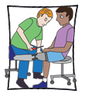 |  | - Creating a Facebook page for Local Hero  - Socratic Seminar: Do we really dehumanise ourselves when we give our bodies new, unnatural functions?  - Team Designing a Prosthetic Leg for Surfing – a WebQuest | Primary Middle  ,  Secondary

Category: Retail & Hospitality
Job | ACGC | Activity | Year Level Focus
BARISTA |  | - Coffee Tasting Anyone?  - Recycling and Coffee: What are the challenges? What business is it of yours?  - The Chemistry of Coffee: What a Barista needs to know | , , All  , , All  Secondary
BREWER |  | - Hops: A Puzzle  - When is ‘hand-crafted’ really just crafty marketing?  - “If you don’t have a beer you’re not a man” – rural workplaces made more dangerous by drugs and alcohol | , , All  Secondary  Secondary
FOOD PROCESS WORKER |  | - Tastes like Chicken: How much chicken do you consume each week?  - Thomas Foods International – their business! | Primary Middle  , , All
TATTOO ARTIST |  | - A Survey of Tatts!  - “The Original Tattooed Lady”  - The Law and Tattoos | ,  Secondary  Secondary
TEXTILE DESIGNER |  | - Different Materials – what do you know?  - DIY Textile Design – How hard can it be?  - Ethics and the Textile Industry in Bangladesh | , , All  Secondary  Secondary

Category: Office & Administration
Job | ACGC | Activity | Year Level Focus
BORDER FORCE OFFICER |  | - Be a part of Border Force by helping raise a Detector Dog or look after an aged Detector Dog!  - Change it up – Concentration  - Worth a thousand words – how photos shape attitudes to refugees | Primary Middle  , , All  Secondary

Category: Research & Development
Job | ACGC | Activity | Year Level Focus
BIOTECHNOLOGIST |  | - How to extract DNA from a Kiwi Fruit  - Why isn’t Australia capitalising on being “an algae gardener’s paradise”?  - Genetically Modified Foods: Because we can, does it mean we should? The ethics of GM foods! | ,  ,  Secondary
CRIMINOLOGIST |  | - Are you one of the third of customers who use self-service checkouts to ‘swipe’ groceries?  - Sewage and the Criminologist! | ,  Secondary

Category: Environments
Job | ACGC | Activity | Year Level Focus
ARBORIST  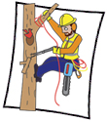 |  | - Site Hazard Assessment: A Study of Trees at School  - What is the Value of Trees? Why should we bother? | , , All  ,
HORSE MANAGER |  | - Managing a mare’s reproductive cycle. Innovative technology - wearable technology - can help this process but is it worth it?  - The Horse Grimace Scale and Horse Behaviour | ,  , , All

Additions
ROB COOK – LIVESTOCK FARMER  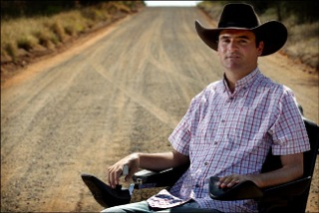 |  | - Inspirational Story  - Your Motivational Quote  - Technology and Disability | , , All  , , All  Middle, Secondary
CAROLINE FIELD – ART CURATOR  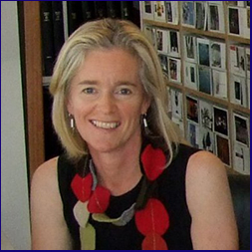 |  | - Our Digital Collection – Curating Our School’s Art Work | , , All

