Snakes and Ladders Board Game

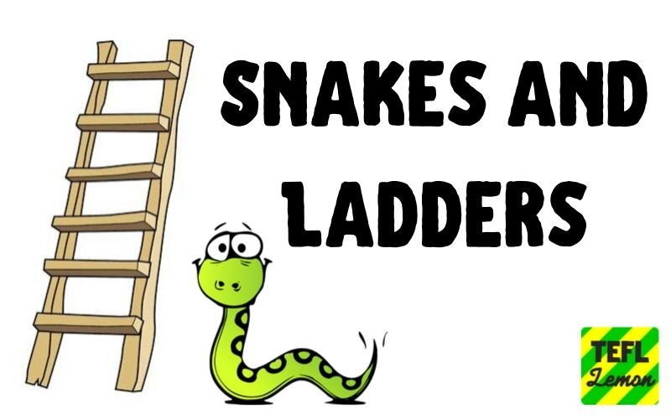

Instructions
Snakes and Ladders is a very versatile game and can be used in many ways. All you need is a die. It's wise to laminate games that will be reused.
Ideas for using the game: Practicing vocabulary, sentence structure, grammatical forms…. it’s endless!
The teacher can make different level games for a heterogeneous class.
Here are two ways to play:
I
- Preparing the game
- Print one copy of the game. I recommend enlarging it to A3.
- On each space write a task (according to the level of the players) for the students to do or a question to answer, (except where there's a snake or a ladder). Try to put tasks/ questions that can be done/answered in more than one way. (See the example.)
(For teachers proficient in Word, there is an explanation below of how to make a professional-looking printed board.)
- On each spot that has the bottom of a ladder, put something a bit more challenging. At the top of the ladder, write a comment like: "You did it," or something similar.
- On the spaces with the head of the snake, write, "Oh, no," or some similar comment. The space with the snake's tail could have something like: "Better luck next time." Or put a particularly challenging question there. (See rules.)
- Make as many copies as necessary of your prepared board, two to four players per board.

- Rules:
Students decide who is first, second, etc. The first player throws the die. He counts the spaces and reads the question/task. If he can answer, he advances to the space. If not, he waits for his next turn. Then the next player goes, etc.
If a player lands on a space where the task/question has already been done/answered, he must answer with a new reply. For example, if it says: "What time do you eat breakfast?" and the first player answered that he eats at 7:30, the next player has to give a different time.
When a player lands on a space where there is the bottom of a ladder, if he answers correctly, he climbs up the ladder. If not, as always, he stays where he was and waits for his next turn.
When landing on a space where there is a snake head, he must answer the question or slide down to the tail.
When landing on a snake tail, a ladder head or FREE, the student doesn't have to do anything.
The winner is the first to reach the end.

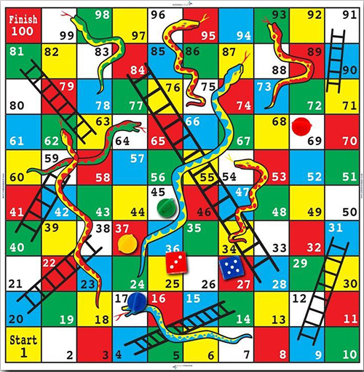

II
A. Preparing the game
1. Don't write anything on the board.
2. Prepare note paper.
3. On the inside of each note, write the answer to a specific question.
4. Fold it in half.
5. Write the question.
6. Fold again.
7. Repeat until there are as many questions as needed.
7. Put all the notes in a bag.
Examples of question types that could be written on the notes:
- Fill in questions (cloze) to review vocabulary.
- Questions with specific answers (to practice grammatical forms or sentence structures).
- Questions about a story or an article that the class read.

B. Rules:
Students decide who is first, second, etc. The first player throws the die. He pulls a note out of the bag, unfolds it once and tries to answer the question. The note is opened all the way and the answer is checked. If he was right, he advances to the space. If not, he waits for his next turn. Then the next player goes, etc.
The teacher could provide more challenging questions on notes of another color, or in a separate bag for the snake heads and ladder bottoms.
When a player lands on a space where there is the bottom of a ladder, if he answers correctly, he climbs up the ladder. If not, as always, he stays where he was and waits for his next turn.
When landing on a space where there is a snake head, he must answer the question or slide down to the tail.
When landing on a snake tail or a ladder head, the student doesn't have to do anything.
The winner is the first to reach the end.
