On the Job: Careers Market
Transport & Travel

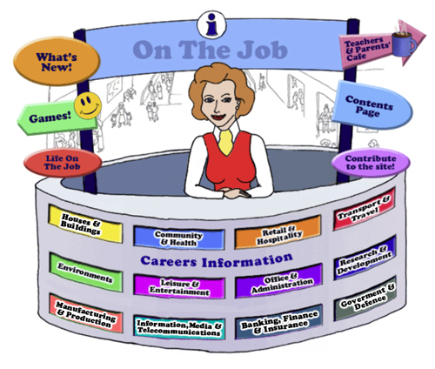

Teachers
Introduction
Welcome to this website for Australian students in Years 5 – 12, their teachers and parents.
The Design concept is based on the local Shopping Mall as students of this age are familiar with the Careers represented here. This initial concept broadened to include careers that they might have encountered outside the Shopping Mall eg. Local Government Inspector or Farmer
The website can be used as an individual activity for students or as a whole group.
This Teacher’s Guide is for the whole class and is aligned to the Australian Curriculum and the General Capabilities.

The Jobs
Each of the jobs listed has three sections
- The Information about each Job. | - Activities | - Links

All content in the Job Info sections have been taken from The Job Guide. Under copyright laws and from the Job Guide’s website – this information can be used for Educational purposes.
This content also encourages reading and therefore literacy but breaks down information into chunks and divided by “Did You Know?” segments.
The Activities can be divided into two sections:
- Offline
- Online
The activities bring a fun element into learning. There are practical skills about the particular job eg. “How to build a beehive” [in the Beekeepers section] is an Offline activity.
The Online activities include mostly free mobile apps, YouTube Videos, games and also WebQuest activities which provide students with Problem-Based Learning and the opportunity to use their Higher Order Thinking and Collaboration Skills.
The Links provide students with access to Association websites for that particular Industry as well as links to examples of people within this job and their experiences.
Life on the Job is divided into three sections:
- Historic or Famous People – mostly Australians | - Indigenous Historic or Famous People | - “Real Life People”
Historic or Famous People
Historic or Famous People are mostly famous Australians whose lives are usually investigated within the Australian Curriculum. Each person is researched and their lives summarised to give students an overview. There are links provided so students can investigate more fully themselves. At the end of the content information, students are given an activity to complete – mostly using the latest and free ICT tools available to increase their knowledge and capability.

Indigenous Historic or Famous People
Indigenous Historic or Famous People are famous Australians whose lives are usually investigated within the Australian Curriculum. Each person is researched and their lives summarised to give students an overview. There are links provided so students can investigate more fully themselves. At the end of the content information, students are given an activity to complete – mostly using the latest and free ICT tools available to increase their knowledge and capability.

Real Life People
Real Life People’s stories are provided here. Parents can submit their job and show students their educational journey to achieve employment within their job category.

Alignment with the Australian Curriculum
Curriculum Area: Australian Curriculum: General Capabilities
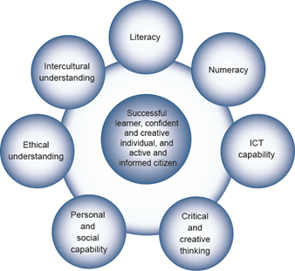

The Australian Curriculum includes seven general capabilities:
- Literacy
- Numeracy
- Information and communication technology (ICT) capability
- Critical and creative thinking
- Personal and social capability
- Ethical understanding
- Intercultural understanding.
(Source: Australian Curriculum)
Literacy involves students in listening to, reading, viewing, speaking, writing and creating oral, print, visual and digital texts, and using and modifying language for different purposes in a range of contexts.
Numeracy involves students in recognising and understanding the role of mathematics in the world and having the dispositions and capacities to use mathematical knowledge and skills purposefully.
Information and communication technologies are fast and automated, interactive and multimodal, and they support the rapid communication and representation of knowledge to many audiences and its adaptation in different contexts. They transform the ways that students think and learn and give them greater control over how, where and when they learn.
Critical and creative thinking are integral to activities that require students to think broadly and deeply using skills, behaviours and dispositions such as reason, logic, resourcefulness, imagination and innovation in all learning areas at school and in their lives beyond school.
Students develop personal and social capability as they learn to understand themselves and others, and manage their relationships, lives, work and learning more effectively. The capability involves students in a range of practices including recognising and regulating emotions, developing empathy for others and understanding relationships, establishing and building positive relationships, making responsible decisions, working effectively in teams, handling challenging situations constructively and developing leadership skills.
Ethical understanding involves students in building a strong personal and socially oriented ethical outlook that helps them to manage context, conflict and uncertainty, and to develop an awareness of the influence that their values and behaviour have on others.
As cultural, social, environmental and technological changes transform the world, the demands placed on learners and education systems are changing. Technologies bring local and distant communities into classrooms, exposing students to knowledge and global concerns as never before. Complex issues require responses that take account of ethical considerations such as human rights and responsibilities, animal rights, environmental issues and global justice.
Building ethical understanding throughout all stages of schooling will assist students to engage with the more complex issues that they are likely to encounter in the future, and to navigate a world of competing values, rights, interests and norms.
Intercultural understanding: The capability involves students in learning about and engaging with diverse cultures in ways that recognise commonalities and differences, create connections with others and cultivate mutual respect. (Source: Australian Curriculum)
Priorities:
Asia and Australia's engagement with Asia
Aboriginal and Torres Strait Islander histories and cultures
Sustainability

Philosophy: This icon represents both Critical and Creative Thinking and Ethical Understanding but at a deeper level. The activities with this icon show a high level of complex thinking is required. The activity can be used with classes undertaking Philosophy in Schools.
Cooperative Learning Activity
A collaborative (or cooperative) learning approach involves students working together on activities or learning tasks in a group small enough for everyone to participate on a collective task that has been clearly assigned. Students in the group may work on separate tasks contributing to a common overall outcome, or work together on a shared task.

Emerging Job
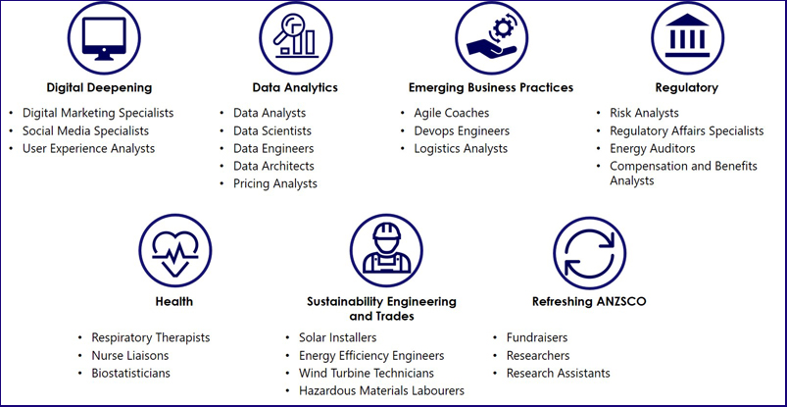
The jobs listed above are emerging jobs identified by the National Skills Commission.
Emerging occupations are defined as new, frequently advertised jobs which are substantially different to occupations already defined in the Australian and New Zealand Standard Classification of Occupations (ANZSCO) – such as data scientist and data analyst. As such, to compile our list we considered data from the time period following the last ANZSCO review in 2013.
The NSC has identified and validated 25 emerging occupations within seven categories in the Australian labour market (Figure 1). This list is not considered exhaustive, and the NSC will continue to monitor and analyse emerging trends.
An advantage of our approach is access to real time internet job advertisement data using Burning Glass Technologies, which will allow us to pick up occupations in emerging fields like blockchain, nanotechnology, quantum computing and the internet of things as soon as the employer demand for these skills increases.
https://www.nationalskillscommission.gov.au/what-are-emerging-occupations

On the Job – Australian Curriculum General Capabilities Alignment with Activities

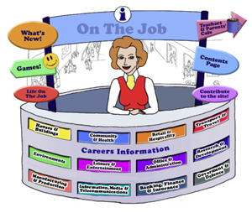
All of the activities in “Life On the Job” have also been aligned with the Australian Curriculum’s General Capabilities. They are meant to be fun and engaging for the student and introduce them to the world of work in a more concrete way. On the Job builds on what students have learnt in their earlier years in Primary School about the world of work and helps students go from the concrete to the abstract in their thinking. Each activity shows the General Capability [GC] being focussed on by showing the GC icon and any Priorities.
Future Growth
Each job is given a Future Growth icon: either Decline; Static; Moderate; Strong or Very Strong growth. These icons were created by On the Job.
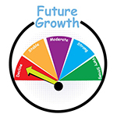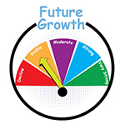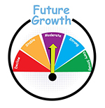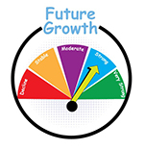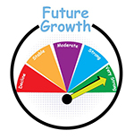
The information has been obtained from the Australian Government website: Labour Market Insights. https://labourmarketinsights.gov.au/

TRANSPORT & TRAVEL
JOB | Australian Curriculum General Capability | ACTIVITY | Target Level
AERONAUTICAL ENGINEER  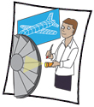 |  | - Water Rocket Launch (developed by TryEngineering.org)  - Blast Off (developed by TryEngineering.org) | , , All  ,
AIR TRAFFIC CONTROLLER |  | - Making a Movie based on information from NOVA: Air Traffic Control in Australia  - Websites: Air Traffic Controller Game; Air Traffic Chief; Flight Control App  - Air Traffic Controller WebQuest  - Pilot Potential Programme WebQuest | Middle  Primary Middle  Middle  Middle
AIRCRAFT MAINTENANCE ENGINEER |  | - The ‘O-Wing” Experiment (created by ABC’s Surfing Scientist)  - Movie – “Paper Planes” (Unit of Work)  - Take Flight (Try Engineering)  - The Aviation Industry – AMEs, Certification, Governments & Market Pressure – Academic Controversy Strategy #TC | Primary  Primary  Primary  Middle Secondary
ARMOURED CAR ESCORT |  | - New Headline, New Story  - The Italian Job revisited! Compare and Contrast | Secondary  Middle Secondary
AUTOMOTIVE ELECTRICIAN  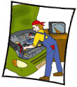 |  | - Batteries  - Make a Crossword Puzzle with the equipment for an Automotive Electrician; or a Word Cloud using Wordle  - Creating a Poster to encourage more people into the industry  - The Effect of Greenhouse Gases on the Environment WebQuest | Primary Middle  , , All  Secondary  Secondary
LOTJ – Andrew  Automotive Electrician |  | - Counting up the cost!  - The Science within an Automotive Electrician’s job | Primary Middle  Secondary
BUS DRIVER  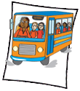 |  | - Bus Drivers are there to help  - What is the best way to travel? Consider all factors  - Websites: Bus Driver Game; London Bus 2; Park My School Bus; School Bus Driver; Harry Potter Bus Driving; A Bus Drive to Yankee Stadium! | Primary  Middle Secondary  Middle
CAR DETAILER  CAR PARK ATTENDANT |  | - Cleaning the Family Car  - Car Detailing in your region? Could this be YOUR business venture? | , , All
CARAVAN PARK & CAMPING GROUND MANAGER  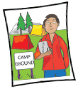 |  | - More people are hitting the road in their caravan and campervans than ever before, but will the traditional caravan park survive? | Secondary
CHAUFFEUR |  | - As shiny as possible  - The Diaries of Malala Yousafzai’s Chauffeur | ,  Secondary
LOTJ – Alf Stafford – Chauffeur |  | - Trust – Who would you trust?  - Which car would you choose for the PM? | Primary  , , All
COXSWAIN |  | - Compare and contrast two or more boats  - Publish a Boating Safety Booklet for Students  - Coxswain of yesteryear: John Cadman – his story | , , All  , , All  Secondary
LOTJ – Andrew  Charter Vessel Operator |  | - Down on the Harbour! Sydney Harbour  - Down on the Harbour! Sydney Harbour
CRANE OPERATOR  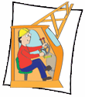 |  | - Three charts on: crane-spotting, a way to tell which Australian cities are growing and where  - Websites, Games & Apps: The Junkyard; Cargo Master; Carrier Truck Game; Coal Express; Rubble Trouble Tokyo; Shipping Yard  - THE CASE OF THE WOULD-BE WIDGET THIEF WebQuest | Primary  Middle
DELIVERY DRIVER  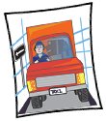 |  | - Can parcel deliveries ever be truly carbon-neutral?  - Investigating UberEats | , , All
DRIVING INSTRUCTOR  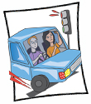 |  | - How did your family learn to drive?  - The Trouble with Mr Bean | , , All  , , All
DRONE OPERATOR  ROV Operator |  | - Designing Drones (Try Engineering)  - Know your sharks from the air!  - How could drones be used in the future? A Brainstorming exercise  - Drone Safety (developed by CASA)  - How shoring up drones with AI helps lifesavers spot sharks at the beach #TC
FLIGHT ATTENDANT |  | - The History of Australian Air Hostess’ (Flight Attendants): A Gender & Cultural Study #TC  - What is it like being an Airport Service Officer for a half an hour?  - Websites: Air Hostess Game; Flight Attendant Game; Where is That?; Geo-Globe; Lizard Point Map Quizzes; Flightmapping; Allthecountries App | , , All  , , All
FLYING INSTRUCTOR  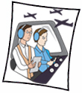 |  | - Teaching Aviation English? | , , All
FORTLIFT OPERATOR  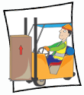  Aircraft Baggage Handler & Airline Ground Crew |  | - In the Movie, “Cars”, there is a special character Guido the forklift!...Design a model of Guido  - Additional Script for “Cars” (Create a movie)  - The Baggage Handler: A Review  - Websites, Games & Apps: Forklift Games; Planet of the Forklift Kid | Primary  Primary Middle  Primary
FURNITURE REMOVALIST |  | - Decluttering Everyone!  - The Removalists and Domestic Violence  - Websites, Games & Apps: My Move App; Moving Day App | , , All
HELICOPTER PILOT |  | - Helicopters: Explain that stuff!  - Consider All Factors: Air Urber | , , All  Secondary
HORSE FLOAT DRIVER  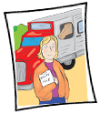 |  | - Driving Force – What next?  - How to tow a Horse Float! Connect Three | Secondary
LIVESTOCK TRANSPORT DRIVER  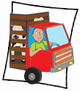 |  | - Counting the Cost of Transport…  - Maths & Livestock Transport  - Live Export Trade – Worth it? An updated BTN on the issue | Primary  Secondary
LOGGING TRUCK DRIVER  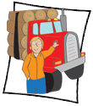 |  | - Safe Work Australia needs your help! | , , All
LOGISTICS ANALYST |  | - The Geography of Mandarins: Where do they come from?  - Logistics, Global Trade & the Suez Canal  - How will COVID-19 vaccines get from the factory to your local pharmacy? | Secondary
MECHANIC |  | - “Just a Minute”  - Mystery/Horror Story: “Your car is hacked!”  - Bicycle Maintenance: A comprehensive presentation  - Get your bearings (developed by TryEngineering)  - Give me a brake(developed by TryEngineering)  - Car Crash WebQuest | Secondary  , , All  , , All  Secondary
MOBILE PLANT OPERATOR |  | - Create a new episode for Scoop to be the hero!  - Restoration of the Earth after mining! Possible? | Primary Middle  Secondary
OVERSIZE LOAD PILOT  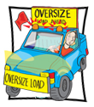 |  | - Staying how far back?  - How many Oversize Load Pilots to employ on these trips?  - Find it with GPS! (developed by Try Engineering.org) STEM classes or Geography | Middle  Primary Middle  , , All
PANEL BEATER |  | - Mr Bean’s $1.7 Million Smash Repair Bill  - Website: Car Repair Game | Primary
PILOT |  | - Pirates of Penzance, or the Slave of Duty – a new Parody?  - What is it like to be a fighter pilot?  - Websites, Games & Apps: Pilot! | Secondary  Middle
LOTJ – Leonard Victor Waters  Pilot |  | - Create a movie about Len Waters’ life  - Create a movie about Len Waters’ life and answer the question: “Why were Indigenous Australians treated so differently during and after the War? Was it ethical? | Primary Middle  Secondary
LOTJ – Sir Charles Kingsford-Smith  Pilot |  | - Australian History - Sir Charles Kingsford Smith - his contribution  - A New Way to celebrate CKS! Mosaically  - Should Australia have two national airlines? An analysis! | , , All
SHIP’S MASTER |  | - Must the Captain go down with his (her) ship?
SUPPLY, DISTRIBUTION, & PROCUREMENT MANAGER  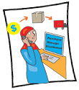  Fleet Manager  Purchasing & Supply Logistics Clerk  Storeperson  Warehouse Administrator |  | - Procurement of …. School Supplies  - The Geography of Mandarins: Where do they come from? | , , All
TAXI DRIVER |  | - Your Local Streets  - London Taxi Drivers’ Brains  - Uber: What’s the Cost? | , , All  Secondary  Secondary
TOW TRUCK DRIVER |  | - Mater – a new story  - “Drive so others survive”: A Community of Inquiry
TRANSPORT COMPANY MANAGER |  | - Comparing the Top 10 Australian Transport Companies!
TRANSPORT ECONOMIST |  | - Sydney’s 2nd Airport Debate | Secondary
TRAVEL AGENT  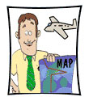 |  | - CRUISING TO THE BUDAPEST  - Plan the perfect trip using TripAdvisor  - Travel Agent – Develop a Play | Middle  Middle  Primary
TRUCK DRIVER |  | - PLANNING A TRIP IN A TRUCK  - How can you teach young drivers to be safe around trucks.  - Websites, Games & Apps: Truck Games | , , All  Primary
LOTJ - Heather Jones |  | - Designing a custom cabin | Secondary
VEHICLE DISMANTLER  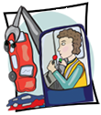 |  | - The new challenges of recycling obsolete cars: 6 Thinking Hats
WATERSIDE WORKER |  | - The Wharfie’s Song  - The Living End: Roll On  - Australian Context: the History of the Waterside Worker | Secondary

