On the Job: Careers Market

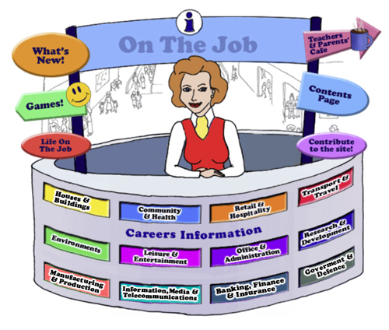
Teachers
Introduction
Welcome to this website for Australian students in Years 5 – 12, their teachers and parents.
The Design concept is based on the local Shopping Mall as students of this age are familiar with the Careers represented here. This initial concept broadened to include careers that they might have encountered outside the Shopping Mall eg. Local Government Inspector or Farmer
The website can be used as an individual activity for students or as a whole group.
This Teacher’s Guide is for the whole class and is aligned to the Australian Curriculum and the General Capabilities.

The Jobs
Each of the jobs listed has three sections
- The Information about each Job. | - Activities | - Links

All content in the Job Info sections have been taken from The Job Guide. Under copyright laws and from the Job Guide’s website – this information can be used for Educational purposes.
This content also encourages reading and therefore literacy but breaks down information into chunks and divided by “Did You Know?” segments.
The Activities can be divided into two sections:
- Offline
- Online
The activities bring a fun element into learning. There are practical skills about the particular job eg. “How to build a beehive” [in the Beekeepers section] is an Offline activity.
The Online activities include mostly free mobile apps, YouTube Videos, games and also WebQuest activities which provide students with Problem-Based Learning and the opportunity to use their Higher Order Thinking and Collaboration Skills.
The Links provide students with access to Association websites for that particular Industry as well as links to examples of people within this job and their experiences.
Life on the Job is divided into three sections:
- Historic or Famous People – mostly Australians | - Indigenous Historic or Famous People | - “Real Life People”
Historic or Famous People
Historic or Famous People are mostly famous Australians whose lives are usually investigated within the Australian Curriculum. Each person is researched and their lives summarised to give students an overview. There are links provided so students can investigate more fully themselves. At the end of the content information, students are given an activity to complete – mostly using the latest and free ICT tools available to increase their knowledge and capability.

Indigenous Historic or Famous People
Indigenous Historic or Famous People are famous Australians whose lives are usually investigated within the Australian Curriculum. Each person is researched and their lives summarised to give students an overview. There are links provided so students can investigate more fully themselves. At the end of the content information, students are given an activity to complete – mostly using the latest and free ICT tools available to increase their knowledge and capability.

Real Life People
Real Life People’s stories are provided here. Parents can submit their job and show students their educational journey to achieve employment within their job category.

Alignment with the Australian Curriculum
Curriculum Area: Australian Curriculum: General Capabilities
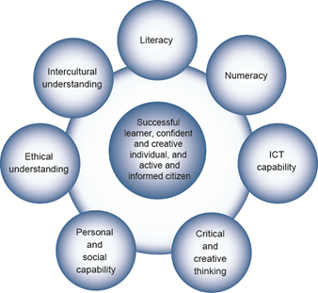

The Australian Curriculum includes seven general capabilities:
- Literacy
- Numeracy
- Information and communication technology (ICT) capability
- Critical and creative thinking
- Personal and social capability
- Ethical understanding
- Intercultural understanding.
(Source: Australian Curriculum)
Literacy involves students in listening to, reading, viewing, speaking, writing and creating oral, print, visual and digital texts, and using and modifying language for different purposes in a range of contexts.
Numeracy involves students in recognising and understanding the role of mathematics in the world and having the dispositions and capacities to use mathematical knowledge and skills purposefully.
Information and communication technologies are fast and automated, interactive and multimodal, and they support the rapid communication and representation of knowledge to many audiences and its adaptation in different contexts. They transform the ways that students think and learn and give them greater control over how, where and when they learn.
Critical and creative thinking are integral to activities that require students to think broadly and deeply using skills, behaviours and dispositions such as reason, logic, resourcefulness, imagination and innovation in all learning areas at school and in their lives beyond school.
Students develop personal and social capability as they learn to understand themselves and others, and manage their relationships, lives, work and learning more effectively. The capability involves students in a range of practices including recognising and regulating emotions, developing empathy for others and understanding relationships, establishing and building positive relationships, making responsible decisions, working effectively in teams, handling challenging situations constructively and developing leadership skills.
Ethical understanding involves students in building a strong personal and socially oriented ethical outlook that helps them to manage context, conflict and uncertainty, and to develop an awareness of the influence that their values and behaviour have on others.
As cultural, social, environmental and technological changes transform the world, the demands placed on learners and education systems are changing. Technologies bring local and distant communities into classrooms, exposing students to knowledge and global concerns as never before. Complex issues require responses that take account of ethical considerations such as human rights and responsibilities, animal rights, environmental issues and global justice.
Building ethical understanding throughout all stages of schooling will assist students to engage with the more complex issues that they are likely to encounter in the future, and to navigate a world of competing values, rights, interests and norms.
Intercultural understanding: The capability involves students in learning about and engaging with diverse cultures in ways that recognise commonalities and differences, create connections with others and cultivate mutual respect. (Source: Australian Curriculum)
Priorities:
Asia and Australia's engagement with Asia
Aboriginal and Torres Strait Islander histories and cultures
Sustainability

Philosophy: This icon represents both Critical and Creative Thinking and Ethical Understanding but at a deeper level. The activities with this icon show a high level of complex thinking is required. The activity can be used with classes undertaking Philosophy in Schools.
Cooperative Learning Activity
A collaborative (or cooperative) learning approach involves students working together on activities or learning tasks in a group small enough for everyone to participate on a collective task that has been clearly assigned. Students in the group may work on separate tasks contributing to a common overall outcome, or work together on a shared task.

Emerging Job
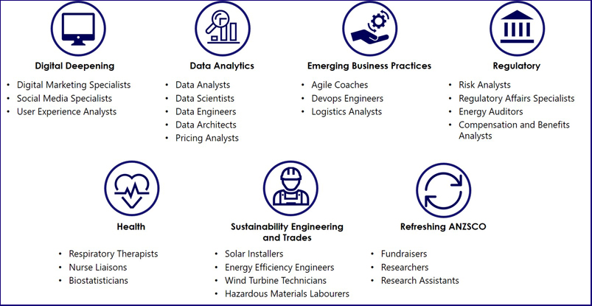
The jobs listed above are emerging jobs identified by the National Skills Commission.
Emerging occupations are defined as new, frequently advertised jobs which are substantially different to occupations already defined in the Australian and New Zealand Standard Classification of Occupations (ANZSCO) – such as data scientist and data analyst. As such, to compile our list we considered data from the time period following the last ANZSCO review in 2013.
The NSC has identified and validated 25 emerging occupations within seven categories in the Australian labour market (Figure 1). This list is not considered exhaustive, and the NSC will continue to monitor and analyse emerging trends.
An advantage of our approach is access to real time internet job advertisement data using Burning Glass Technologies, which will allow us to pick up occupations in emerging fields like blockchain, nanotechnology, quantum computing and the internet of things as soon as the employer demand for these skills increases.
https://www.nationalskillscommission.gov.au/what-are-emerging-occupations

On the Job – Australian Curriculum General Capabilities Alignment with Activities
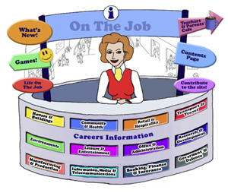
All of the activities in “Life On the Job” have also been aligned with the Australian Curriculum’s General Capabilities. They are meant to be fun and engaging for the student and introduce them to the world of work in a more concrete way. On the Job builds on what students have learnt in their earlier years in Primary School about the world of work and helps students go from the concrete to the abstract in their thinking. Each activity shows the General Capability [GC] being focussed on by showing the GC icon and any Priorities.
Future Growth
Each job is given a Future Growth icon: either Decline; Static; Moderate; Strong or Very Strong growth. These icons were created by On the Job.
The information has been obtained from the Australian Government website: Labour Market Insights. https://labourmarketinsights.gov.au/
RETAIL AND HOSPITALITY:
JOB | Australian Curriculum General Capability | ACTIVITY | LEVEL
ANTIQUE DEALER  Antique Appraiser and Valuer |  | - Create a Virtual Antique Collection  - Antique Timeline  - Science and the Art of the Islamic World: Expert Jigsaw Strategy (developed by The Met) | , , All  Primary
AUCTIONEER  BLOODSTOCK AGENT  STOCK & STATION AGENT |  | - Auctioning items with Monopoly money  - “World Livestock Auctioneer Championships” – Practising Public Speaking | Primary
BAKER |  | - Your Local Bakery  - Baking Bread  - Multigrain, wholegrain, wholemeal: what’s the difference and which bread is best?  - Chan Khun’s famous Chicken Curry Pie – can you make it?  - Websites, Games & Apps: Bakery Story App  - From Yeast to Bread WebQuest | , , All  , , All  , , All  Primary  Secondary
LOTJ – Lesley and Roger Gillespie  Baker’s Delight Owners |  | - Creating a new bun or scroll | , , All
BARISTA |  | - Coffee Tasting Anyone?  - Recycling and Coffee: What are the challenges? What business is if of yours?  - The Chemistry of Coffee: What a Barista needs to know | , , All  , , All  Secondary
BEAUTICIAN  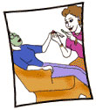  Nail Technician |  | - Comparing Nail Prices  - Nail Art Anyone?  - Girls' Life, Boys' Life: What are the marketing messages to each? Should they be different?  - Clipper Creations  - Websites; Games & Apps: Nail Studio Games; Make Up Games; Skin, Hair & Nails App  - The Quest for Perfection: A WebQuest | , , All  , , All  Primary  Secondary
BUTCHER & SMALLGOODS MAKER |  | - The Butcher Shop  - Fact Check: Australian meat consumption? Changing?  - Websites, Games & Apps: Sausage Making Made Easy; The Main Meal; Masterchef; The Main Meal Videos; Ask the Butcher App | , , All  ,  , , All
CHEF  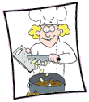  FAST FOOD COOK  KITCHEN HAND |  | - Prepare a baked lamb dinner for your family  - Comparing Recipes Online  - Websites; Games & Apps: Cooking Games; Masterchef; Epicurious Recipes & Shopping List App; Kitchen Calculator PRO App; Jamie Oliver – 20 minute meals; ABC Splash Gobbling Goblins | , , All  , , All  , , All
LOTJ – Mark Olive – Chef |  | - Using Native Ingredients | , , All
CROUPIER |  | - How Macau became the world’s casino capital: Retrieval Chart Strategy  - Probability, Odds and Random Chance: Expert Jigsaw Strategy  - Mr Nussbaum: Probability Fair - Game
DRYCLEANER |  | - Plastics, Coat Hangers and Drycleaning | Secondary
ENTREPRENEUR  Franchisor  Franchisee |  | - The Shark Tank!  - A Quick Quiz on Franchises in Australia  - Young Change Agents – can you become one? | , , All  , , All  , , All
LOTJ - SOCIAL ENTREPRENEURS  Nic Marchesi and Lucas Patchett – Orange Sky Laundry |  | - Australian Social Entrepreneurs and You!  - Analysing Social Entrepreneurship #TC  - Australian Social Enterprise Awards (lesson plans from VCAA) | , , All  Secondary  Middle
LOTJ – FRANCHISOR  Janine Allis – Boost Juice Bars |  | - A new Boost drink? Your Pitch to Janine | , , All
EVENTS COORDINATOR |  | - Let’s Plan a Birthday Party!  - Pop-Up Dining: Let’s get organised! | Primary Middle  Secondary
LOTJ – EVENTS COORDINATOR  Steve Duggan |  | - Invitations are going out! | Middle Secondary
FLORIST |  | - Flower Decoration at Home  - Your Flower Business?  - Cut Flowers and Valentine’s Day: What do you know!  - Websites, Games & Apps: Flower Memory Game; Flower Games; Plant and Flower Games; The Florist Game  - Seed Power – A WebQuest | Middle  Primary  Primary
FUNERAL DIRECTOR  FUNERAL ATTENDANT  EMBALMER |  | - The Top 10 Funeral Songs – would you choose anything different?  - The cost of a death notice?  - Writing a Death Notice or Obit!  - Mummification: Research Project | , , All
GREEN GROCER  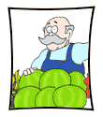 |  | - Research into Onions  - Internet Shopping – a comparison of prices and value  - Websites: Green Grocer’s Game; Fruit Sudoku Puzzle; Fruit Ninja Lite App | Primary  Primary
HAIRDRESSER |  | - Hair Style Comparison  - Shampoos and Conditioners – are they all they crack up to be?  - Websites: Hairdresser Games 2; Hairdressing Video Tour App; Hair Salon App | Secondary  Primary  Secondary
HOME ENTERTAINMENT STORE ATTENDANT |  | - What do people like in Home Entertainment?  - Make an up-to-date Public Service Announcement Netflix [or another streaming service] and Australian Content.  - Software Piracy in Thailand WebQuest | Primary Middle  Secondary
HOTEL/MOTEL MANAGER |  | - Managing your staff  - Survey of Motels  - The Impact of AirBnB on the Industry  - Working in Freycinet, Tasmania?  - Hotel Rwanda – the Ethical Issues Involved | Primary Middle
KENNEL or CATTERY OPERATOR |  | - 8 things we do that really confuse our dogs!  - How much do we spend on our pets? Is it ethical? | Primary Middle  , , All
LOCKSMITH |  | - Comparing Keys and Codes!  - Intricate and Cryptic Key Designs  - Toys Keyed in!  - How do keys open locks? A presentation! Cornell Note-taking Method & Mind-Mapping | Primary
MAKEUP ARTIST |  | - I’m entering the Australian Makeup Artist of the Year Awards!  - Movie Makeup | , , All
NEWSAGENT |  | - Newspaper Readership – hard copy or online?  - Muckracker Magazine WebQuest | Primary Middle  Middle
PASTRYCOOK  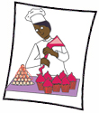 |  | - Try your hand at Pastry!  - The Sugar Bite | , , All
PET GROOMER |  | - How would I groom this dog?  - A Mobile Pet Grooming Fit Out!  - Critical and Creative Thinking Skills: Self Reflection | Primary  Secondary
PHARMACIST |  | - Chemist and Pharmacist  - A possible antidote to box jellyfish venom? How is a pharmacist involved?  - Websites, Games & Apps: Brain Pop: Medicines (2); Generation RX | Primary Middle  Secondary  Primary Middle
PICTURE FRAMER |  | - Creating a Straw Picture Frame  - DIY – Instructions on making this…  - Art Works and the Art of Framing | Primary  Primary
RESTAURANT MANAGER |  | - Chinese Restaurants in Australia! Researching the one in a town or suburb near you!  - Evolving Restaurant Types  - What does it take to open an Entomophagy Restaurant? | , , All  Secondary
RETAIL MANAGER |  | - Costing…  - Fish shop: quality or quantity?  - Fish Biz: Cash Flow  - Is this mirror correct?  - Is it a good idea for the grocery stores you know to become Grocerants? | Primary  Primary Middle  Middle  Secondary
SALESPERSON |  | - Garage Sale  - Websites: Lemonade Stand (3); Style App;  - Dealing with Difficult Customers  - Cracking the Code (developed by Try Engineering)  - Nice Shoes: What’s the Price WebQuest  - When in Rome – Shop! WebQuest  - Parts of a Computer - WebQuest | Primary  Secondary  , , All  Primary  Secondary
SCREEN PRINTER |  | - Pretty Rooster – A T-shirt Design Business with a Purpose  - Compare & Contrast: Coping with a T-Shirt Designing Business | Primary
LOTJ – Lachlan  Screen Printer and Fashion Designer |  | - Size Seven: How did Lachlan do it?  - Designing a new T-Shirt | , , All  , , All
SIGNWRITER |  | - The Signmaker’s Assistant  - Designing Your Home Town Name Sticker for a Car  Café Menu Board or Food Truck Menu Board – What’s in a Design? | , , All  , , All
TATTOO ARTIST |  | - A Survey of Tatts  - “The Original Tattooed Lady”  - The Law and Tattoos | Secondary  Secondary
VENDING MACHINE SERVICER |  | - What is in the school’s vending machine?  - Hospitals, Schools, Aged Care and Vending Machines: what are the healthy choices?
VISUAL MERCHANDISER |  | - There are DISPLAYS and displays! Do you know the difference?  - Your classroom will be on display for Parent-Teacher Night! How would you display it?
WAITER |  | - Where do that knife and fork go?  - Comedy Drama: There’s a rat in my soup! Or Basil the Rat  - Websites: The Waitress; Café Waitress; Restaurant Waiter: Thrills and Spills | Primary  Primary Middle
WEDDING COORDINATOR |  | - Wedding List: Where to seat my family?  - Pricing the Centre Piece for a Wedding! | Primary Middle  Middle Secondary
WEIGHT LOSS CONSULTANT |  | - Cold Showers – really? Let’s see using the Cornell Note-taking Method  - Healthy Food? | Secondary  , , All

