On the Job: Careers Market
Category: Office & Administration

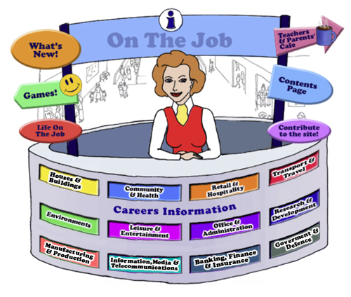

Teachers
Introduction
Welcome to this website for Australian students in Years 5 - 12, their teachers and parents.
The Design concept is based on the local Shopping Mall as students of this age are familiar with the Careers represented here. This initial concept broadened to include careers that they might have encountered outside the Shopping Mall eg. Local Government Inspector or Farmer
The website can be used as an individual activity for students or as a whole group.
This Teacher’s Guide is for the whole class and is aligned to the Australian Curriculum and the General Capabilities.

The Jobs
Each of the jobs listed has three sections
- The Information about each Job. | - Activities | - Links

All content in the Job Info sections have been taken from The Job Guide. Under copyright laws and from the Job Guide’s website – this information can be used for Educational purposes.
This content also encourages reading and therefore literacy but breaks down information into chunks and divided by “Did You Know?” segments.
The Activities can be divided into two sections:
- Offline
- Online
The activities bring a fun element into learning. There are practical skills about the particular job eg. “How to build a beehive” [in the Beekeepers section] is an Offline activity.
The Online activities include mostly free mobile apps, YouTube Videos, games and also WebQuest activities which provide students with Problem-Based Learning and the opportunity to use their Higher Order Thinking and Collaboration Skills.
The Links provide students with access to Association websites for that particular Industry as well as links to examples of people within this job and their experiences.
Life on the Job is divided into three sections:
- Historic or Famous People – mostly Australians | - Indigenous Historic or Famous People | - “Real Life People”
Historic or Famous People
Historic or Famous People are mostly famous Australians whose lives are usually investigated within the Australian Curriculum. Each person is researched and their lives summarised to give students an overview. There are links provided so students can investigate more fully themselves. At the end of the content information, students are given an activity to complete – mostly using the latest and free ICT tools available to increase their knowledge and capability.

Indigenous Historic or Famous People
Indigenous Historic or Famous People are famous Australians whose lives are usually investigated within the Australian Curriculum. Each person is researched and their lives summarised to give students an overview. There are links provided so students can investigate more fully themselves. At the end of the content information, students are given an activity to complete – mostly using the latest and free ICT tools available to increase their knowledge and capability.

Real Life People
Real Life People’s stories are provided here. Parents can submit their job and show students their educational journey to achieve employment within their job category.

Alignment with the Australian Curriculum
Curriculum Area: Australian Curriculum: General Capabilities
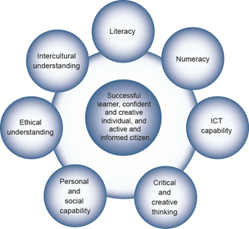

The Australian Curriculum includes seven general capabilities:
- Literacy
- Numeracy
- Information and communication technology (ICT) capability
- Critical and creative thinking
- Personal and social capability
- Ethical understanding
- Intercultural understanding.
(Source: Australian Curriculum)
Literacy involves students in listening to, reading, viewing, speaking, writing and creating oral, print, visual and digital texts, and using and modifying language for different purposes in a range of contexts.
Numeracy involves students in recognising and understanding the role of mathematics in the world and having the dispositions and capacities to use mathematical knowledge and skills purposefully.
Information and communication technologies are fast and automated, interactive and multimodal, and they support the rapid communication and representation of knowledge to many audiences and its adaptation in different contexts. They transform the ways that students think and learn and give them greater control over how, where and when they learn.
Critical and creative thinking are integral to activities that require students to think broadly and deeply using skills, behaviours and dispositions such as reason, logic, resourcefulness, imagination and innovation in all learning areas at school and in their lives beyond school.
Students develop personal and social capability as they learn to understand themselves and others, and manage their relationships, lives, work and learning more effectively. The capability involves students in a range of practices including recognising and regulating emotions, developing empathy for others and understanding relationships, establishing and building positive relationships, making responsible decisions, working effectively in teams, handling challenging situations constructively and developing leadership skills.
Ethical understanding involves students in building a strong personal and socially oriented ethical outlook that helps them to manage context, conflict and uncertainty, and to develop an awareness of the influence that their values and behaviour have on others.
As cultural, social, environmental and technological changes transform the world, the demands placed on learners and education systems are changing. Technologies bring local and distant communities into classrooms, exposing students to knowledge and global concerns as never before. Complex issues require responses that take account of ethical considerations such as human rights and responsibilities, animal rights, environmental issues and global justice.
Building ethical understanding throughout all stages of schooling will assist students to engage with the more complex issues that they are likely to encounter in the future, and to navigate a world of competing values, rights, interests and norms.
Intercultural understanding: The capability involves students in learning about and engaging with diverse cultures in ways that recognise commonalities and differences, create connections with others and cultivate mutual respect. (Source: Australian Curriculum)
Priorities:
Asia and Australia's engagement with Asia
Aboriginal and Torres Strait Islander histories and cultures
Sustainability

Philosophy: This icon represents both Critical and Creative Thinking and Ethical Understanding but at a deeper level. The activities with this icon show a high level of complex thinking is required. The activity can be used with classes undertaking Philosophy in Schools.
Cooperative Learning Activity
A collaborative (or cooperative) learning approach involves students working together on activities or learning tasks in a group small enough for everyone to participate on a collective task that has been clearly assigned. Students in the group may work on separate tasks contributing to a common overall outcome, or work together on a shared task.

Emerging Job
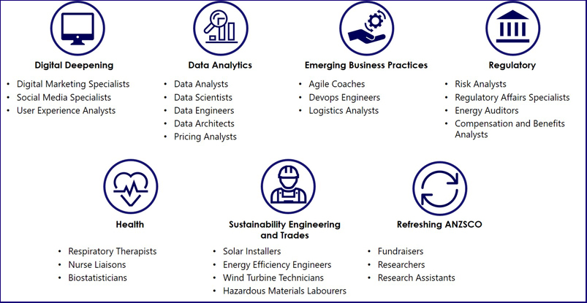
The jobs listed above are emerging jobs identified by the National Skills Commission.
Emerging occupations are defined as new, frequently advertised jobs which are substantially different to occupations already defined in the Australian and New Zealand Standard Classification of Occupations (ANZSCO) – such as data scientist and data analyst. As such, to compile our list we considered data from the time period following the last ANZSCO review in 2013.
The NSC has identified and validated 25 emerging occupations within seven categories in the Australian labour market (Figure 1). This list is not considered exhaustive, and the NSC will continue to monitor and analyse emerging trends.
An advantage of our approach is access to real time internet job advertisement data using Burning Glass Technologies, which will allow us to pick up occupations in emerging fields like blockchain, nanotechnology, quantum computing and the internet of things as soon as the employer demand for these skills increases.
https://www.nationalskillscommission.gov.au/what-are-emerging-occupations

On the Job – Australian Curriculum General Capabilities Alignment with Activities

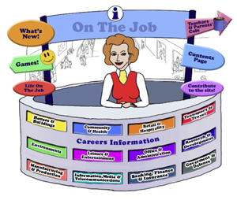
All of the activities in “Life On the Job” have also been aligned with the Australian Curriculum’s General Capabilities. They are meant to be fun and engaging for the student and introduce them to the world of work in a more concrete way. On the Job builds on what students have learnt in their earlier years in Primary School about the world of work and helps students go from the concrete to the abstract in their thinking. Each activity shows the General Capability [GC] being focussed on by showing the GC icon and any Priorities.
Future Growth
Each job is given a Future Growth icon: either Decline; Moderate, Static; Strong or Very Strong growth. These icons were created by On the Job.
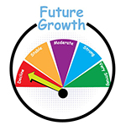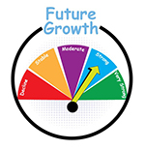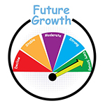
The information has been obtained from the Australian Government website: Labour Market Insights. https://labourmarketinsights.gov.au/

OFFICE AND ADMINISTRATION
JOB | Australian Curriculum General Capability | ACTIVITY | Target Level
ARCHIVIST |  | - Researching your family tree  - Create a Memory Box  - Research the History of your suburb  - Research the History of your school  - Websites: UK National Archives – Games and Activities; US National Archives: Teacher Resources; Researching your family history using the National Archives of Australia  - The Conversation: Why Germaine Greer’s life in letters is one for the archives | , , All  Primary Middle  Primary Middle  , , All  , , All  Secondary
BOOKMAKER  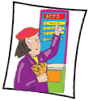  Bookmaker’s Clerk  Betting Clerk  Betting Agency Counter Clerk  Other Betting Clerks - Bingo Caller & Keno Terminal Operator  Telephone Betting Clerk  Tote Operator |  | - Probability – Horse Racing Game  - Probability: the Horse Race Game (from NZ Maths)  Your Best Friend at the Races: Maths! Know when to bet, and when to hold (from UniMelb) | Primary Middle  ,
CALL CENTRE OPERATOR  CALL CENTRE TEAM LEADER |  | - Do you see what you hear?  - Voiceprint and the ATO  - Websites, Games & Apps: Triple Zero Kids Challenge | , , All
CHILD CARE CENTRE MANAGER |  | - Are women ‘outsourcing’ parenting by sending their children to childcare? A Community of Inquiry
CONVEYANCER |  | - The Ethics of Buying or Selling on Flood Plains – Community of Inquiry. Geography Students.
CORPORATE TRAINER |  | - School Policies: Need explaining?  - Ice Breakers  - Train a partner in a new technology! | Primary  ,  , , All
LOTJ – Anne-Marie Esler  Corporate Trainer |  | - Make a Presentation | , , All
FUNDRAISER |  | - Fundraising! What’s your charity or cause?  - Should Political Fundraising be limited and transparent or not? Academic Controversy Strategy | , , All
HOSPITAL ADMINISTRATOR |  | - McHospitals – should we have them?  - Big Data, Better Hospitals | All
INTERPRETER |  | - Translate accurately?  - The Interpreter Movie – a follow up | Primary Middle  Secondary
JUDGE  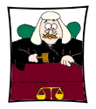 |  | - Conflict Resolution  - Ned Kelly – Trial  - Human Rights Issues or Injustices in 2018: Pick one!  - Conflict Yellowstone Wolves WebQuest | Middle
LOTJ – Chief Justice of the High Court – Susan Kiefel |  | - Judgements  - Making Ethical Decisions  - Constitutional Recognition of Indigenous Australians? How? | , , All  Secondary
LAWYER |  | - Mock Trial: Revisiting the Lindy & Michael Chamberlain (‘Dingo’) Trial, 1982  - Policing and Informants in Victoria: What are the ramifications?  - Websites, Games & Apps: Dictionary Legal Guide App; Butterworths Concise Australian Legal Dictionary App; Enquiring Minds: Human Rights | Secondary  Secondary  , , All
LOTJ – Professor Mick Dodson  Barrister, Lawyer, Academic |  | - PowToon…”Mick Dodson come on down!”  - Concerns of Young Indigenous Australians | Primary Middle  Secondary
LOTJ – Nelson Mandela  Lawyer, President of South Africa |  | - Racism – What does it feel like? | , , All
LOTJ – Grata Flos Greig – First Female Australian Lawyer |  | - “The Gender Debate” – Now and then | Secondary
LOTJ – Deng Thiak Adut  Lawyer and Refugee Advocate |  | - Determination, Optimism and Courage!  - Refugee kids adapt to Australia
LIBRARIAN  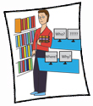 |  | - Is Dewey working in your Library?  - Creating a National Book Week Theme and Activities  - Banning Books – Is this Ethical? | , , All  Secondary
MANAGEMENT CONSULTANT |  | - What does this really say?  - Writing a Job Description: School Captain  - Websites, Apps & Games: Be Your Own Boss; Gazillionaire!; Lemonade Stand; Coffee Shop;  - Small Business WebQuest: Take Charge of Your Future  - Strategic Planning WebQuest | Secondary  , , All  , , All  Secondary  Middle
LOTJ – Dave  Management Consultant |  | - Conducting a Survey: How could School Assemblies be improved? What does the community think? | , , All
MARKET RESEARCH ANALYST |  | - Kids vs Food: Brussels Sprouts; Vegemite; Blue Vein Cheese; and Oysters! Let’s Analyse  - Which eggs to buy?  - Should Twitter change its format? | , , All  Secondary
MARKETING OFFICER |  | - Make a Flip Book Ad  - Make a Jingle for a Product  - Create a new slogan for Tourism Australia’s Aboriginal Tourism website  - Gruen: We're back! Spin Free!  - Marketing Mix WebQuest  - Marketing: Responsive or Responsible WebQuest | , , All  , , All  , , All  Secondary  Middle  Secondary
LOTJ – Paris Touma  Marketing Officer |  | - Psychology of Buying – Designer Jeans  - Psychology of Buying | , , All  Secondary
MEDICAL ADMINISTRATOR |  | - Do the benefits of sharing clinical images outweigh the ethical concerns of patient privacy?  - Assassination by pacemaker: how would we protect our patients?
NURSE MANAGER  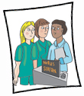  MIDWIFERY MANAGER  MIDWIFERY UNIT MANAGER  NURSING CLINICAL DIRECTOR |  | - The Monthly Roster!  - Want to improve care in nursing homes? Mandate minimum staffing levels: PSA!
OFFICE ADMINISTRATOR  CORPORATE GENERAL MANAGER  CHIEF EXECUTIVE AND MANAGING DIRECTOR |  | - The Office – Remake: Australian version!  - Improving Air Quality at School  - An Inspiring CEO: Melanie Perkins  - Websites, Games & Apps: Corkulous App; Easy Sign App; Genius Scan App | Secondary  , , All  Secondary
PRIVATE INVESTIGATOR |  | - Treasure Hunt  - Spot It! Game  - How Private Investigators Work | Primary  , , All  Secondary
RECEPTIONIST |  | - A Day in the Life of a Medical Receptionist  - Corporate Deception: will you be part of it?  - Wearing Heels: is this essential as a Receptionist? | Secondary
SECRETARY  Executive Secretary  Legal Secretary  Machine Shorthand Report  Medical Secretary  Medical Transcriptionist |  | - Activity: Shorthand  - Dictation! Dictation! Dictation! How to develop this skill  - Websites, Games & Apps: Typing Master; Free Typing Games; Typing Games; Typing Test; Typing Test 2; | Middle  , , All  , , All
LOTJ – Carmel Warnock  School Secretary |  | - Act like a Secretary … Organising my family | Primary Middle
SECURITY CONSULTANT |  | - Safety or profit? The booming business of CCTV and Safer Streets  - So where does the balance lie, between people’s privacy and keeping people safe?  - Websites, Games & Apps: Laptop Security Game; Escape Security Game | , , All  , , All
SPORTS ADMINISTRATOR  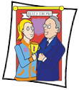 |  | - Planning a Sporting Event  - Sports, Doping & Ethics!  - It’s not Cricket! | , , All  Secondary  Secondary
SPORTS CENTRE MANAGER (Amusement & Fitness) |  | - Your favourite ride! Just a minute  - Step counting  - VR, Theme Parks & Thrill Seekers | , , All  , , All  , , All
STEWARD (of Racing)  Cadet or Stipendiary Steward  Handicapper  Judge  Licensing & Administrator Coordinator |  | - How did I get here? A Profile of Kristian Hawkins – A Cadet Steward  - Handicaps: How does it work, then?  - Jiggers, Whips & Stewards: A Community of Inquiry
LOTJ Collie Waller - Steward Victoria Racing |  | - Flemington Stewards’ Report  - Connect Three: Corie Waller
LOTJ Natashia Radford – Judge Victoria Racing |  | - Learn the Colours! | , , All

