On the Job: Careers Market

Category: Environments

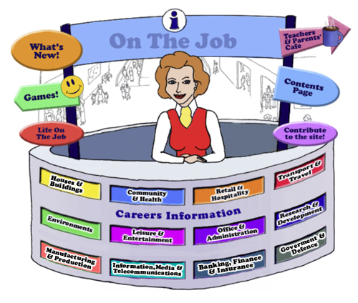

Teachers
Introduction
Welcome to this website for Australian students in Years 5 - 12, their teachers and parents.
The Design concept is based on the local Shopping Mall as students of this age are familiar with the Careers represented here. This initial concept broadened to include careers that they might have encountered outside the Shopping Mall eg. Local Government Inspector or Farmer
The website can be used as an individual activity for students or as a whole group.
This Teacher’s Guide is for the whole class and is aligned to the Australian Curriculum and the General Capabilities.
The Jobs
Each of the jobs listed has three sections
- The Information about each Job. | - Activities | - Links

All content in the Job Info sections have been taken from The Job Guide. Under copyright laws and from the Job Guide’s website – this information can be used for Educational purposes.
This content also encourages reading and therefore literacy but breaks down information into chunks and divided by “Did You Know?” segments.
The Activities can be divided into two sections:
- Offline
- Online
- Primary School is for students from Years 5 – 6
- Middle School is for students from Years 7 – 8
- High School is for students from Years 9 - 12
The activities bring a fun element into learning. There are practical skills about the particular job eg. “How to build a beehive” [in the Beekeepers section] is an Offline activity.
The Online activities include mostly free mobile apps, YouTube Videos, games and also WebQuest activities which provide students with Problem-Based Learning and the opportunity to use their Higher Order Thinking and Collaboration Skills.
The Links provide students with access to Association websites for that particular Industry as well as links to examples of people within this job and their experiences.
Life on the Job is divided into three sections:
- Historic or Famous People – mostly Australians | - Indigenous Historic or Famous People | - “Real Life People”
Historic or Famous People
Historic or Famous People are mostly famous Australians whose lives are usually investigated within the Australian Curriculum. Each person is researched and their lives summarised to give students an overview. There are links provided so students can investigate more fully themselves. At the end of the content information, students are given an activity to complete – mostly using the latest and free ICT tools available to increase their knowledge and capability.
Indigenous Historic or Famous People
Indigenous Historic or Famous People are famous Australians whose lives are usually investigated within the Australian Curriculum. Each person is researched and their lives summarised to give students an overview. There are links provided so students can investigate more fully themselves. At the end of the content information, students are given an activity to complete – mostly using the latest and free ICT tools available to increase their knowledge and capability.

Real Life People
Real Life People’s stories are provided here. Parents can submit their job and show students their educational journey to achieve employment within their job category.

Alignment with the Australian Curriculum
Curriculum Area: Australian Curriculum: General Capabilities
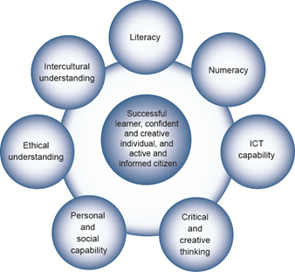

The Australian Curriculum includes seven general capabilities:
- Literacy
- Numeracy
- Information and communication technology (ICT) capability
- Critical and creative thinking
- Personal and social capability
- Ethical understanding
- Intercultural understanding.
(Source: Australian Curriculum)

Literacy involves students in listening to, reading, viewing, speaking, writing and creating oral, print, visual and digital texts, and using and modifying language for different purposes in a range of contexts.
Numeracy involves students in recognising and understanding the role of mathematics in the world and having the dispositions and capacities to use mathematical knowledge and skills purposefully.
Information and communication technologies are fast and automated, interactive and multimodal, and they support the rapid communication and representation of knowledge to many audiences and its adaptation in different contexts. They transform the ways that students think and learn and give them greater control over how, where and when they learn.
Critical and creative thinking are integral to activities that require students to think broadly and deeply using skills, behaviours and dispositions such as reason, logic, resourcefulness, imagination and innovation in all learning areas at school and in their lives beyond school.
Students develop personal and social capability as they learn to understand themselves and others, and manage their relationships, lives, work and learning more effectively. The capability involves students in a range of practices including recognising and regulating emotions, developing empathy for others and understanding relationships, establishing and building positive relationships, making responsible decisions, working effectively in teams, handling challenging situations constructively and developing leadership skills.
Ethical understanding involves students in building a strong personal and socially oriented ethical outlook that helps them to manage context, conflict and uncertainty, and to develop an awareness of the influence that their values and behaviour have on others.
As cultural, social, environmental and technological changes transform the world, the demands placed on learners and education systems are changing. Technologies bring local and distant communities into classrooms, exposing students to knowledge and global concerns as never before. Complex issues require responses that take account of ethical considerations such as human rights and responsibilities, animal rights, environmental issues and global justice.
Building ethical understanding throughout all stages of schooling will assist students to engage with the more complex issues that they are likely to encounter in the future, and to navigate a world of competing values, rights, interests and norms.
Intercultural understanding: The capability involves students in learning about and engaging with diverse cultures in ways that recognise commonalities and differences, create connections with others and cultivate mutual respect. (Source: Australian Curriculum)
Priorities:
Asia and Australia's engagement with Asia
Aboriginal and Torres Strait Islander histories and cultures
Sustainability

Philosophy: This icon represents both Critical and Creative Thinking and Ethical Understanding but at a deeper level. The activities with this icon show a high level of complex thinking is required. The activity can be used with classes undertaking Philosophy in Schools.
Cooperative Learning Activity
A collaborative (or cooperative) learning approach involves students working together on activities or learning tasks in a group small enough for everyone to participate on a collective task that has been clearly assigned. Students in the group may work on separate tasks contributing to a common overall outcome, or work together on a shared task.

Emerging Job
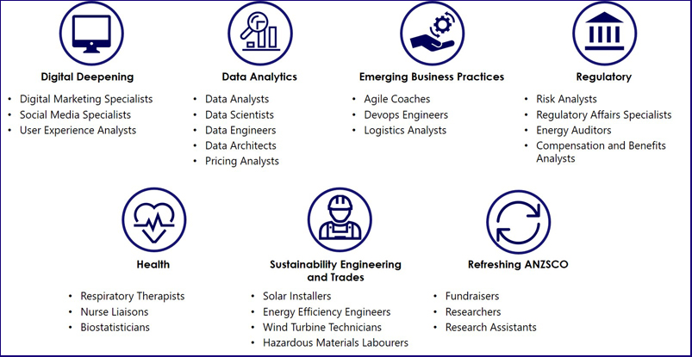
The jobs listed above are emerging jobs identified by the National Skills Commission.
Emerging occupations are defined as new, frequently advertised jobs which are substantially different to occupations already defined in the Australian and New Zealand Standard Classification of Occupations (ANZSCO) – such as data scientist and data analyst. As such, to compile our list we considered data from the time period following the last ANZSCO review in 2013.
The NSC has identified and validated 25 emerging occupations within seven categories in the Australian labour market (Figure 1). This list is not considered exhaustive, and the NSC will continue to monitor and analyse emerging trends.
An advantage of our approach is access to real time internet job advertisement data using Burning Glass Technologies, which will allow us to pick up occupations in emerging fields like blockchain, nanotechnology, quantum computing and the internet of things as soon as the employer demand for these skills increases.
https://www.nationalskillscommission.gov.au/what-are-emerging-occupations

On the Job – Australian Curriculum General Capabilities Alignment with Activities

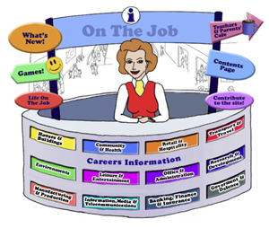
All of the activities in “Life On the Job” have also been aligned with the Australian Curriculum’s General Capabilities. They are meant to be fun and engaging for the student and introduce them to the world of work in a more concrete way. On the Job builds on what students have learnt in their earlier years in Primary School about the world of work and helps students go from the concrete to the abstract in their thinking. Each activity shows the General Capability [GC] being focussed on by showing the GC icon and any Priorities.
Future Growth
Each job is given a Future Growth icon: either Decline; Static; Moderate, Strong or Very Strong growth. These icons were created by On the Job.
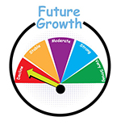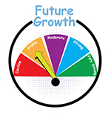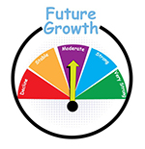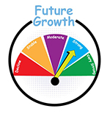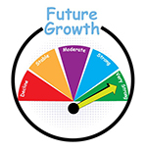
The information has been obtained from the Australian Government website: Labour Market Insights. https://labourmarketinsights.gov.au/

ENVIRONMENTS:
JOB | Australian Curriculum General Capability | ACTIVITY | Target LEVEL
AGRICULTURAL CONSULTANT  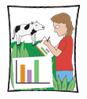 |  | - Australia has a heritage conservation problem. Can farming and Aboriginal heritage protection co-exist? A Community of Inquiry #TC | Secondary
ANIMAL ATTENDANT/TRAINER  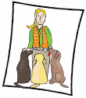  Dog Handler/Trainer  Guide Dog Instructor |  | - TV Animal Wrangler – a new ad for the RSPCA  - Training Dolphins – how clever are they? Should we treat them the way we do?  - Clicker Training for your dog | , , All
AQUACULTURE FARMER  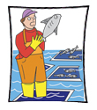  Abalone Diver  Aquaculture Worker  Fisheries Diver  Pearl Diver |  | - School of Fish – What’s Involved?  - Are Salmon Farms damaging Australian waters?  - It’s about domestication, changed Ecology, sustainability! Should we do it?  - Dangerous Diving [from NMA]  - “The Pearl Diver” by Julia Johnson [a range of activities around this book]  - Prawns for Profit (developed by CSIRO, UTS & AAMT) – a range of activities for mathematics and ecology students | , , All  Secondary
ARBORIST  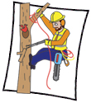 |  | - Site Hazard Assessment: A Study of Trees at School  - What is the Value of Trees? Why should we bother?  - Design a Park  - Leaf Abscission – A Research Project | , , All
BEEKEEPER  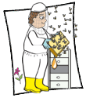  Bee Broker |  | - Building a Warre Hive: What’s the cost?  - BEES AND HEXAGONS  - Fires and Beekeeping: What’s the implications?  - Let’s do the maths for the Almond Industry and the Bee Brokers  - Investigating the maths inside: Bees with backpacks (UTS, CSIRO, AAMT)  - Websites & Games: Beekeeping Games; Killer Bees; Bees and Honey  - To Bee or Not to Bee: WebQuest: An adaptation for students in Years 5 - 8 | Secondary  Secondary  Primary  Middle
LOTJ – Cedar & Stu Anderson |  | - Connect Three: Honey Bees  - The Way of the Waggle Dance | , , All  , , All
CIVIL ENGINEER |  | - What do you know: Fungi can help concrete heal its own cracks!  - The Sydney Harbour Bridge: An investigation  - Websites, Games and Apps: Building Games; Building Bridge Game; Extreme Engineering Games; Play Games; Design a Mars Parachute; Beat the Heat; PowerUp; Enquiring minds: Building;  - Cracking Dams WebQuest  - A Bridge over Water WebQuest | , , All  Secondary  Secondary
COASTAL ENGINEER |  | - Ocean Pools described using cartoons  - Ocean pools, Mathematics & Google Earth  - The Great Southern Reef – an Infographic Assignment | , , All
CROP FARMER  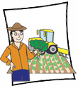 |  | - Wind Farm: Pros and Cons Game  - Science Plant Experiment: Can it be repeated? | Primary Middle
ELECTRICAL LINESMAN  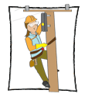 |  | - Wichita Lineman: the only song about Electrical Linesperson: analysis  - Australian Birds of Prey and Power Lines: 6 Thinking Hats
ENVIRONMENTAL CONSULTANT |  | - Juukan Gorge: Creating a WebQuest
FARMER  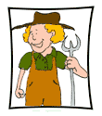 |  | - Drought in Australia! Should farmers be helped?  - A better understanding!  - Websites, Games & Apps: Word search; Write a poem; Virtual Farm; Horse Fun; Farm Frenzy 2 App
FARRIER  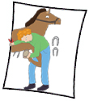 |  | - Horse Shoe Art  - The Anatomy of the Horse’s Hoof: What’s it all about? | Primary Middle
FLORICULTURIST |  | - Flowers in your garden – have a go! | , , All
FORESTER  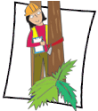 |  | - Reforestation: What can you do?  - Websites, Games & Apps: Forest Learning; Rainforest Alliance; Wildlife Detective App – NSW  - Bushfire! WebQuest  - The Science of Bushfires WebQuest (Web Archive Only) | Secondary  Primary  Secondary  Secondary
LOTJ – Charles Edward Lane Poole 1885-1970  Forester |  | - National Arboretum Canberra – How can you market this feature of Canberra to the rest of Australia and particularly to Australian children? | , , All
GRAIN, OILSEED OR PASTURE GROWER  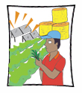 |  | - Watching it grow!  - Sleeping Giant: Linseed’s Health Properties could lead to a farming boom- possible? | Primary  Secondary
GREENKEEPER  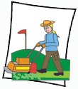 |  | - Water and Golf Courses  - Water and The Royal Adelaide Golf Club  - Best Practice | Primary Middle
HAZARDOUS MATERIALS LABOURER  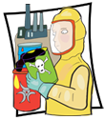  Hazardous Waste Manager |  | - Visually striking science experiments at school can be fun, inspiring and safe – banning is not the answer!? A Community of Inquiry #TC  - Chemical Safety in Schools – a Data Analysis
HORSE GROOMER  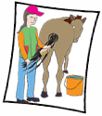 |  | - On the Shoulders of Giants: Create Your Own Horse Story | All
HORSE MANAGER  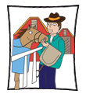 |  | - Managing a mare’s reproductive cycle. Innovative technology – wearable technology – can help this process but is it worth it?  - The Horse Grimace Scale and Horse Behaviour | All
HORSE TRAINER  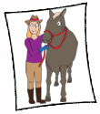 |  | - Mathematics and Horse Trainers  - Websites: Horse Rancher; Derby Quest Horse Racing Game App  - Mustangs Run Free WebQuest | Primary Middle  Primary
LOTJ – Gai Waterhouse  Horse Trainer |  | - What makes a great Australian Horse Trainer? | , , All
HORTICULTURAL ASSISTANT  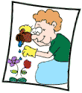 |  | - Get your school to join Stephanie Alexander’s Kitchen Garden for Schools!  - Make your own garden  - Website: Bloomin’ Gardens  - Our Indigenous Garden WebQuest | , , All  , , All  Primary  Secondary
LOTJ – Jenny  Plant Nursery Worker |  | - Design a nursery space that has flowers all year round | , , All
HORTICULTURALIST  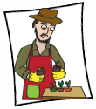 |  | - Can you really be poisoned by green or sprouting potatoes?  - Plants in Space? How does that work?  - What Apples?  - Websites, Games & Apps: Australian National Botanic Gardens: Horticultural Activities; Growing in the Garden; Experiments and Fun Activities; Horticulture: Your Yard & Garden  - The Science of Bushfires WebQuest | Middle  Secondary  Primary Middle  Secondary
LOTJ – Rob McGavin – Horticulturalist |  | - Tasting Extra Virgin Oil: “Oils Ain’t Oils” | , , All
JILLAROO/JACKEROO  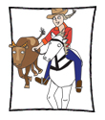 |  | - ABC’s Jillaroo School: A new series!  - The Reluctant Jillaroo vs The Jillaroo: What’s the best in your opinion?
LANDSCAPE ARCHITECT |  | - What does a Landscape Architect do?  - Design a Mini Golf Course  - The Roof is Growing  - Create a Rain Garden or Bioswale  - Design a Reading Garden | Primary  Middle  Middle  MiddleF
LOTJ – Edna Walling  Landscape Architect |  | - Create your own garden design | , , All
LIFEGUARD  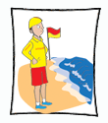 |  | - Surf Life Saving Queensland – Games  - Swimmers in Trouble!  - Bondi Rescue: Fitness all year?  - Investigate the Surf Boat Rowing within Surf Life Saving: for those living by the coast! | Primary  , , All  , , All
LOTJ – Edith (Kieft) Rowe 1907 – 1998  Life Guard |  | - The Up to Date Magazine  - Prejudice at Australian Beaches – still alive? | Primary Middle
LIVESTOCK FARMER  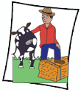 |  | - Sheep Game  - A Taste for Magpie Geese? Really!  - Seaweed, methane emissions and cow burps: What’s the connection? | Primary  Secondary
MINER  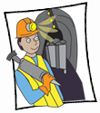 |  | - Mine Diorama  - Treasure from Trash: how mining waste can be mined a second time  - Beaconsfield Mine Collapse  - Websites, Games & Apps: ABC Splash: Space Lab Mine Rescue | Primary  Primary Middle
MINING ENGINEER |  | - Coal Seam Gas - Dispute
OLERICULTURIST |  | - Chinese Market Gardeners, the Gold Rush & Australian History: Expert Jigsaw Strategy  - Carrots: Girl Power: “Just Veg” Story  - About “FEAST” | , , All  , , All
PEST & WEED CONTROLLER  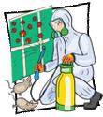 |  | - Australia’s Introduced Species: Pest or Resource? A Matter of Degrees – A Philosophical Exercise  - Mrs. Frisby and the Rats of NIMH – The Next Chapter  - Alternative Weed Control – create an experiment! | , , All  Primary Middle  Primary
PETROLEUM ENGINEER |  | - Oil, Oil Everywhere – What happens to birds and other wildlife?  - Australia and Timor-Leste: Who’s oil is it anyway?  - Websites, Games & Apps: Energy4Me: Lesson Plans and Activities | Primary Middle  Secondary  , , All
POMOLOGIST  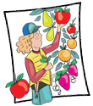 |  | - What Apples?  - Upple! What’s its story?  Bee Brokers & Pomologists | , , All  , , All  , , All
SHEARER |  | - Eric the Sheep  - Sheep Characters in the Media | Primary  Primary Middle
STONEMASON  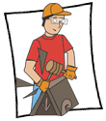 |  | - Design your headstone  - Gargoyles  - The Stonemason’s Yard by Canaletto | , , All  , , All
SURVEYOR |  | - Measuring distances using Google maps  - How ancient Babylonian land surveyors developed a unique form of trigonometry – 1000 years before the Greeks: Retrieval Chart Strategy  - Websites, Games & Apps: Surveyor Game; Grid Game – Bike Route; Coordinate Game; Worm Hunt | , , All
LOTJ – Augustus Alt  Surveyor General |  | - Who is the real Augustus Alt? | , , All
SUSTAINABILITY CONSULTANT  Conservation Officer [Landcare]  Conservation Worker  Natural Resource Manager  Sustainability Manager |  | - Cars and City Pollution - What can be done? Academic Controversy Strategy  #TC
VITICULTURALIST  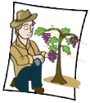 |  | - Visit a Viticulturalist  - Trellising! Which one?  - Viticulture & Climate Change? What are the effects on the Australian Industry?
WASTE WATER OPERATOR |  | - It’s not all about poo! Sparkling Success a different story  - What if we could clean waste water with corn cobs? Feasible?
WIND TURBINE TECHNICIAN |  | - The Science behind frozen wind turbines – Retrieval Chart Strategy #TC  - So how can Australia transform into a renewable energy powerhouse without leaving anyone behind 6 Thinking Hats? #TC  - Wind Turbines & Birds: A Community of Inquiry #TC  - Mathematical Calculations & Wind Turbines: NZ Maths – Wind Power; Wind Turbine Power Calculations – Royal Academy of Engineering; Working with Wind Energy - Try Engineering; Wind Energy Math Calculations: Calculating the Tip Speed Ration of Your Wind Turbine; Hydro Australia: Year 6 & 7: wind energy & design a wind turbine – varying numbers, angles, sizes and shapes of turbine blades | Secondary  Middle Secondary  Secondary  , , All
WOOL CLASSER  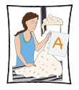 |  | - Alan Curtis – This is your life!  - Words and Wool Classing  - What is involved in Superfine Wool Contracts? | Primary Middle  Primary Middle  Secondary
ZOO EDUCATION MANAGER  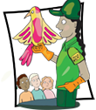  Zoo Education Officer  Zoo Curator  Zoo Instructional Designer  Zoo Science Writer |  | - Education Tour! Let’s make a Presentation! ZooNooz!  - Using Taronga Zoo’s Videos to be a Zoo Science Writer  - Challenging Activity: Pet Record keeping using “Blender”  - Websites: Tiger Adventures; Word Jumbles; Project Noah, Taronga Zoo – Learning Resources | , , All  , , All  , , All  , , All
ZOOKEEPER  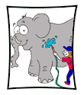 |  | - Design a suitable enclosure  - Zoo Mathematics! (Created by Taronga Zoo & NSW Education)  - Websites: Tiger Adventures; Word Jumbles; Project Noah | , , All  Primary Middle  , , All
LOTJ – Steve Irwin (1962 – 2006)  Zookeeper |  | - A Conservation Issue Movie | , , All

