On the Job: Careers Market – A Free Resource for teachers, parents & students from Years 5 – 12

CATEGORY: BANKING, FINANCE & INSURANCE

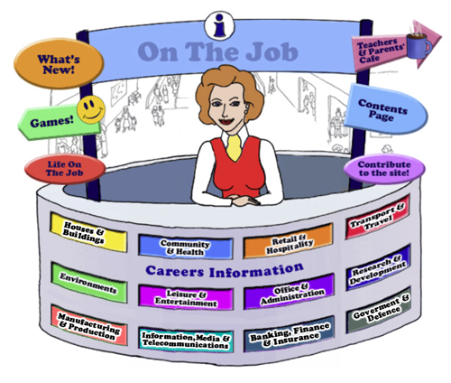

Teachers
Introduction
Welcome to this website for Australian students in Years 5 - 12, their parents and teachers.
The Design concept is based on the local Shopping Mall as students of this age are familiar with the Careers represented here. This initial concept broadened to include careers that they might have encountered outside the Shopping Mall eg. Local Government Inspector or Farmer
The website can be used as an individual activity for students or as a whole group.
This Teacher’s Guide is for the whole class and is aligned to the Australian Curriculum and the General Capabilities.

The Jobs
Each of the jobs listed has three sections
- The Information about each Job. | - Activities | - Links

All content in the Job Info sections have been taken from The Job Guide. Under copyright laws and from the Job Guide’s website – this information can be used for Educational purposes.
This content also encourages reading and therefore literacy but breaks down information into chunks and divided by “Did You Know?” segments.
The Activities can be divided into two sections:
- Offline
- Online
The activities bring a fun element into learning. There are practical skills about the particular job eg. “How to build a beehive” [in the Beekeepers section] is an Offline activity.
The Online activities include mostly free mobile apps, YouTube Videos, games and also WebQuest activities which provide students with Problem-Based Learning and the opportunity to use their Higher Order Thinking and Collaboration Skills.
The Links provide students with access to Association websites for that particular Industry as well as links to examples of people within this job and their experiences.
Life on the Job is divided into three sections:
- Historic or Famous People – mostly Australians | - Indigenous Historic or Famous People | - “Real Life People”
Historic or Famous People
Historic or Famous People are mostly famous Australians whose lives are usually investigated within the Australian Curriculum. Each person is researched and their lives summarised to give students an overview. There are links provided so students can investigate more fully themselves. At the end of the content information, students are given an activity to complete – mostly using the latest and free ICT tools available to increase their knowledge and capability.

Indigenous Historic or Famous People
Indigenous Historic or Famous People are famous Australians whose lives are usually investigated within the Australian Curriculum. Each person is researched and their lives summarised to give students an overview. There are links provided so students can investigate more fully themselves. At the end of the content information, students are given an activity to complete – mostly using the latest and free ICT tools available to increase their knowledge and capability.

Real Life People
Real Life People’s stories are provided here. Parents can submit their job and show students their educational journey to achieve employment within their job category.

Alignment with the Australian Curriculum
Curriculum Area: Australian Curriculum: General Capabilities
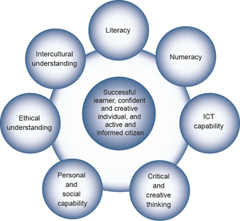

The Australian Curriculum includes seven general capabilities:
- Literacy
- Numeracy
- Information and communication technology (ICT) capability
- Critical and creative thinking
- Personal and social capability
- Ethical understanding
- Intercultural understanding.
(Source: Australian Curriculum)

Literacy involves students in listening to, reading, viewing, speaking, writing and creating oral, print, visual and digital texts, and using and modifying language for different purposes in a range of contexts.
Numeracy involves students in recognising and understanding the role of mathematics in the world and having the dispositions and capacities to use mathematical knowledge and skills purposefully.
Information and communication technologies are fast and automated, interactive and multimodal, and they support the rapid communication and representation of knowledge to many audiences and its adaptation in different contexts. They transform the ways that students think and learn and give them greater control over how, where and when they learn.
Critical and creative thinking are integral to activities that require students to think broadly and deeply using skills, behaviours and dispositions such as reason, logic, resourcefulness, imagination and innovation in all learning areas at school and in their lives beyond school.
Students develop personal and social capability as they learn to understand themselves and others, and manage their relationships, lives, work and learning more effectively. The capability involves students in a range of practices including recognising and regulating emotions, developing empathy for others and understanding relationships, establishing and building positive relationships, making responsible decisions, working effectively in teams, handling challenging situations constructively and developing leadership skills.
Ethical understanding involves students in building a strong personal and socially oriented ethical outlook that helps them to manage context, conflict and uncertainty, and to develop an awareness of the influence that their values and behaviour have on others.
As cultural, social, environmental and technological changes transform the world, the demands placed on learners and education systems are changing. Technologies bring local and distant communities into classrooms, exposing students to knowledge and global concerns as never before. Complex issues require responses that take account of ethical considerations such as human rights and responsibilities, animal rights, environmental issues and global justice.
Building ethical understanding throughout all stages of schooling will assist students to engage with the more complex issues that they are likely to encounter in the future, and to navigate a world of competing values, rights, interests and norms.
Intercultural understanding: The capability involves students in learning about and engaging with diverse cultures in ways that recognise commonalities and differences, create connections with others and cultivate mutual respect. (Source: Australian Curriculum)
Priorities:
Asia and Australia's engagement with Asia
Aboriginal and Torres Strait Islander histories and cultures
Sustainability

Philosophy: This icon represents both Critical and Creative Thinking and Ethical Understanding but at a deeper level. The activities with this icon show a high level of complex thinking is required. The activity can be used with classes undertaking Philosophy in Schools.
Cooperative Learning Activity
A collaborative (or cooperative) learning approach involves students working together on activities or learning tasks in a group small enough for everyone to participate on a collective task that has been clearly assigned. Students in the group may work on separate tasks contributing to a common overall outcome, or work together on a shared task.

Emerging Job
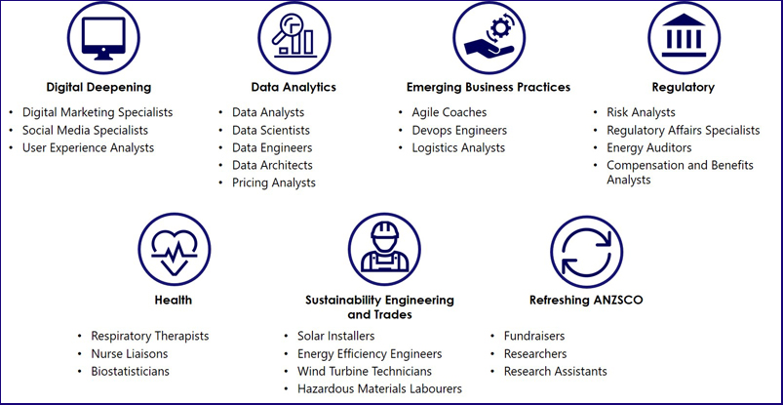
The jobs listed above are emerging jobs identified by the National Skills Commission.
Emerging occupations are defined as new, frequently advertised jobs which are substantially different to occupations already defined in the Australian and New Zealand Standard Classification of Occupations (ANZSCO) – such as data scientist and data analyst. As such, to compile our list we considered data from the time period following the last ANZSCO review in 2013.
The NSC has identified and validated 25 emerging occupations within seven categories in the Australian labour market (Figure 1). This list is not considered exhaustive, and the NSC will continue to monitor and analyse emerging trends.
An advantage of our approach is access to real time internet job advertisement data using Burning Glass Technologies, which will allow us to pick up occupations in emerging fields like blockchain, nanotechnology, quantum computing and the internet of things as soon as the employer demand for these skills increases.
https://www.nationalskillscommission.gov.au/what-are-emerging-occupations

On the Job – Australian Curriculum General Capabilities Alignment with Activities

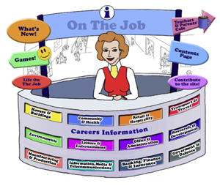
All of the activities in “Life On the Job” have also been aligned with the Australian Curriculum’s General Capabilities. They are meant to be fun and engaging for the student and introduce them to the world of work in a more concrete way. On the Job builds on what students have learnt in their earlier years in Primary School about the world of work and helps students go from the concrete to the abstract in their thinking. Each activity shows the General Capability [GC] being focussed on by showing the GC icon and any Priorities.
Future Growth
Each job is given a Future Growth icon: either Decline; Static; Moderate, Strong or Very Strong growth. These icons were created by On the Job.
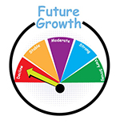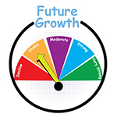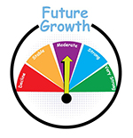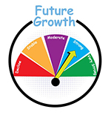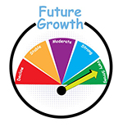
The information has been obtained from the Australian Government website: Labour Market Insights.
https://labourmarketinsights.gov.au/

Banking, Finance & Insurance
Job | 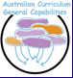 | Activity | Target Level
ACCOUNTANT |  | - Research the stock market  - Trees and Economics: The Story  - Websites: Mad Money; Monopoly: A Hands On Simulation Game for Beginner Accountant Students; Kids Money App  - So You Want to Own a Business? WebQuest  Sweatshops and Child Labor WebQuest | Secondary  , , All
LOTJ – Chris  Tax Accountant |  | - Kids’ saving accounts review | , , All
LOTJ – Rebecca  Tax Accountant |  | - Demonstrate CPA Qualifications as a Wordle | , , All
ACCOUNTS CLERK |  | - Luca Pacioli – what about him?  - The Cost of Food Waste | , , All  , , All
ACTUARY |  | - Race to the Top  - Is it Fair? | Primary Middle
AUDITOR |  | - Household Toilet Paper – An Audit  - The Cost of Rubbish Removal at School – any alternatives?  - The Dead Tree Detective | , , All  , , All  , , All
BANK OFFICER  Bank Manager  Credit Analyst  Credit & Loan Officer  Credit Manager  Decline |  | - Research task – Understanding chip and PIN  - Could “Watson” do a better job at being a bank teller than most current staff?  - What is Money Laundering? How does it effect Australian banks?: Cornell Note-taking Method & Analysis  - Credit Terms: Mindmap  - Personal Budget WebQuest  - Websites, Games & Apps – Banking 101 – Research Topic | Secondary  ,  Secondary
BOOKKEEPER |  | - Record Keeping of Entertainment Expenditure at Home | , , All
COMMODITIES TRADER |  | - ASX: Sharemarket Game  - A Resource for the Teaching & Learning of Commerce (developed by Consumer Affairs Victoria)
DEBT COLLECTOR  Credit Controller  Debt Counsellor  Repossession Agent |  | - Credit & Debt (developed by MoneySmart.gov.au)  - Mobile Savvy? (developed by ACCC & MoneySmart)  - Keeping Score: Why Credit Matters (Developed by Practical Money Skills USA)
ECONOMIST |  | - Economics and Commerce: Units of Work for Years 9 – 10 (developed by RBA)  3 Modules of work  - Superstar Productivity & Pay: Evidence from the AFL: Cornell Note-taking Method
INSURANCE AGENT |  | - Pet Insurance?  - Insurance explained  - Adani beware: coal is on the road to becoming completely uninsurable! | , , All  Secondary  Secondary
INSURANCE CLAIMS INVESTIGATOR |  | - Convenient but susceptible to fraud: why it makes sense to regulate charitable crowdfunding  - Can you be a fraudster? Would I Lie to You? | Secondary  , , All
INSURANCE CONSULTANT |  | - Banks, Insurance and Climate Change (adapted from NYT 22 April 2021) | Secondary
VALUER |  | - Comparing unimproved values in homes in Canberra, ACT!  - What should buyers of a house be told about it? | , , All

