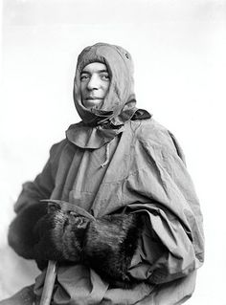
Frank Hurley- The Man Who Made History

Director- Simon Nasht (2004)

Documentary Script

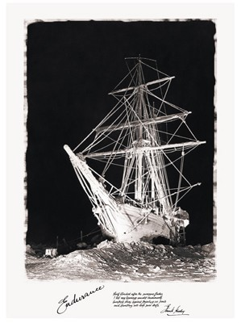
Frank Hurley- The Man Who Made History
Introduction and Mawson expedition to the Antarctic 0:00:00 TO 0:14:21

Archival footage

Sub-title “Film Finance Corporation Australia presents a Real Pictures Production BBC”
Man introduces documentary
I’ll now show you the films taken on the expedition by that remarkable photographer and daring man, Frank Hurley.
Film clip of man starting to show film
Alright gentlemen?

Montage of Hurley’s images

Dramatic noble music highlighting importance of Hurley’s achievements

Title “Frank Hurley The Man Who Made History”

Film clip of boat sailing through icy waters

Narrator voice over For decades, the story of Ernest Shackleton’s voyage to the Antarctic lay forgotten. But the rediscovery of the photos of that glorious failure has made it one of the great adventures of all time.

Film clips of boat sailing through ice, men working on boat and ice

Dramatic music

Narrator voice over An Australian photographer, Frank Hurley, made these images.

Image of Hurley

Narrator voice over Now they’re among the most valuable ever taken.

But it’s not just the photos that make them so sought after. It’s the stories that go with them.

(images and sounds of auction)

(auctioneer) That’s 85,000

Narrator voice over These collectors are after a piece of history. But is it possible they’re buying a grand illusion?

(auctioneer) 100 thousand pounds
***
Dramatic music with backdrop of various Hurley images and film clips
Pauses between each line

Narrator voice over Hurley travelled the world, pioneered the use of colour, helped invent the documentary film, and risked his life to bring back images of some of the great events of the 20th century.
But we now know some of his photos were elaborate concoctions. A few were outright fakes.

Today the experts are divided.

Was he an expert in photography or just a conjurer with a camera?

Music and shots of Hurley’s images continue
We see the interviewees as they begin to speak
Interviewees are not identified at this stage

Steve Martin (Polar Historian, Mitchell Library) It’s a dalliance with the truth that’s quite often quite upsetting.

Alasdair McGregor (Hurley’s biographer) Hurley was quite content to resort to faking.

Interviewee 2 He was a showman, he was a performer.

Mike Gray (Fox Talbot Museum) I think he was absolutely a master of the medium.

Gael Newton (National Gallery of Australia) He certainly invents things about himself.

Music becomes gentler, less dramatic as we shots of Hurley as well as images of the first expedition to the Antarctic

Sub-title “Hobart Tasmania 1911”

Narrator voice over Hurley was 26 when he talked his way into his job as cameraman on Australia’s first and greatest Antarctic expedition.

Film clip of crew laughing and joking
Narrator voice over Led by Douglas Mawson, it aimed to explore miles of uncharted territory.

Images of Hurley and crew

Narrator voice over Fifty years later, Hurley still remembered that first adventure.

Hurley aged 76 The Mawson expedition was Australia’s first expedition to Antarctica. I think that everybody who carried a camera applied for that job. I had spent my teenage life in the steelworks in Lithgow. I was a good mechanic and I had turned my hobby photography into my profession.

More shots of people waving on docks near Antarctic expedition boat

Narrator voice over Hurley was different to the other members of the expedition.

Alasdair McGregor He was a working class boy. The others were generally university men. A number of them had doctorates. One of them had deferred a Rhodes scholarship. They were highly educated. He wasn’t. He left school at the age of 12.

Film clip of boat sailing (b/w) next to film clip of modern boat (colour)

Full screen shot of modern boat in colour.
Cut to b/w film clip of ocean waves
Slow music continues
Image of Hurley transposed on screen

Narrator voice over Even today, retracing the footsteps of this restless adventurer is a challenge.

Film clip of penguins with small boat and men in background.

Narrator voice over But the places he explored left their mark on him and his photography.

Colour film clip of water and rocky island - Macquarie Island

Narrator voice over On a small finger of rock, halfway to the Antarctic, the city boy was stunned by the power of nature.

b/w clip of seal, man “playing” with seal

Hurley (voice over from diaries) Had I sufficient plates and films I could stay here for the rest of my life.

Image of two men on island (colour)

Clips and images of seals

McGregor He was bowled over by the miraculous potential of photography. He saw it as a means of escaping the drudgery of an ordinary working class life.

Colour clips of penguins, penguin sounds

Hurley voice over From the first time I gazed at the latent image I knew I’d found my real work and the key that would perhaps unlock the portals of the undiscovered world.

B/W images of penguins, B/W clip of rigging on boat, sounds of creaking ship Boat sailing past iceberg

Narrator voice over As they travelled south, Hurley imagined they were on an odyssey for the empire.

Image from “Argonauts of the South” - man (Hurley?) attaching Australian flag to small flagpole

Hurley voice over from diaries We felt like Argonauts, whose quest had led us to the world’s brim.

Image of iceberg

Music becomes more dramatic

Hurley voice over from diaries Slowly we crept on, filled with wonder and expectancy.

Narrator Reaching the unknown coast of the Antarctic, they grabbed their chance to go ashore.

Images of penguins with boat in ocean in background Small boats going to island
Man ‘riding’ seal

Images change to shots and clips of ice and snow, sounds of wind in background, men sliding down snow covered hill

Narrator But the brief summer was deceptive

Shots of ocean

Sounds of cold wind continues

McGregor Well, from personal experience, Commonwealth Bay in Cape Denison is the most appalling place. It’s actually the windiest place on the entire planet at sea level.

Film clips of men unloading provisions in windy icy and rocky area.

McGregor v/o They had literally built their accommodation in a raging river of wind.

Image of men building frame of wooden hut

Narrator In this alien place, Hurley struggled with his heavy camera.

Now, before there was even a word for it, he was making one of the first documentaries.

Shots and film clips of ice, snow, sound of wind, men walking in snow

Sub-title “Home of the Blizzard” 1913

McGregor v/o The results were staggering. And in terms of a narrative, he virtually made it up as he went along.

Shots of Hurley’s images showing difficult conditions

McGregor v/o He had to create a story out of the most appalling conditions in which they found themselves.

Further images and film clips of conditions

Men working in icy blizzard conditions
Images are at times difficult to see clearly due to snowy windy conditions

Hurley v/o from diaries I am determined to make the blizzard itself the subject for my film. My fingers froze and often I was swept away by fierce gusts or educed to crawling on all fours. One time I was lifted bodily with my camera and tripod, and dumped far away on the rocks.

Joanna Wright (National Geographic Society) What Hurley managed to bring together was a fantastic story with fantastic images.

More images and clips of men moving and working in blizzard conditions

Mike Oray (Fox Talbot Museum) It showed you a whole range of human experience, that nobody had ever seen before.

Film clips - sleds and dogs moving on ice, men putting up tent

Joanna Wright It was a seminal moment in the history of photography because no-one had ever realised just how powerful images are. And Hurley did that.

[NOTE: seminal = important, momentous)

Colour image of ice berg in blue waters.

Image of man with ice covering face placed over centre of iceberg image
Narrator v/o Hurley’s camera transformed their misfortune into the classic struggle between man and nature. His film retold the oldest myth of all: the hero’s journey.

Film clips of men, dogs, icy windy conditions in Antarctica

Sounds of wind blowing
Gently dramatic music

Narrator v/o It was the story he would tell repeatedly throughout his career as adventurer and showman.

Film clips gradually change from B/W shots of blizzard and snow to colour recent image of what remains of Mawson’s hut on rocky island.

Narrator Mawson’s hut has survived almost a century of buffeting by the blizzards.

Colour shots of inside of hut. Ice covered shelves and cupboards, with some provisions

Narrator Inside, 18 men waited out the winter storms.

B/W images of crew in sitting at table in hut

Sounds of men talking

Narrator Hurley made the most of his confinement, reading the tales of heroism that so inspired him
Images of Hurley in hut, books

Cut to images of remains of hut as McGregor begins to speak

McGregor As he was a self-made man, he was also a self-educated man.

Narrator And he had a captive audience on which to practise elaborate tricks. A showman in the making.

B/W images of men at table in hut

Alf Howard [Polar expedition 1929-31] (elderly man) I think he was generally accepted as the humourist of the party.

Narrator Alf Howard is the last man alive, who travelled with Hurley to the Antarctic.

Howard He nearly always got around with one of these gadgets around his neck (holds up woollen scarf).

Images of Hurley and crew posing for shots

Howard v/o I can remember on one occasion with us we were all sitting around the wad room table and suddenly smoke started to come out of his ears. He just had some tubes coming out of his mouth where he was smoking a cigarette. He used to love playing with rubber tubes.

Shot of dark room door and images from dark room from Mawson’s hut, images of chemicals etc

Narrator But Hurley never joked about his work. This tiny dark room was a sanctuary where he laboured for hours, transforming the real world into startling images.

Images of ice bergs

McGregor Near enough is not good enough. A simple sentence that Frank inscribed on the dark room wall.

Shot of words “NEAR ENOUGH IS NOT GOOD ENOUGH” written on wall

McGregor It really sums up a lot of his personality and his approach to life and work. If it wasn’t perfect, it wasn’t good enough for Frank Hurley. And he would go to any lengths to get the perfect image.
Images of Antarctic expedition: penguins, snow, ice bergs

Cut to modern day film clip of ocean

Daughters Adelie and Toni on small boat. They are identical twins (now elderly women) and are dressed the same

Adelie is holding a camera

Toni Hurley Looking around I’d say all the icebergs are different. I can’t see any two looking the same.

Adelie Hurley Oh look at that that. Oh my goodness. You can touch it.

Reaches out and touches ice berg they are passing.

Cut to interview with Adelie and Toni - sitting on couch at home

Adelie He wasn’t a father as fathers are expected to be at all. He was rather a fascinating stranger that visited.

Cut to film of Adelie and Toni on small boat

Narrator Though he was hardly ever home to raise them, Frank Hurley’s twin daughters, Toni and Adelie, have become guardians of their father’s legacy. Adventurers too, they’ve made several expeditions to some of the sites of their father’s expeditions.

Toni The things he did were quite hazardous. They were. He was taking his life in his hands quite a bit down there photographing.

B/W film clips of penguins in ice and snow, men on sleds

Sound of wind blowing

Narrator Hurley wanted to live the adventures as much as photograph them. And more than once, it nearly got him killed.

On a desperate sled journey to the South Magnetic Pole, he and two colleague battled blizzards for weeks.

Film of man sitting outside small tent on ice

Sounds of wind

Colour shots of men walking through snow

Transposed with shot of hands writing (in diary)

Hurley v/o from diary What three insignificant microbes of life we are, to trespass on these icy regions.

Colour shots of three men dragging sled through snow.

McGregor v/o They had about half a day’s ration left, the three of them. They’re facing death at this stage.

Narrator Only luck brought them back to safety. Two others on the expedition died.

Colour shots of three men dragging sled through snow.

Shot of wooden cross on rocks.

Narrator Hurley had chosen a dangerous life. So like many adventurers, he became a loner.
Notes:

Second voyage to Antarctica with Shackleton

B/W film clip docks and boat leaving

Sub-title “London 1914”

Narrator The Mawson expedition had established his reputation. Now, he aimed to make his fortune.

Hurley (elderly man) In 1914, I went south again for Ernest Shackleton’s Antarctic expedition.

Narrator Shackleton’s ambitious plan was to cross the Antarctic continent from coast to coast.

Image of map, boat sailing through icy waters

McGregor If they had been able to pull that feat off, it would have been the most staggering achievement in exploration history. And Hurley recognised this so he was there for a share, not just a salary.

Film clip (coloured) of iceberg

Narrator Hurley demanded part ownership of the photo royalties. Now he needed a drama to help sell them.

Shots of shadow of person filming

Steve Martin (Polar historian, Mitchell Library) It’s an epic story in just about every sense. It’s a literary epic, where the place of the gods is taken by the place of nature. Men are at the whim of these incredible forces of nature and the roll of the dice is really quite extraordinary. But to have Hurley’s images beside the retelling of that epic makes it one of the greatest adventures of all time.

Film of ship in icy waters

Gently dramatic music

Narrator With a stake in the outcome, he was never reluctant to express his opinions.

Film clip of Hurley climbing on rigging at front of boat

Mike Gray (Fox Talbot Museum) From the diary I can remember certain passages that stick in my mind, talking about Hurley perambulating aloft (walking above up high) and the stream of profanities coming down from above, extending the vocabulary of the British public school boys. I love the idea that he was irritating that privileged group.

Film clips, boat, icy water, Hurley sitting on mast

Narrator The Endurance travelled south until eventually, there was only a frozen sea in every direction. They were trapped.

Images of ship surrounded by ice.

Film clip of men digging ice.

Film clip of ship moving through ice - voice over of Frank Worsley Endurance captain A moment’s intense excitement to see what would be the result of forty-eight hours of unremitting toil. The ship is now being out full-speed ahead at the weakened ice. Hurley stood so close on the ice taking this picture that the ship’s stem broke off part of the ice floe on which he was standing. Fortunately it went up instead of down, otherwise you wouldn’t be seeing these pictures.

Film clip of men paying soccer on ice, with ship in background

Narrator The Endurance was doomed, but it lives on in Hurley’s images.

Various images of ship

Joanna Wright (National Geographic Society) When you look at a Frank Hurley photograph, when you look at the ice, you feel like you could walk into it, and touch it and hear it and smell it and feel the coldness of it.

Images of ship

Wright I think while Hurley was on that boat he realised the dramatic story that was happening around him and he had something that was gold dust.

Image of Hurley on ice with camera and tripod

Wright He got home and he was going to be able to sell that story in a way that no-one else had ever sold the Poles before.

Narrator Hurley needed photos equal to the drama engulfing them so he collected a palette of effects, especially clouds, using them to add impact and emotion.

Images of dramatic skies

Images of ship - original and with enhanced sky

Narrator And he was never shy about making himself part of the story. His archives are full of elaborately constructed self-portraits.

Images of Hurley on ice with camera and tripod

Frank Worsley Endurance captain v/o It was really heart-breaking to see the dear little endurance, which had been our home for so long, being crushed before our eyes. Hurley had rigged up his camera and got this picture of the ship in her death tolls.

Film clip of ship mast breaking

Narrator They made camp on floating ice and hoped for a miracle.

Image of dogs sitting on ice, trapped ship in background

McGregor If we didn’t have the visual record of the expedition, these exploits would virtually be a footnote in Antarctic history.

Images of men on ice with boxes of provisions

Narrator It’s remarkable that we have anything left at all. Hurley had to dive into the stricken ship to save his film, then was forced to abandon 400 of his glass plates. They were too heavy to carry.

Images of boat

Interviewee So he’s sitting there, possibly beside the boat, smashing negatives he knows he will never be able to retrieve again. And in a way there must have been a sense of, well more than regret, almost pain for Hurley.

Narrator He now had to make do with just a single small camera and a pocketful of film.

Hurley from diaries I wonder if three spools of film ever went through such exacting experiences before they were developed.

Film clips of men preparing small boats
Narrator They were forced into open boats, but Hurley would not give up his precious negatives.

Film clip of icy waves on sea and dramatic cloudy sky

Hurley from diaries I had to preserve them almost with my life. The time came when I had to choose between heaving them overboard or throwing away our surplus food. And the food went over.

Narrator They were seeking a bleak pile of rocks known as Elephant Island. Here, Hurley would create the most notorious of his photographic illusions.

Film clip of small rocky island seen from rocking boat

Cut to film of daughters (and others) on boat travelling to Elephant Island

Daughters What a desolate place.

How they found a place to camp is beyond me.
I think I’ll go back inside now that we’ve seen it.

The sisters hug and begin to cry.

Toni Adelie said it’s sad and sad is the exact word. I mean, he’s gone, and we can’t tell him (begins to cry). He’s not here to tell. I’m only hoping he’s looking down from there, you know?

Narrator Hurley and his fellow castaways were stranded on Elephant Island while Shackleton left on a desperate boat journey in search of help.

Shots of island, men dragging boat ashore

Narrator He spent one of his precious negatives immortalising Shackleton’s departure. He removed the background and replaced it with dramatic skies.

Hurley from diaries Look at it in the light of the facts. Survey it, and say honestly if you’ve seen a photograph more pregnant with human interest and heroism.

Film clip of ocean, seals

Shot of men organising upturned boat

Narrator The castaways were left for months, living beneath two upturned boats.

Steve Martin (Polar historian, Mitchell Library) They really had no idea, except faith in Shackleton and hope that they were going to get off the island.

Image of men posing for photograph

* Daughters list difficulties - one heart attacks, man had toes amputated

Film clip of ocean waves

Narrator It has now become one of the legendary stories of survival that Shackleton did come back to save his men. Hurley claimed this was their moment of salvation. In reality it was a shot taken when Shackleton was leaving to find help.

Wright Hurley needed to tell a story which had a beginning, a middle and an end. And without doing that, he couldn’t tell a story. He could only tell half a story.

Shots of men on snow covered rocky island

Martin It tells us a lot about history. Hurley tells us that a photograph should tell us something more, a different truth if you like. It should reflect an artistic angle as well as the truth of the actuality of what happened. So mucking around with the photos of the rescue was just Hurley’s way of looking at his art.

Film clip of images in museum

Narrator Time has obscured what is real and what is not in Hurley’s photos. They have transcended art and history and become both.

Wright When you actually handle a glass negative it’s a special thing. And then when you handle those particular glass negatives - and they’re quite large. They’re ten by eight (inches) and they’re quite thick. You hold them and you think, where has this been? Who else has held it? You certainly know Frank Hurley has held it. And then it’s been on a boat and it’s done all sorts of crazy things in its life and you’re left holding this artefact. That is very very special.

Film clip of hands holding glass negative of Hurley with tripod.

World War I

Image (head and shoulders) of Hurley in army uniform

Film clip and sounds of cannons firing

Narrator There was no time to savour his escape from the ice. With war waging in Europe, Hurley was appointed an honorary captain and assigned to the Western Front as a cameraman.

Film clip of destroyed buildings in war torn city

Sub-title: FIGHTING IN FLANDERS 1917
Film clip of soldiers marching
Dramatic music with sounds of gunshots

Narrator He arrived just as the war reached its bloody climax at Passchendaele (pronounced Passiondale). He turned the battlefield into a giant canvas of his own making.

Film clips of tank, soldiers

Narrator At first, Hurley’s films and photos told his familiar heroic story: men against the odds. But they began to change as the reality of machine guns, mustard gas and mud sank in.

Hurley v/o And this madness was the civilisation we had been yearning to return to?

Martin And this is a man who’s just come from the south, where human life is precious, people are working together to save human life. And he comes to the first world war and there’s bit of human life all over the place. Disregarded, disembodied. There’s a real sense in his diaries of shock.

Photograph of war - dead soldier with smoke of explosion in background

Hurley v/o Every twenty paces or less lay a body, some frightfully mutilated, covered with mud and slime. I can’t help but think that the next moment I might become one of these things. It’s impossible to realise that men are just murdering each other around you.

Image of dead mutilated soldier in mud
Solemn music
Daughters When you look at the photographs, the realism there, it was shocking. I think that could have really changed his attitude to life altogether.

Photographs of desolation of war

Flicking through pages of diary

Hurley v/o I saw a horrible sight take place twenty yards from me. Five Boche prisoners carrying our wounded (NOTE: Boche = French slang for Germans)

Sounds of Hurley speaking fade out / some phrases are indistinguishable
It’s like passing through the Valley of Death for no-one knows when the shell will lob.

Images of wounded soldiers, soldiers marching

Dramatic music with sounds of military drum beat

Narrator Soldiers called him a mad photographer and he took incredible risks to get near the action. Always an innovator, he experimented with colour, the first time it had been used in war.

Images of (lightly) colourised photographs

Image of Australian War Memorial

Stephen Burton (Senior Photographer) I have here an original contact transparency taken from one of Hurley’s original plates. It was taken with a Paget Taking Screen. Here I have a viewing screen which I place over the top of the transparency. It’s just a matter of lining these up and moving them around until the colour actually comes out. (Burton carries out actions he is describing as he speaks)

Narrator But even in colour, Hurley sensed something was missing. There was a gulf between what he saw and what was captured on the glass plates.

Hurley v/o To include the event on a single negative I have tried and tried but the results are hopeless.

B/W photograph with word “REJECT”

Hurley v/over Everything is on such a vast scale. Figures are scattered, the atmosphere is dense with haze and smoke, shells will not burst where required. It might as well be a rehearsal in a paddock.

Film clip of long shot of soldiers marching through fields
Ian Affleck (Curator) This is Hurley saying, OK, I can’t do this. It’s technically impossible. I can’t get any decent photographs. So I’m going to actually make photographs.

Film clip of soldiers digging trenches and standing in trench

Narrator Hurley’s response was to use his darkroom skills to combine different images into a single dramatic picture.

Four images combine to make a single image (right)

Narrator But this time, his manipulations would lead to bitter conflict. Australia’s official wartime correspondent, Charles Bean, was in charge of the photographic unit.

Image of Charles Bean

Narrator He branded the composites fakes, and demanded Hurley stop making them.

Two shots - original and composite (below)

Narrator Bean was in charge of the photographic unit. He branded the composites fakes and demanded Hurley stop making them.

McGregor Well Charles Bean was an historian and as an historian he was after the truth, the literal truth, the unvarnished truth was Bean’s almost zealous objective.

Image of Bean taking photograph

Narrator Events came to a head with a heated clash one morning in September.

Film clip of soldiers helping wounded soldier

Image of overturned carts with smoke from explosion in background

Bean v/over Had a long argument with Hurley. I can see his point. He has been nearly killed a dozen times and has failed to get the real pictures he wants but I will not have it at any price.

Dr Martyn Jolly On one level his photographs were fake. They were a mixture of some stuff shot during battle perhaps, some stuff shot before the battle in a training ground. Some stuff shot maybe after the battle in a re-enactment. So they were a kind of phantasmagoric mixture of all these things. It sat between between photography, between cinema, and between history painting. It was this entirely unique and I might say technologically up to the minute spectacle, a very modern spectacle.

Image of war torn battlefield, dramatic sky with sun shining through clouds, smoke from explosion in back corner

Slow, dramatic music

Narrator But others aren't so impressed. The curator of Australia’s wartime photo archives believes Hurley’s manipulations have undermined their historic value.

Image of planes in sky from composite photo

Ian Affleck (Curator) Yeah, I think Bean was right. I do. My own view is that they are interesting but they don’t carry any particular illustration. I mean the illustration to my mind is not real. I don’t think that it really does give a proper feel for what the actual real action was. I just think it’s has been missed.

Film clip (colour / modern day) of photo being enlarged on computer

Photographic expert (not identified) As you can see, when I open up these images I'm getting problems with moiré from the screen as I magnify it up.

Narrator Today it is so easy to manipulate images that Hurley composites would seem commonplace

B/W image of soldiers in gas masks

Sounds of explosions

Narrator But at the time the struggle between Hurley and Bean went all the way to the High Command. Hurley was indignant.

Colour image of military column / sculpture

B/W posed photo of soldier standing next to missile

Hurley v/over It was impossible to secure full effect of this bloody war without composite pictures. It is unfair to ask soldiers, so I light a fuse. I have tendered my resignation.

B/W photos (composites)

Narrator Hurley’s brinkmanship succeeded. A compromise was struck in which he was allowed to exhibit six of the composites in London. Bean ensured they were not seen in Australia.

Trumpet plays “The Last Post” - soldiers at memorial at Menin Gate, Ypres, Belgium Panning of soldiers’ names on Honour Roll at memorial

Narrator In Hurley’s four horrific months on the Western Front ½ million men were killed or wounded, almost 40000 of them Australians. He gave a face to their names.

Panning shot (colour) of military cemetery

B/W images of soldiers

Colour film clip of desert and hills in Palestine

Shepherd with goats

Narrator Hurley was reassigned to Palestine. It was a fine setting for gallant heroes and he found them in the Australian Light Horse.

B/W film clip of soldiers riding in desert

Sound of “Waltzing Matilda” being sung

Narrator For three years this mounted infantry had fought its way across the Middle East, but with most of the fighting over, entire regiments were put at the command of Hurley’s camera.

Hurley v/over January 30 1918. The keenness of the staff and the brigade to have their photos taken is amusing. Generals come from distant parts of the country and all possible stunts are enacted for the camera.

Single images are placed side by side to create a panorama of the regiment

Narrator He’d arrived too late to capture the Light Horse’s legendary victory at Beersheba, the last triumphant cavalry charge in history. No matter, he arranged for it to be re-enacted. This was no longer war photography. It was an epic circus with Hurley as the ringmaster.

B/W film clip of re-enactment

Hurley v/over It is amazing what troops will do for a camera.

Narrator The only surviving frames of the re-enactment are in a classic Australian feature film shot many years later by Frank Hurley. There on the sands of a Sydney beach, the Light Horse charged to glory once more for the master of illusion.

Film clip from the film

Narrator Hurley kept copious diaries. All written with an audience in mind but several pages have been torn from entries for March 1918. They concerned his meeting with Antoinette Theirault.

Images of diary pages

Photo of Hurley with Antoinette
Sound of operatic singing

Daughters Our mother was an opera singer with the Opera in Cairo. Young raven-haired, olive skinned, brown-eyed a beautiful woman really. Dad went to the opera, now I can’t understand going to an opera, but he was young then and he did get around. Not so much with the women or anything but with the men and expedition people. And he saw mum singing and he coo-eed out in the good old Australian fashion. I could imagine dad doing it in his younger days because with all the expeditions he was quite a comic and an actor and everything.

B/W images of pyramids, Antoinette

Daughter So he took her out to the pyramids for a drive, sat her on one of the pyramids. Now those rocks are very high and he lifted her up and he wouldn’t let her down until she said yes. He proposed. They had a ten-day world-wind courtship.

B/W image of boats on Nile River

Narrator Antoinette and Frank took a brief honeymoon on the Nile. It was their only holiday together in 42 years of marriage.

Daughter I think as a wife she had a rather hard life, well actually, not having a husband really
B/W family photos

Image of daughters as young girls

Hurley I am married but unanchored. I still long for another bout with the foe. To tread again the glamours of unbroken trails.

Daughter We accepted him. We were so used to him being away out of our lives.

Daughter (2) It wasn’t like having a father at all really.

Notes:

Papua New Guinea

Film clip of Hurley with large globe

Sub-title: “The region of our forth-coming adventures”

Narrator Hurley saw a market for exciting adventure films and he found his new frontier in the last great unexplored region on earth, New Guinea.

Film clip - cane pointing to New guinea on globe

Colour image of tribal PNG males
Dramatic music with tribal drum beat

Dr Jim Specht (Australian Museum) It’s everything he ever wanted. Spectacular architecture, spectacular masks and just wonderful imagery.

B/W and colour overhead shots of jungle and river

Narrator In this hidden world, Hurley left behind any pretence of being a mere observer.

B/W film clips

Hurley standing on seaplane at wharf
Canoes near seaplane on river

Dr Jim Specht What we are looking a here is a man putting together an expedition, the like of which ahs never been seen. The first aeroplanes into Papua, the use of radio, the wireless, to communicate from the field back to the newspapers in Australia.

Images of Hurley with villagers

Narrator To add a veneer of scientific credibility, Hurley recruited Alan McCulloch a respected zoologist. But this was no research expedition. The aim above all was to promote Frank Hurley as fearless photographer.

B/W photo of McCulloch

Images of Hurley with villagers
Dramatic music with tribal drum beat continues

Colour film clip of PNG males on canoe on river in jungle

Specht His very first entry in his diary when he left Sydney to go to Torres Straight and then to Papua in 1920 says I’m on my own here, I am out to make my name. The success is all in my hands.

Colour film changes to B/Q film of PNG males on canoe
Sub-title: “Pearls and Savages” 1925
Music changes to typical adventure style music from old B/W films

Hurley The farther we pressed into the interior, the louder came the constant and monotonous beating of the distant drums. Each was a warning to the unseen tribes of cannibals and headhunters that strange paled face men were approaching and to prepare the huge kettles to receive the flesh of these enemies transgressing upon their virgin soil. Our hearts jumped to our throats.

Film clip - New Guinea - masked dancers

Tribal music

Film clips of Papuan villagers in traditional dress juxtaposed with modern day film clip and sounds

Film clip of (Hurley?) Placing necklace on Papuan man

Narrator Just who was most in danger is open to question. The expedition carried a small arsenal of weapons, and in their hunger for trophies, Hurley and McCulloch were unscrupulous.

Image of Hurley with McCulloch and Papuan males, holding rifles
Film clip of Hurley smiling, holding spears and skull

Images of further skulls

Hurley In the cause of science, even an unfair exchange is no robbery. Human heads, stuffed heads, glorious beyond words. Had we raided a bank and carried off the bullion, we could scarcely have been more pleased with such desirable objects.

Images of skulls, Hurley holding skull and smiling, moving jaw of skull up and down

Seuna Malaki (Village spokesman) These days we cannot find those things. Like when explorers came in, and they were missionaries who came in, they took some away. They started telling our people these things were bad. And people started believing them and destroying them. They manipulated us, destroyed our things.

Film clips of traditional New Guinea village and people

Seuna Malaki Our trust, and our pride and our identity.

Tribal music

Images of artefacts in museum

Narrator As Hurley’s sensational aims became clear, local administrators seized the collection and launched an investigation.

Images of “urgent telegram” and official letterhead “Territory of Papua / Government House”

Museum curator All hell did break loose. So much so, that it involved not only the administration of Papua, it went all the way up to the Prime Minister’s office, Minister for home and Territories, and every newspaper. It was milked by Hurley though, for every free bit of publicity he could get.

Label for package containing “human skull”
Images of artefacts, some labelled with catalogue numbers

Hurley We are accused of practically being pirates, chasing and terrifying the people and robbing villagers. It’s absurd.

Curator McCulloch and Hurley did steal things. McCulloch admitted it in his catalogue of the artefacts sent to the museum. They did eventually manage to steal a few extra items. There was absolutely no justification for that.

Film clip of Hurley with villagers

Narrator McCulloch’s career never recovered from the scandal. Two years later he committed suicide.

Images - Hurley with camera
Hurley holding sign for film “Head-hunters of Unknown Papua”

Narrator But frank Hurley turned the fiasco into a triumph.

Image of city streets, panning to front of theatre

Hurley What sort of people could these be, that so callously they toy with their victims.

Sound of clapping and cheering as theatre front is seen on screen

Narrator Versions of his film toured the globe, playing to packed audiences at Covent Garden and Carnegie Hall (famous theatres in London).

Image of poster for film version (renamed) “Capt

Frank Hurley’s Pearls and Savages”

Hurley v/o Infinitely barbarous, ferocious and cruel, with no feeling or thought for human agony and suffering. And I shuddered to think of the ghastly scenes that took place in the small clearing by the gloomy bamboos.

Film clip - villagers dancing, tribal music

Clapping and cheering as Hurley finishes speaking

McGregor He actually appeared at 200 performances, lecturing day and night, day after day, to this film. A feat of great stamina actually. It was rip-roaring adventure from start to finish. And the more sensational the better as far as Hurley was concerned.

Poster “Capt Frank Hurley’s … with the Headhunters of Unknown Papua”

Film clip - villagers dancing

Narrator At first, New York was unimpressed. Until the showman hit upon a new angle.

Image of newspaper article “Capt Frank Hurley - The Lost Tribe”

Hurley It seemed as if we had discovered one of the lost tribes of Israel. That was news, big news. It kindled the imagination of the young Jewish reporters and soon, flamed up front page headlines.

Film clips of villagers dancing

Tribal music

Curator It was silly, but for marketing, it was brilliant. Until the lost tribe idea came in, people had really been ignoring him.

Film clips of villagers in traditional activities

Curator He changed the name of his film, he started giving interviews on the subject. It was only then that the film became a success in the USA.

Film clip - Hurley and others boarding sailing ship

Narrator With his love for drama, the next step was inevitable. A British film studio backed him to make two melodramas, shot in the steamy tropics.

Film clip - Hurley talking to village tribesman

Film clip - Hurley and others on set in New Guinea
Narrator Hurley was in charge of every detail.

Clip of lead actress (white female playing lead female indigenous role)

Narrator Before he arrived, few of the locals had seen a white man. Now, they were movie stars.

Clip of white female laughingly applying powder to own nose and village leader’s nose Clip from “The Jungle Woman 1926”- villagers hunting in forest

Music - typical silent movie soundtrack / piano playing

Curator Unfortunately for both films, the storyline was rubbish, horrible and over-acted and because they were silent, no popular appeal.

Film clip sub-titles - “Surrounded by brutal enemies, the chums are carried into captivity” Film clip - “prisoner” tied to pole carried by villagers

Narrator Frank was not the man to be writing love stories and the critics were cruel.

Image of “hero” with “native girl”

Narrator Within a decade of Hurley’s visit to the Gulf of Papua, its traditional culture was lost. The missionaries had come to civilise them.

Film clip of modern day village

Narrator The giant communal houses, some of them a hundred metres long, were destroyed. The ceremonies of ancestral worship and spirit life were forbidden.

Film clip of modern day villagers watching Hurley film of traditional PNG village life Tribal music

Narrator Hurley had plundered these villages, but he unintentionally left them something of intense value: a record of their lost culture.

Seuna Malaki (Village spokesman) Our young people today should pick up from those pictures and try to maintain our identity, our culture and the value of our customs.

Film clip of modern day villagers watching Hurley film of traditional PNG village life.

Return to the Antarctic

Film clip of small plane taking off

Narrator After five years in the Tropics, Hurley returned home. But he couldn’t sit still for long. He agreed to go back to the Antarctic, neglecting to tell Antoinette. She read about it in the newspapers.

Images of Hurley, film clip of ship breaking through icy waters

Sub-title “Siege of the South” 1931

Narrator But this time, there was no glorious story for Hurley to tell.

Film clip of men going ashore onto rocky island from small boat

Narrator Desperate to compete with the talkies, Hurley added sound on his return.

Film clip of Hurley
Hurley In the name of his majesty, George the 5th, King of Great Britain, Ireland, the British Dominion beyond the seas, Emperor of India.

Film clip of Hurley raising flag

Narrator No-one noticed that the British Empire’s last land grab was actually filmed on the cliffs of Sydney’s Bondi Beach.

Film clip of Hurley claiming the land juxtaposed with film clip of penguins diving into sea

Film clip of penguins around record player as “God Save Our Gracious King” (British national anthem) plays and boat leaves Antarctica.

Cameraman at Cinesound Studios

Image of Hurley and other cameramen outside Cinesound Studios

Narrator Hurley’s dream of conquering the world faded. He took a salaried job as chief cameraman for Australia’s Cinesound studios.

Film clip of Hurley directing and filming a scene

Regal music and shot of mob of sheep moving through bush

Sub-title “The Squatter’s Daughter” 1933

Narrator Cinesound specialized in epics, full of patriotic sheep and well-fed farmers. Escapist fare. That was hugely popular. And who better than to weave these patriotic fables than Hurley.

Graham Shirley (Film historian) “The Squatter’s Daughter” has a look of grandeur, of nobility, of immense national sentiment. And I think Frank Hurley, through his perfectionistic methods, was very important towards the achievement of that almost propagandistic spin on Australia.

Film clip from film “The Squatter’s daughter” - man riding through bush

Sound of kookaburra laughing

Film clip of car driving through desert

Narrator But he hated working inside the studio system.

Daughters He was a loner, he was a man’s man. He was an outdoors man. He hated being indoors really.

Travelogues

Film clip of car driving through small outback town

Hurley v/o from one of his travelogues

Narrator He returned to making travelogues, usually government funded, faithfully representing prevailing values.

Image of Aboriginal family outside house on Aboriginal mission

Sub-title: “Oasis 1934”

Film clips of Aboriginal children with dogs and at school

Hurley v/o The Mission and its school is achieving praiseworthy results and playing a noble part in training the rising dark generation to become useful helpers to the settlers and stock breeders in Central Australia.

Colour film clip of harvesting machine in field
Cut to b/w film clip of old-fashioned tractor

Narrator Hurley was still searching for mythical stories. And he found them in his own backyard. This time the legend was the rise to glory of a young nation.

Majestic music

Sub-title “ Nation is Built” 1938

Image of steam train on tracks in open bushland

Hurley The amazing transformation of a country of wild bushland into a highly productive developed commonwealth in the brief span of 150 years has no parallel in history.

B/W film clips of ocean liner under Sydney Harbour Bridge

Lifesavers marching on the beach

Narrator The triumphant message was intended to lift spirits in uncertain times.

Film clip of school children marching forward
Sub-title: “Thus a nation is built” finish.
World War II

Narrator A change was coming. And it threatened to leave him behind.

Film clip - tank in desert

Sub-title: “Drive into Libya” 1941
Dramatic music

Hurley v/o In the cold light of the dawn, the Empire Army of the Nile sweeps forwards to the Italian positions in the Egyptian desert.

Film clip of tanks and soldiers on motorbikes in desert

Narrator When the Second World war began, Hurley was 54, and desperate to be involved. Three times he was rejected because of his age.

Film clip of group of soldiers

Narrator So he cheated a few years on his passport and called in old favours.

Film clip of passport

Younger photo of Hurley in Captain’s uniform transposed over passport image

Narrator He was sent to the Middle East, to take charge of a unit of young cameramen.

Image of Hurley and other soldiers with camera and tripod

Film clip of tank leaving with dust churned up

McGregor Hurley was virtually left in a swirl of dust as the tanks charged ever forward. He resorted to faking again and some of it is very obviously contrived.

Photograph of Hurley with camera looking towards road in mountains

Narrator He was soon up to his old habits. As one soldier recalled:

Male v/o On arrival we learnt that the purpose of the outing was to get a photograph, so we took up prone positions as directed.

Image of tank on dusty road
Male v/o An engineer rigged the charge

Image of explosion behind tank / sound of bomb exploding

Male v/o Captain Hurley took an excellent photograph.

McGregor This caused some disquiet amongst his colleagues and the troops. They really didn’t like it. They thought it was taking short cuts with heroism.

Narrator The magician had run out of tricks. Though he would never admit it, the diaries reveal a lonely man, exhausted by the struggle.

Photographs of line of soldiers

Images of soldiers walking in battle conditions

Image of lone soldier posed in front of dramatic sky

Hurley Christmas 1941. In times of reminiscence I like being alone. So Christmas passes this year and I hope sincerely hope that the next will see the madness we call war ended. I’ve been involved in two wars and I am weary.

Colour film clip of modern day Middle Eastern city

Narrator But Hurley was not quite finished with the Holy Land. The British recruited him to help bolster their waning days of rule in the Middle East.

Photo of Hurley with man in Middle Eastern clothing and with camera

Film clip of book opening with title: “Cradle of Creation”

Narrator: Who better to create an illusion of harmony than Hurley?

Images of Palestine

Sub-title: “Cradle of Creation” 1946

Hurley v/o Palestine. The Holy Land at the centre of the three great world religions. The meeting place of cultures, races and languages since the far dawn of ancient history. The land where through the centuries, men have praised God from the rising of the sun until the going down of the same.

Images of Palestine and men from different cultures - Middle Eastern Jewish, Anglo-Saxon.

Notes:

Return to Australia

B/W film clip of plane in sky

Narrator After six years away, Hurley finally returned to Australia.

Toni Hurley And he came back to a different world entirely.

Narrator Daughter Adelie had become Australia’s first female press photographer.

B/W images of a younger Adelie with camera

Adelie So many people think ‘Oh, your dad taught you everything’. He didn’t teach me a thing. He was never there.

Family photo of Antoinette with the four adult children

Narrator But the biggest shock of all, was that he was broke. During his long absence, the family savings had been lost.

McGregor Hurley decides, in typical Hurley fashion, to get to work. And he reinvents himself literally, in the last decade or so of his life.

Photographs of Hurley and photographs of various Australian scenes

Narrator At 61, he began all over again, returning to his roots as a pictorial photographer.

B/W images of Hurley with camera and tripod

Gael Newton (National Gallery of Australia) He was the face of Australian scenic publishing, from 1948 to his death. So half of what you see, or what people saw outside the country, was his stuff.

Narrator For fifteen years, Hurley tirelessly travelled his giant homeland.

Colour images of Hurley’s car in outback Australia

B/W images of scenes of nature and Sydney

Narrator Australians saw themselves through his images. His photo books and calendars became hugely popular. They helped sell Australia to migrants from the devastated towns of Europe.

Image of migrant fruit pickers

Newton They gave a very endorsed view of Australia on the sheep’s back, Australia as a place to immigrate. It was very much supported, I think, by various government agencies, because they were selling migration.

B/W image of women posing in swimsuits, three women posing near car in bush land

Narrator He photographed the nation as he wished it to be, not as it really was. There were no poor, no indigenous Australians, no struggling farmers.

B/W images of bush and farmland

Narrator The wheat was high and the living was easy.

Images of Sydney

David Malouf (Australian author) These pictures are manipulated. They choose what they want to show. They hope, I think, that life is going to imitate the art they’re practising. And that when the people turn up to judge what they’ve seen in the picture against the reality, they won’t be too shocked.

B/W photos of people

Colour clip of woman taking photo of beach scene

B/W images of migrant workers - factory,

Narrator In the post-war years, 6 million migrants came to share Hurley’s vision of this land of boundless opportunity.

Malouf And they also belonged to a period of belief when we thought that Australia’s possibilities were infinite. And I think one of the differences now is that we recognise that the geographical and meteorological conditions here mean that Australia is not Australia unlimited.

Images of mine, industry, factories

B/W image of Hurley with camera and tripod

Narrator Working tirelessly until the very day at 76 that he died, Hurley rebuilt the family fortune.
Colour photo of Hurley and Antoinette

Fade to image of Antoinette sitting alone

Narrator Antoinette was left with a substantial sum. She gave his cameras away, sold his archive to the National Library, and spent the inheritance.

Shot of Auction House

Voice of auctioneer (from start of documentary)
Image of sign “The Polar Sale”

Narrator For decades his work was forgotten. But in a world searching for heroes, it’s proving popular again. If there were deceptions, he made no apologies. That was the difference between the artist and the mere photographer.

Various Hurley photographs

Hurley v/o A picture is not a record of things in view. Regard your camera as an artist does his brush. Think that you hold a piece of apparatus worthy of the same possibilities as the artist. The camera is just a piece of mechanical apparatus. You are its intellect.

Image of Hurley taking photograph on ice - camera zooms in to focus on Hurley B/W image of elderly Hurley with camera

Narrator Hurley embellished many stories, made up quite a few. But the one he couldn’t fake, and the most enduring, was his own. I’ve eaten raw seal meat and caviar, and drunk melted ice and champagne. I’ve lived the life that suited me, took risks and did not complain. If I could live my life over again, I’d do it all exactly the same.

Film clips and images of Hurley with camera

** Hurley’s voice (read by John Noble)

THE CAST (in order of appearance)
Narrator - Linda Cropper
Voice of Frank Hurley - John Noble
Endurance captain - Frank Worsley
Alasdair McGregor – author of Frank Hurley – A Photographer’s Life, Viking (Penguin Books), 2004
Joanna Wright - Royal Geographical Society, London
Mike Gray - Fox Talbot Museum, Lacock, England
Dr Alf Howard - polar expeditioner on Mawson’s BANZARE expedition to Antarctic, 1929-31
Adelie and Toni Mooy-Hurley - Hurley’s daughters
Steve Martin - Mitchell Library (now Antarctic author)
Stephen Burton – photographer, Australian War Memorial
Ian Affleck – curator, Australian War Memorial
Charles Bean – WW1 official historian. Bean was instrumental in the establishment of the Australian War Memorial and of the creation and popularisation of the ANZAC legend.
Dr Martyn Jolly – Head of Photography and Media Arts, School of Art, ANU College of Arts and Social Sciences
Dr Jim Specht – worked at the Australian Museum from 1971-2000, head of anthropology. Much of his work focused on PNG and he was instrumental in the repatriation of cultural property by the museum.
Seuna Malaki – PNG village spokesman
Graham Shirley - film historian for the National Film & Sound Archive
Gael Newton - Senior Curator of Australian and International Photography at the National Gallery of Australia
David Malouf – author

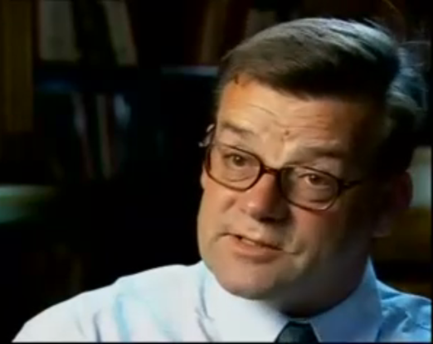 Steve Martin- Polar Historian, Mitchell Library

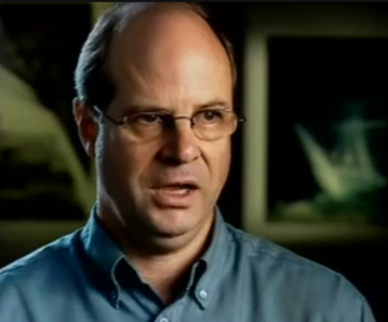 Alisdair McGregor, Hurley’s biographer
Dr Martyn Jolly, Australian National University

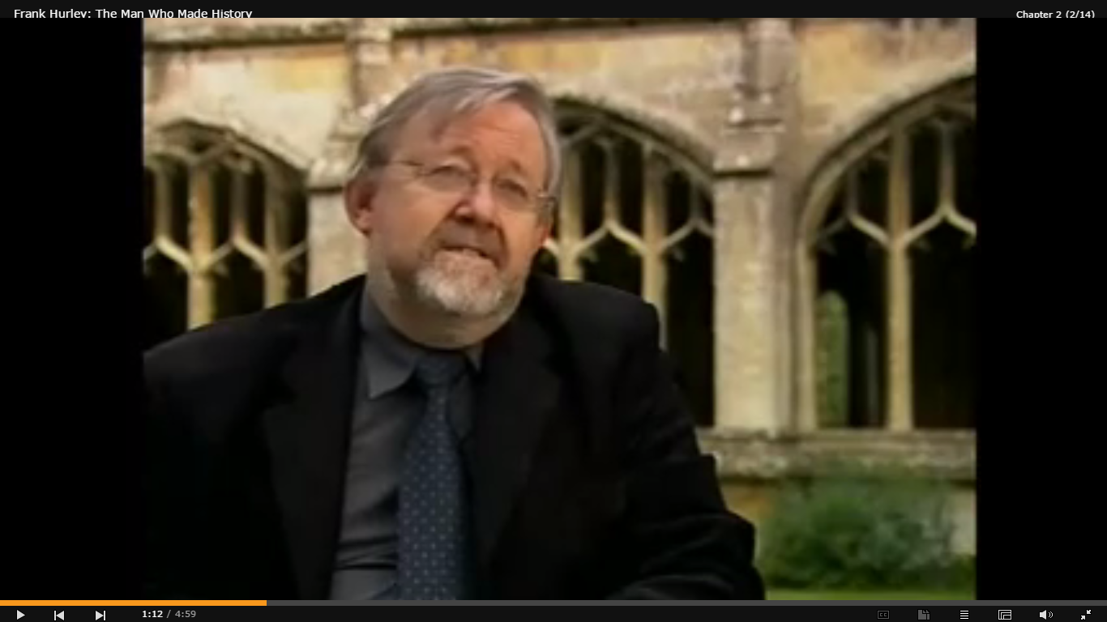 Mike Gray, Fox Talbot Museum

Gael Newton, National Gallery of Australia

Frank Hurley, aged 76

Joanna Wright, National Geographic Society

Dr Alf Howard, Polar Expedition 1929-31

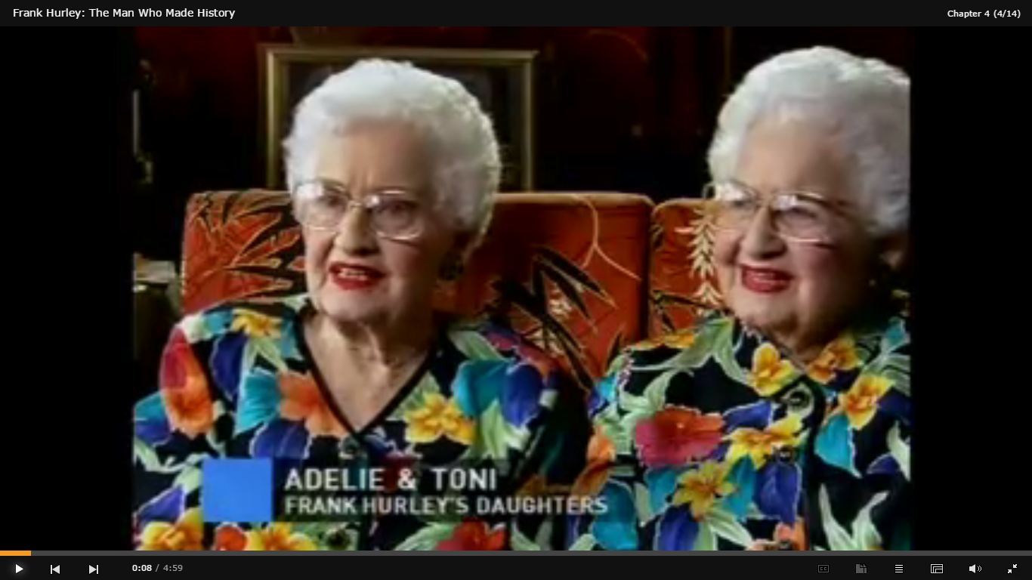 Adelie and Toni Hurley, Frank’s daughters

Ian Affleck, Curator, Australian War Memorial

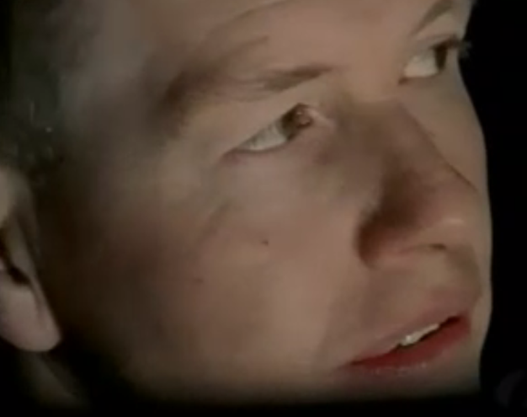 Steven Burton, Senior Photographer Australian War Memorial

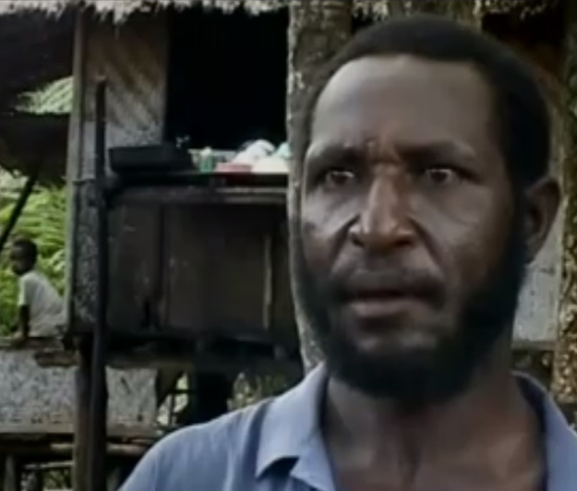 Seuna Malaki (PNG Village Spokesman)

Dr Jim Specht, Australian Museum

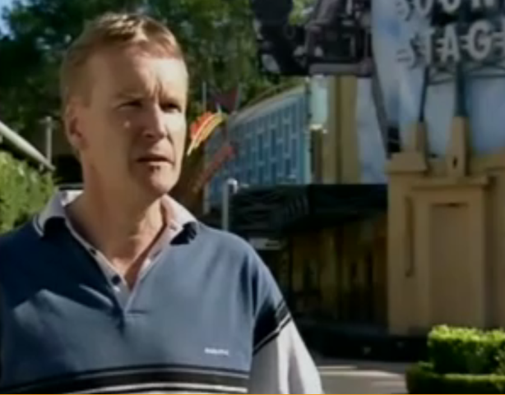 Graham Shirley, film historian - National Film & Sound Archive

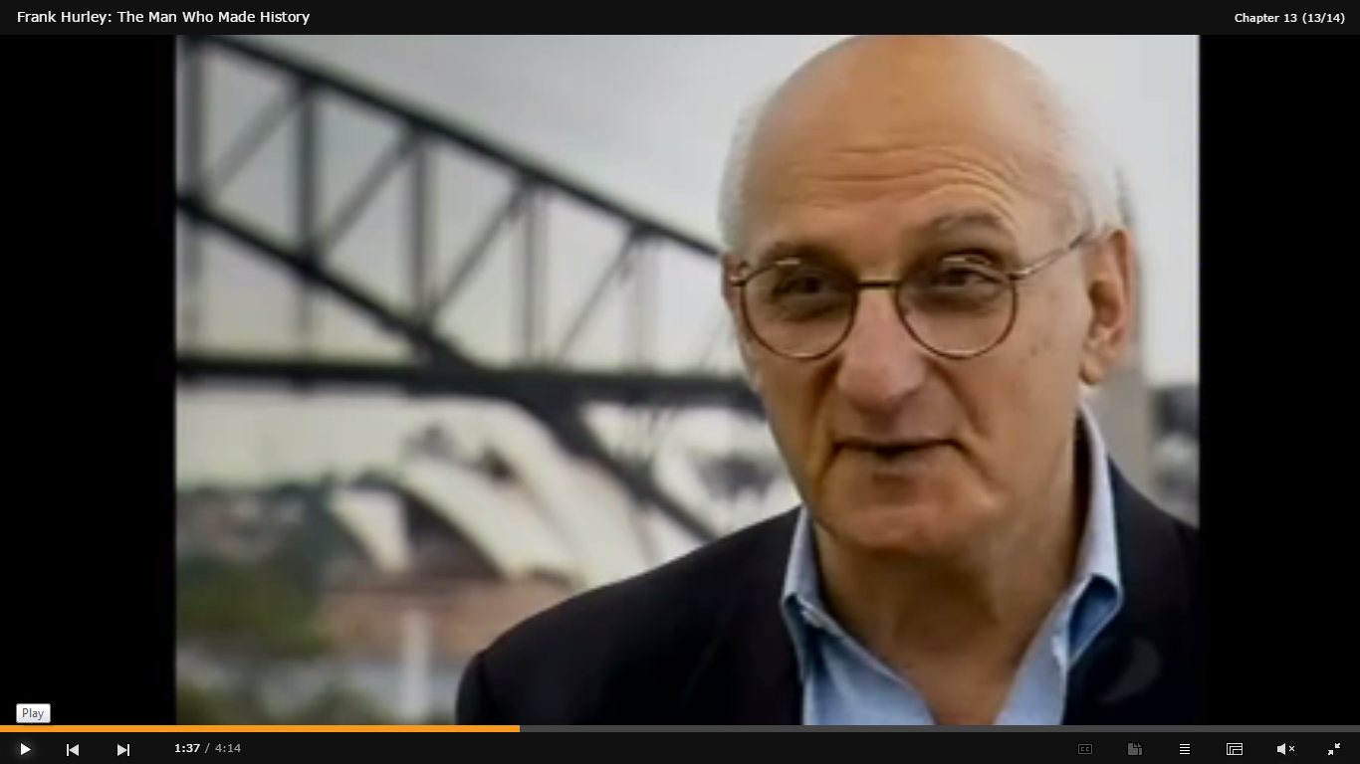 David Malouf, Author

Charles Bean, Australia’s Official War Historian World War One

