Waterproof that Roof!

**Student Worksheet:**

**◆ Engineering Teamwork and Planning**

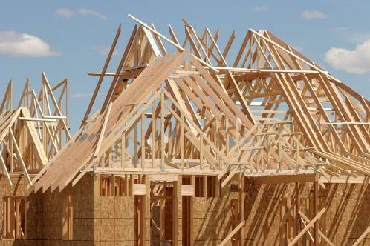You are a team of engineers given the challenge of creating a waterproof roof for a small house. You may use any materials provided to you and will have to devise a frame and covering that will prevent water from entering the interior. You can expect a rainstorm containing a liter of water!

**◆ Planning and Design Phase**

Be sure to read the summary sheet about different roofing techniques. Your team has been provided with a set of materials. Review these as a group and draw a structural design in the box below. Please also include a list of materials you think you'll need to build and test your roof.

|  |
| --- |
|  |
| Materials Required for Building: |

 **Waterproof that Roof!**

**Student Worksheet**

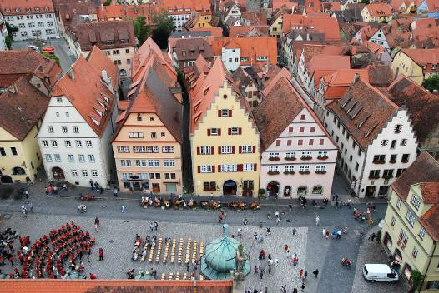**◆** **Construction Phase**

Build your roof, and be sure to put your team's name or number on plastic base of your "home" for easy identification during testing. Then, answer the questions below:

1. How similar was your built roof to your written design?

2. If you found you needed to make changes during the construction phase, describe why

your team decided to make revisions.

3. Did you find you needed to add additional materials during construction? What did you add, and why?

4. Did you find you had materials left over after construction?

5. What would happen on a real construction job if there were left over materials?

6. Did you test your roof at all during construction? If so, how did your roof work during these pre-tests?

7. Do you think that engineers often change their original plans during the manufacturing or construction process? What do you think this might do to their construction budget?

 **Waterproof that Roof!**

**Student Worksheet (continued):**

**◆** **Testing Phase**

Your teacher will test each of the roofs in a bin or sink, or outside if space and weather permits. One liter of water will be poured on the roof, and after 10 minutes, the roofs will be removed and your team will measure the amount of any water that leaked into your plastic bin "house."

As you observe other teams' roofs being tested, mark any observations you have about interesting designs, or ideas they came up with in the box below:

|  |
| --- |
|  |

**◆ Scoring**

Use the rankings below to score your roof based on the amount of water which leaked into your structure:

|  |  |  |  |  |  |
| --- | --- | --- | --- | --- | --- |
| Amount of water | No water | 3/4 liter of water | 1/2 liter of water | 3/4 liter of water | 1 Liter of water |
| Score | 5 | 4 | 3 | 2 | 1 |

 **Waterproof that Roof!**

**Student Worksheet (continued):**

◆ **Evaluation**

Complete the evaluation questions below:

1. What aspect of the design of the package that had the best overall score do you think

lead to its success?

2. What was the best aspect of your design? Describe one part of your design that you think worked the best.

3. If you had a chance to do this project again, what would your team have done

differently?

4. How do you think your roof would have held up to 10 liters of water? How about 100 liters of water?

5. If you could have selected some building materials which were not made available to you, what would you have selected? Why?

6. If your roof design were used on a real building, do you think it would require frequent maintenance? Why?

7. Do you think your roof design might be considered "green?" Why or why not?

8. Do you think this project worked better because you were part of a team, or do you think you could have done a better job working alone?

9. Do you think that engineers work alone, or in a team when they are developing new materials, processes, or products?